GISFI TR CSeON V0.1.0 (2013-09)
Technical Report
Global ICT Standardisation Forum for India
CSeON
Technical Report on Emergency Telecom Services
Draft

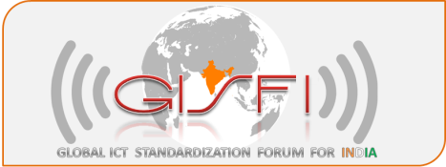

The present document has been developed within GISFI and may be further elaborated for the purposes of GISFI.

Keywords
<keyword[, keyword]>

GISFI
Postal address

GISFI office address
Address
Tel.: +91 xxxxxxx Fax: +91 xxxxxx
Internet
http://www.gisfi.org
Copyright Notification
No part may be reproduced except as authorized by written permission.
The copyright and the foregoing restriction extend to reproduction in all media.

© 2012, GISFI
All rights reserved.
Contents
Foreword 5
Introduction 5
1 Scope 6
2 References 6
3 Definitions, symbols and abbreviations 12
3.1 Abbreviations 12
4 ETS in Global Standards for Wired, 2G, 3G and 4G systems 16
4.1 Voice based Emergency Services 16
4.2 IMS based architecture for Emergency Services for 3G and LTE networks 16
4.3 Non-Voice based Emergency Services 16
4.4 Total Conversation Emergency Services 17
5 ETS in India 18
5.1 National Telecom Policy 2012 (NTP-12) 18
5.2 TRAI Consultation paper on Telecom Network Failures during Emergencies 19
5.2.1 Solutions Proposed by Stakeholders 19
5.2.2 Cellular Operator’s views on priority routing of calls for response and recovery personnel 20
5.3 TRAI Consultation paper on Integrated Emergency Communication and Response System (IECRS) 23
5.3.1 Cellular Operator’s views on IECRS system 23
5.4 GISFI view on ETS 42
5.5 Recommendations of the National Institute of Disaster Management 43
5.6 ETS in Transportation emergency in India 43
5.7 IECS Reference Architecture based on NG-911 for India 44
5.7.1 Description of Functional Elements 47
5.7.1.1 Terminology used in the context of NG 911 50
5.7.2 Call Architecture 50
5.7.3 Relationship of NENA i3 to IETF Standards 51
5.7.4 Location Information 52
5.7.4.1 Location-by-Value (LbyV) 52
5.7.4.2 Location-by-Reference (LbyR) 52
5.7.5 Routing of IP-based Emergency Calls in a generic IETF SIP originating network 55
5.7.6 Generic SIP as an Emergency Services IP Network 56
5.7.6.1 Simple ESInet 57
5.7.6.2 Multiple ESRPs in ESInet Architecture 57
5.7.6.3 Internal ESRP functions 58
5.7.7 End to End generic SIP emergency call architecture 60
5.7.8 Legacy Gateway Architectures -- Examples in i3 61
5.7.8.1 Legacy Wireline Origination Network 61
5.7.9 Description of Call Flow 63
5.7.9.1 Basic 9-1-1 call 63
5.8 Gap analysis based on survey of the NENA standards 65
6 Indian Requirements for Emergency Telecom Services 66
6.1 Broadcast Emergency Services 66
6.1.1 Early Warning System based on Cell Broadcast System with support for Indian languages 66
6.1.2 Known Solutions 67
6.1.2.1 EU-Alert system 67
6.1.2.2 3GPP Cell Broadcast System 67
6.1.2.3 Japan: NTT Docomo Area Mail Service 69
6.1.2.4 USA: The Commercial Mobile Alert System 69
6.1.2.4 Gap analysis of global standards on CBS for Indian requirements 70
6.1.3 GISFI Proposal 71
6.1.4 Benefits 75
6.2 Numbering Plan 77
6.3 Location Tracking and Caller Identification Issues 77
6.4 Emergency Calls without Subscriber Identity Module 77
6.5 Location and ownership of Public Service Access Points 78
6.6 Local Language Support and Social Inclusion 78
6.7 National Security Implications 79
6.8 National e-Governance Plan 79
6.9 Issues related to call routing 79
6.10 Machine Initiated Emergency Calls 80
7 Perceived open areas for standardization in Emergency Telecom Services in India 81
7.1 PSAP Standards 81
Conclusions 82
Annex <1>: Proposed Classification of ETS and their service requirements 83
Annex <2>: GISFI Response to the TRAI Consultation paper on IECRS 86
Annex <3>: Change history 113

Foreword
This Technical Report (TR) has been produced by GISFI WG Cloud and Service Oriented Networks (CSeON).
The present document may be referenced by other TRs and Technical Standards (TS) developed by GISFI WG CSeON.

Introduction
Emergency scenarios are unexpected, often disastrous, consequences of natural or manmade origin. Due to their impact on the lives of people, security of communities as well as entire nation, they constitute a major challenge for governments, citizens and service providers. As evident from history of such events, the crumbling of physical infrastructure (transport, electricity, telecommunication, food and water supply) can manifold increase the magnitude of such events thereby delaying the rescue and restoration operations for aid agencies and Government authorities Error: Reference source not found.
For effective rescue, response and restoration mechanism to be developed, it is understood that modern telecommunication infrastructure should support mechanisms for resilience, robustness, fault tolerance, emergency service provisioning and self organization with minimal human intervention. In this technical report a detailed study is carried out on the progress made by global standardization bodies and architectures deployed worldwide that already support such services. Further, India specific challenges for emergency telecom services are studied and potential standardisation considerations are outlined.

1 Scope

The present document surveys the state of art in Emergency Telecom Services (ETS) and corresponding standards and technologies. Further, this document also provides gap analysis with respect to existing specifications from global organizations like ETSI, 3GPP and also discusses the scope of standardization activities for GISFI in terms of ETS in India.

2 References
The following documents contain provisions which, through reference in this text, constitute provisions of the present document. (All website links mentioned in this section have been verified as ‘active and operational’ as on Nov 19, 2012).

- ITU-T, "International Emergency Preference Scheme (IEPS) for disaster relief operations ", ITU-T Recommendation E.106, 2003. URL: http://www.itu.int/rec/T-REC-E.106-200310-I/en
- ETSI, Emergency Telecommunications. URL: http://www.emtel.etsi.org/
- Emergency Communications (EMTEL); Basis of requirements for communication of individuals with authorities/organizations in case of distress (Emergency call handling). ETSI TR 102 180 V1.3.1 (2011-09).
- Emergency Communications (EMTEL); Requirements for communication between authorities/organizations during emergencies. ETSI TS 102 181 V1.2.1 (2008-02).
- Emergency Communications (EMTEL); Requirements for communications from authorities/organizations to individuals, groups or the general public during emergencies. ETSI TS 102 182 V1.4.1 (2010-07).
- Emergency Communications (EMTEL); Basis of requirements for communications between individuals and between individuals and authorities whilst emergencies are in progress. ETSI TR 102 410 V1.1.1 (2007-08).
- 3rd Generation Partnership Project; Technical Specification Group Services and System Aspects; IP Multimedia Subsystem (IMS) emergency sessions (Release 11) 3GPP TS 23.167 V9.6.0 (2011-03)
- 3rd Generation Partnership Project; Technical Specification Group Services and System Aspects; Study on Non-Voice Emergency Services (Release 11) 3GPP TR 22.871 V11.3.0 (2011-09).
- ITU-T SERIES F: NON-TELEPHONE TELECOMMUNICATION SERVICES Audiovisual services Multimedia conversational services.
- Emergency Communications (EMTEL); Total Conversation Access to Emergency Services
Total Conversation Access to Emergency Services URL: http://webapp.etsi.org/workProgram/Report_WorkItem.asp?wki_id=37761
- National Telecommunication Policy. Final Draft. 06 June, 2012. URL : http://www.dot.gov.in/ntp/NTP-06.06.2012-final.pdf
- TRAI Consultation paper: Telecom network failures during Emergencies/Disasters – Priority routing of calls of persons engaged in ‘response and recovery’ 10 May 2012, Paper No. 11/2012.
- Emergency Management and Research Institute URL: http://www.emri.in/
- United States Wireless Priority Call service URL: http://wps.ncs.gov/use.html
- Detailed requirements for GSM operation on Railways, TR 102 281, URL: http://www.etsi.org/WebSite/Technologies/RailwayTelecoms.aspx
- Peru, Security & Prosperity Steering Group (SPSG), Communications in Emergency Situations
2008/TEL38/SPSG/007, Lima, Peru. URL:http://www.mtc.gob.pe/portal/apectel38/tele_disaster/08_tel38_spsg_tdm_005_PRESENTACION%20EMERGENCIAS%20APEC%20[Compatibility%20Mode].pdf
- Purnachandra Rao, GSM – R, Sept 2012
URL: http://www.csi-india.org/c/document_library/get_file?uuid=7c580609-2860-4dbf-a71f-3530cc36ce01&groupId=10616.
- GISFI CSeON Workgroup, “SeON Framework, Gap Analysis and Architecture” GISFI_CSeON_201209310
URL: http://gisfi.org/wg_documents/GISFI_CSeON_201209310.doc
- Bharti Comments on TRAI Consultation Paper
URL:http://www.trai.gov.in/WriteReadData/ConsultationPaper/Document/201206260212465468867Bharti.pdf
- TATA Comments on TRAI Consultation Paper URL:
URL:http://www.trai.gov.in/WriteReadData/ConsultationPaper/Document/201206260213280479491Tata.pdf
- MTS Comments on TRAI Consultation Paper URL:http://www.trai.gov.in/WriteReadData/ConsultationPaper/Document/201206260214066583125MTS.pdf
- Reliance Comments on TRAI Consultation Paper URL:
URL:http://www.trai.gov.in/WriteReadData/ConsultationPaper/Document/201206260214297214029Reliance.pdf
- COAI Comments on TRAI Consultation Paper URL:
URL:http://www.trai.gov.in/WriteReadData/ConsultationPaper/Document/201206260215099413160COAI.pdf
- BSNL Comments on TRAI Consultation Paper URL:
URL:http://www.trai.gov.in/WriteReadData/ConsultationPaper/Document/201206290351004465026BSNL.pdf
- Standard Operating Procedures, disaster management, NDMA URL:http://nidm.gov.in/PDF/manuals/sop_ndm_2010.pdf
- National number plan URL: http://www.dot.gov.in/numbering_plan/nnp2003.pdf
- Justice Verma Committee Report on Amendments to Criminal Law in India URL:http://www.prsindia.org/uploads/media/Justice%20verma%20committee/js%20verma%20committe%20report.pdf
- COAI Response to DoT instruction to setup Location Based Services in mobile networks URL: http://coai.in/docs/PressReleases/Press%20Release%20-%20Location%20Based%20Services%20-%2016-6-2011.pdf
- Draft Amendment to the Telecommunications (Emergency Call Service) Determination 2002 – blocking of SIM-less calls, Consultation Paper, ACMA, Australia, 2007. URL: www.acma.gov.au
- Mobile Standards Association of India URL: http://www.msai.in/
- DoT to trial central IMEI register URL: http://indiatoday.intoday.in/story/govt-rings-up-us-firm-telcordia-technologies-to-curb-cell-phone-theft-india/1/236110.html
- Response to TRAI Consultation paper on issues relating to blocking of IMEI for lost/stolen mobile handset URL: http://trai.gov.in/WriteReadData/ConsultationPaper/Document/5Bharti.pdf
- COAI input at ETS Workshop Organized by TRAI URL:http://www.trai.gov.in/WriteReadData/Events/Presentation/PPT/201211050554241072138Shri%20Vikram%20Tiwathia%20-%20Associate%20Director%20General,%20COAI.pdf
- Languages of India URL: http://en.wikipedia.org/wiki/Languages_of_India
- National Emergency Number Association Standards URL : http://www.nena.org/?page=Standards
- Expectations of the deaf and hard of hearing communities URL: http://www.911.gov/pdf/TDI-11072006.pdf
- Crime and Criminal Tracking System, MHA, Govt. of India URL: http://ncrb.nic.in/cctns.htm
- Instructions on verification of new mobile subscribers (Prepaid and Postpaid) URL: http://www.dot.gov.in/as/2012/DOC181012.pdf
- National e-Governance Plan URL: http://www.negp.gov.in/
- Single number access for non emergency services. URL: http://pib.nic.in/newsite/erelease.aspx?relid=86571
- eGovernance standards for India URL: http://egovstandards.gov.in/
- Rakshak, Mobile App, URL: http://apps.mgov.gov.in/descp.do?appid=274&action=0
- Framework for mobile governance URL: http://deity.gov.in/content/framework-mobile-governance
- TRAI Consultation Paper on “Universal Single Number Based Integrated Emergency Communication and Response System” 15 March 2013, Paper No. 3/2013. URL:http://trai.gov.in/WriteReaddata/ConsultationPaper/Document/Consultation%20paper%20IECS%2015-3-13.pdf
- AUSPI Inputs on TRAI consultation paper. URL:http://trai.gov.in/Content/ConsultationComment_PreviewALL.aspx?CP_COMMENT_USER_ID=2545&CONSULT_ID=679
- COAI Inputs on TRAI consultation paper. URL:http://trai.gov.in/Content/ConsultationComment_PreviewALL.aspx?CP_COMMENT_USER_ID=2539&CONSULT_ID=679
- Airtel Inputs on TRAI consultation paper. URL:http://trai.gov.in/Content/ConsultationComment_PreviewALL.aspx?CP_COMMENT_USER_ID=2544&CONSULT_ID=679
- Idea Inputs on TRAI consultation paper. URL:http://trai.gov.in/WriteReadData/ConsultationPaper/Document/201304180714584942718Idea%20Cellular.pdf
- Loop Mobile Inputs on TRAI consultation paper. URL:http://trai.gov.in/Content/ConsultationComment_PreviewALL.aspx?CP_COMMENT_USER_ID=2547&CONSULT_ID=679
- Aircel Inputs on TRAI consultation paper. URL:http://trai.gov.in/Content/ConsultationComment_PreviewALL.aspx?CP_COMMENT_USER_ID=2543&CONSULT_ID=679
- MTNL Inputs on TRAI consultation paper. URL:http://trai.gov.in/Content/ConsultationComment_PreviewALL.aspx?CP_COMMENT_USER_ID=2523&CONSULT_ID=679
- MTS Inputs on TRAI consultation paper. URL:http://trai.gov.in/Content/ConsultationComment_PreviewALL.aspx?CP_COMMENT_USER_ID=2542&CONSULT_ID=679
- RCOM Inputs on TRAI consultation paper. URL:http://trai.gov.in/Content/ConsultationComment_PreviewALL.aspx?CP_COMMENT_USER_ID=2520&CONSULT_ID=679
- TTSL Inputs on TRAI consultation paper. URL:http://trai.gov.in/Content/ConsultationComment_PreviewALL.aspx?CP_COMMENT_USER_ID=2515&CONSULT_ID=679
- Vodafone Inputs on TRAI consultation paper. URL:http://trai.gov.in/Content/ConsultationComment_PreviewALL.aspx?CP_COMMENT_USER_ID=2519&CONSULT_ID=679
- GISFI inputs on TRAI consultation paper. URL:http://trai.gov.in/Content/ConsultationComment_PreviewALL.aspx?CP_COMMENT_USER_ID=2548&CONSULT_ID=679
- eCall URL: http://ec.europa.eu/information_society/activities/esafety/ecall/index_en.htm
- ETSI TS 102 900 V1.2.1 (2012-01) Emergency Communications (EMTEL); European Public Warning System (EU-ALERT) using the Cell Broadcast Service
- ETSI TS 123 041: "Digital cellular telecommunications system (Phase 2+); Universal Mobile Telecommunications System (UMTS); Technical realization of Cell Broadcast Service (CBS) (3GPP TS 23.041)".
- 3GPP TS 22.268 Technical Specification: Public Warning System (PWS) Requirements
- 3GPP TS 23.038 V11.0.0 (2012-09) Technical Specification Group Core Network and Terminals; Alphabets and language-specific information (Release 11).
- Itsuma Tanaka, Kenichiro Aoyagi, Anil Umesh and Wuri Hapsari, “Advanced warning message distribution platform for the next generation mobile communication network,” Technology Reports, NTT Docomo Technical Journal Vol, 11 No. 3.
- Indian Script Code for Information Interchange (ISCII) URL : http://pune.cdac.in/html/gist/standard/iscii.aspx
- BWCI : Indic SMS in the global 3GPP standard. Opportunities and next steps URL: http://bwci.org.in/demo/upload_files/file/bwci_files/activities/sigils/Reports&Workshops/Reports/Indic-SMS-Report-BWCI-final.pdf
- The Unicode Standard (6.0 ed.). Mountain View, California, USA: The Unicode Consortium. ISBN 978-1-936213-01-6.
- Wireless Emergency Alert, NOAA http://www.srh.noaa.gov/bmx/?n=wirelessalerts

- i3 Technical Requirements Document, National Emergency Number Association, NENA 08-751
- NENA Master Glossary of 9-1-1 Terminology, National Emergency Number Association, NENA 00-001
- Interim VoIP Architecture for Enhanced 9-1-1 Services (i2), National Emergency Number Association, NENA 08-001
- Framework for Emergency Calling in Internet Multimedia, B. Rosen, J. Polk, H. Schulzrinne, A. Newton, Internet Engineering Task Force, draft-ietf-ecrit-framework
- Geopriv Requirements, J.Cueller et. Al, Internet Engineering Task Force, RFC 3693
- A Presence-based GEOPRIV Location Object Format, J. Peterson, Internet Engineering Task Force, RFC 4119
- Dynamic Host Configuration Protocol Option for Coordinate-based Location Configuration Information, J. Polk, J. Schnizlein, M. Linsner, Internet Engineering Task Force, RFC 3825
- Dynamic Host Configuration Protocol (DHCPv4 and DHCPv6) Option for Civic Addresses Configuration Information, H. Schulzrinne, Internet Engineering Task Force, RFC 4776
- HTTP Enabled Location Delivery (HELD) M. Barnes, ed., Internet Engineering Task Force, draft-ietf-geopriv-http-location-delivery
- Session Initiation Protocol Location Conveyance, J. Polk, B. Rosen, Internet Engineering Task Force, draft-ietf-sip-location-conveyance
- A Hitchhikers Guide to the Session Initiation Protocol (SIP), J. Rosenberg, Internet Engineering Task Force, draft-ietf-sip-hitchhikers-guide
- Session Initiation Protocol, J, Rosenberg et. al., Internet Engineering Task Force, RFC 3261
- RTP: A Transport Protocol for Real-Time Applications, H. Schulzrinne et. al., Internet Engineering Task Force, RFC 3550
- SDP: Session Description Protocol, J. Handley, V. Jacobson, Internet Engineering Task Force, RFC 4566
- Session Initiation Protocol (SIP): Locating SIP Servers, J. Rosenberg, H. Schulzrinne, Internet Engineering Task Force, RFC 3263
- An Offer/Answer Model with the Session Description Protocol (SDP), J. Rosenberg, H. Schulzrinne, Internet Engineering Task Force, RFC 3264
- Session Initiation Protocol (SIP)-Specific Event Notification, A. Roach, Internet Engineering Task Force, RFC 3265
- The Session Initiation Protocol UPDATE Method, J. Rosenberg, Internet Engineering Task Force, RFC 3311
- A Privacy Mechanism for the Session Initiation Protocol (SIP), J. Peterson, RFC 3323
- Private Extensions to the Session Initiation Protocol (SIP) for Asserted Identity within Trusted Networks, C. Jennings, J. Peterson, M. Watson, Internet Engineering Task Force, RFC 3325
- Session Initiation Protocol (SIP) Extension for Instant Messaging, B. Campbell et. al., Internet Engineering Task Force, RFC 3428
- The Reason Header Field for the Session Initiation Protocol (SIP), H. Schulzrinne, D. Oran, G. Camarillo, Internet Engineering Task Force, RFC 3326
- The Session Initiation Protocol (SIP) Refer Method, R. Sparks, Internet Engineering Task Force, RFC 3515
- Grouping of Media Lines in the Session Description Protocol (SDP), G. Camarillo et. al., Internet Engineering Task Force, RFC 3388
- An Extension to the Session Initiation Protocol (SIP) for Symmetric Response Routing, J. Rosenberg, H. Schulzrinne, Internet Engineering Task Force, RFC 3581
- Real Time Control Protocol (RTCP) attribute in Session Description Protocol (SDP), C. Huitema, Internet Engineering Task Force, RFC 3605
- Control of Service Context using SIP Request-URI, B. Campbell, R. Sparks, Internet Engineering Task Force, RFC 3087
- Connected Identity in the Session Initiation Protocol (SIP), J. Elwell, Internet Engineering Task Force, RFC 4916
- Indicating User Agent Capabilities in the Session Initiation Protocol (SIP), J. Rosenberg, H. Schulzrinne, P. Kyzivat, Internet Engineering Task Force, RFC 3840
- Caller Preferences for the Session Initiation Protocol (SIP), J. Rosenberg, H. Schulzrinne, P. Kyzivat, Internet Engineering Task Force, RFC 3841
- A Presence Event Package for the Session Initiation Protocol (SIP), J. Rosenberg, Internet Engineering Task Force, RFC 3856
- A Watcher Information Event Template-Package for the Session Initiation Protocol (SIP), J. Rosenberg, Internet Engineering Task Force, RFC 3857
- The Session Initiation Protocol (SIP) "Replaces" Header, R. Mahy, B. Biggs, R. Dean, Internet Engineering Task Force, RFC 3891
- The Session Initiation Protocol (SIP) Referred-By Mechanism, R. Sparks, Internet Engineering Task Force, RFC 3892
- Best Current Practices for Third Party Call Control (3pcc) in the Session Initiation Protocol (SIP), J. Rosenberg et. al., Internet Engineering Task Force, RFC 3725
- Using E.164 numbers with the Session Initiation Protocol (SIP), J. Peterson et. al., Internet Engineering Task Force, RFC 3824
- Early Media and Ringing Tone Generation in the Session Initiation Protocol (SIP), G. Camarillo, H. Schulzrinne, Internet Engineering Task Force, RFC 3960
- Presence Information Data Format (PIDF), H. Sugano, Internet Engineering Task Force, RFC 3863
- Session Timers in the Session Initiation Protocol (SIP), S. Donovan, J. Rosenberg, Internet Engineering Task Force, RFC 4028
- Internet Media Type message/sipfrag, R. Sparks, Internet Engineering Task Force, RFC 3420
- [41] The Session Initiation Protocol (SIP) "Join" Header, R. Mahy, D. Petrie, Internet Engineering Task Force, RFC 3911
- Transcoding Services Invocation in the Session Initiation Protocol (SIP) Using Third Party Call Control (3pcc), G. Camarillo et. al., Internet Engineering Task Force, RFC 4117
- Basic Network Media Services with SIP, J. Berger et. al., Internet Engineering Task Force, RFC 4240
- An Extension to the Session Initiation Protocol (SIP) for Request History Information, M. Barnes et. al., Internet Engineering Task Force, RFC 4244
- Actions Addressing Identified Issues with the Session Initiation Protocol's (SIP) Non-INVITE Transaction, R. Sparks, Internet Engineering Task Force, RFC 4320
- Extending the Session Initiation Protocol (SIP) Reason Header for Preemption Events, J. Polk, Internet Engineering Task Force, RFC 4411
- Communications Resource Priority for the Session Initiation Protocol (SIP), H. Schulzrinne, J. Polk, Internet Engineering Task Force, RFC 4412
- Suppression of Session Initiation Protocol (SIP) REFER Method Implicit Subscription, O. Levin, Internet Engineering Task Force, RFC 4488
- Conveying Feature Tags with the Session Initiation Protocol (SIP) REFER Method, O. Levin, A. Johnston, Internet Engineering Task Force, RFC 4508
- Addressing an Amplification Vulnerability in Session Initiation Protocol (SIP) Forking Proxies, R. Sparks et. al., draft-ietf-sip-fork-loop-fix
- Session Initiation Protocol Call Control - Conferencing for User Agents, A. Johnston, O. Levin, Internet Engineering Task Force, RFC4579
- A Session Initiation Protocol (SIP) Event Package for Conference State, R. Rosenberg, H. Schulzrinne, O. Levin, Internet Engineering Task Force, RFC 4579
- Obtaining and Using Globally Routable User Agent (UA) URIs (GRUU) in the Session Initiation Protocol (SIP), J. Rosenberg, Internet Engineering Task Force, draft-ietf-sip-gruu
- Managing Client Initiated Connections in the Session Initiation Protocol (SIP), C. Jennings et. al., Internet Engineering Task Force, draft-ietf-sip-outbound
- SDP: Session Description Protocol, M. Handley et. al, Internet Engineering Task Force, RFC 4566
- Session Initiation Protocol Package for Voice Quality Reporting Event, A. Pendleton et. al., Internet Engineering Task Force, draft-ietf-sipping-rtcp-summary
- Interactive Connectivity Establishment (ICE): A Methodology for Network Address Translator (NAT) Traversal for Offer/Answer Protocols, J. Rosenberg, Internet Engineering Task Force, draft-ietf-mmusic-ice
- A Uniform Resource Name (URN) for Services, H. Schulzrinne, Internet Engineering Task Force, draft-ietf-ecrit-service-urn
- Best Current Practice for Communications Services in support of Emergency Calling, B. Rosen, J. Polk, Internet Engineering Task Force, draft-ietf-ecrit-phonebcp
- Location-to-URL Mapping Architecture and Framework, H. Schulzrinne, Internet Engineering Task Force, draft-ietf-ecrit-mapping-arch
- LoST: A Location-to-Service Translation Protocol, T. Hardie et. al., Internet Engineering Task Force, draft-ietf-ecrit-lost
- NENA Technical Requirements Document for Location Information to Support IP-Based Emergency Services, NENA 08-752, Issue 1
- NENA Recommended Method(s) for Location Determination to Support IP-Based Emergency Services - Technical Information Document, NENA 08-505, Issue 1
- GEOPRIV PIDF-LO Usage Clarification, Considerations and Recommendations, J. Winterbotton, M. Thomson, H. Tschofenig, Internet Engineering Task Force, draft-ietf-geopriv-pdif-lo-profile
- Revised Civic Location Format for PIDF-LO, M. Thomson, J. Winterbottom, Internet Engineering Task Force, draft-ietf-geopriv-revised-civic-lo
- Requirements for a Location-by-Reference Mechanism used in Location Configuration and Conveyance, R. Marshall, Internet Engineering Task Force, draft-marshall-geopriv-lbyr-requirements
- Using HELD as a Location URI Dereference Protocol, J. Winterbottom, M. Thomson, M. Dawson, Internet Engineering Task Force, draft-winterbottom-geopriv-held-deref-bcp
- http://www.ustda.gov/program/regions/southasia/
- http://trai.gov.in/Content/Event_Sessions.aspx?EVENT_ID=116&EventType=1&qid=0
- NENA Functional and Interface Standards for Next Generation 9-1-1 Version 1.0 (i3) NENA 08-002 Version 1.0, December 18, 2007

3 Definitions, symbols and abbreviations

3.1 Abbreviations
3GPP 3rd Generation Partnership Project
AIP Access Infrastructure Provider
B2BUA Back to Back User Agent
BCF Border Control Function
BCF Border Control Function
BPR&D Bureau of Police Research & Development
CAMA Centralized Automatic Message Accounting
CCTNS Crime and Criminal Tracking Network & Systems
CM Connection Management
CSP Communication Service Provider
DHCP Dynamic Host Configuration Protocol
DNS Domain Name Service
DoS Denial of Service
ECRF Emergency Call Routing Function
ECRIT Emergency Context Resolution with Internet Technologies
EIRENE European Integrated Radio Enhanced Network
eMLPP Enhanced Multi-level Precedence and Pre-emption
EMRI Emergency Management and Research Institute
EMTEL Emergency Telecommunications
ERTMS European Railway Train Management System
ESInet Emergency Services IP Network
ESRP Emergency Services Routing Proxy
ETS Emergency Telecom Services
ETSI European Telecommunications Standards Institute
GETS Government Emergency Telecommunications Service
GMLC Gateway MLC
GMLC Gateway Mobile Location Centre
GUID Globally Unique ID
HELD HTTP Enabled Location Delivery
HTTP Hyper Text Transfer PRotocol
IECRS Integrated Emergency Communication and Response System
IECS Integrated Emergency Communication System
IETF Internet Engineering Task Force
IM Instant Message
IMEI International Mobile Equipment Identifier
IMS IP Multimedia Subsystem
IMSI International Mobile Subscriber Identifier
IP Internet Protocol
ISDN Integrated Services Digital Network
ISUP ISDN User Part
ITS International Telecommunication Service
ITU-T International Telecommunication Union – Telecommunication Sector
LAF Location Acquisition functions
LAN Local Area Network
LbyR Location-by-Reference
LbyV Location-by-Value
LCP Location Configuration Protocol
LDF Location Determination Functions
LIS Location Information Server
LoST Location to Service Translation
LQF Location Query Function
LTE Long Term Evolution
LVF Location Validation Function
MAP Mobile Application Part
MHA Ministry of Home Affairs
MLC Mobile Location Center
MPC Mobile Positioning Center
MPLS Multi Protocol Label Switching
MSAG Master Street Address Guide
MSC Main Switching Centre
MSISDN Mobile Subscriber Integrated Services Digital Network
MTPAS Mobile Telecommunication Privileged Access Scheme
MVNO Mobile Virtual Network Operator
NAT Network Address Translation
NENA National Emergency Number Authority
NTP National Telecom Policy
OST Optimal Solutions and Technologies
PIDF-LO Presence Information Data Format Location Object
PIN Personal Identification Number
PLMN Public Land Mobile Network
PRF Policy Routing Function
PSAP Public Service Answering Points
PSTN Public Switched Telephone Network
RAN Radio Access Network
RDF Root Discovery Function
RQF Route Query Function
RTO Road Transport Organization
RTP Real Time Protocol
RTSP Real Time Control Protocol
SAI Service Area Identity
SCCP SS7 Connection Control Part
SDO Standards Developing Organizations
SDP Session description Protocol
SGSN Serving GPRS Support Node
SIM Subscriber Identity Module
SIP Sesssion Initial Protocol
SMS Short Message Service
SR Selective Router
SS7 Signalling System Number 7
TDM Time Division Multiplexing
TN Telephone Number
TRAI Telecom Regulatory Authority of India
UA User Agent
UAC User Agent Client
UAS User Agent Server
URI Uniform Resource Identifier
URN Uniform Resource Name
USTDA U.S. Trade and Development Agency
VF Validation Function
VHF Very High Frequency
VMSC Visited MSC
VoIP Voice over Internet Protocol
VPN Virtual Private Network
WPS Wireless Priority Service

4 ETS in Global Standards for Wired, 2G, 3G and 4G systems
Emergency Telecom Services (ETS) addresses a broad range of solutions that provision voice and data communication services in emergency situations. Nature of emergency situations itself may shape the scope and implemented technologies to provide the ETS to all stakeholders (victims, police forces, fire fighting units, ambulance services and other citizen services) during and in the aftermath of a disaster.

Due to the impetus formed in the last decade due to changing geopolitical situations and natural disasters of massive scale, telecommunication standardization bodies have contemplated including support for ETS as a mandatory feature of future telecom standards and a supplemental feature in existing telecom standards. In this section, various global standardization initiatives have been summarized.

4.1 Voice based Emergency Services
Emergency Telecom Services was envisaged by ITU-T [1] for disaster response and management by providing preferential call treatment to relief agencies, Government departments, medical and essential services. An international calling scheme is also detailed in [1] to provide International Telecommunication Service (ITS) to these relief agencies in case of disasters which may be established over wired (PSTN) and mobile (PLMN) networks. Further other standardization bodies (like ETSI, 3GPP) have published ETS service requirements and architectures.

EMTEL (Special Committee) under ETSI [2] oversees the requirements for the four main areas of emergency communications:

- Communication from citizens to authorities/organizations (emergency calls) [3]
- Communication between authorities/organizations (public safety communications) [4]
- Communication from authorities/organizations to citizens (warning systems) [5]
- Communication amongst citizens during emergencies (report wellbeing and to avoid panic) [6]

Each of the above four documents specify the detailed requirements for the emergency services supported to the various stakeholders.

4.2 IMS based architecture for Emergency Services for 3G and LTE networks
3GPP [7] has defined the technical specifications to support emergency services over IMS network over 2.5G / 3G/ 4G networks. Apart from plain voice, these specifications also support adding session mode video and text chat services within the emergency calling framework.

4.3 Non-Voice based Emergency Services
Additionally 3GPP [8] is now in the process of gathering requirements to support non-voice call services such as text, delayed media, data to be exchanged in a post-disaster scenario. Additionally, it support sign based interaction for differently abled people as per European Union requirements that includes support for video.

4.4 Total Conversation Emergency Services
Total Conversation, as defined in ITU-T F.703 [9], is a combination of three media in a conversational call: video, real-time text and audio. Total conversation services and terminals are deployed in the Internet in a number of countries in Europe, and adopted by people with disabilities who, for example, need video for sign language or real-time text for a text based conversation or as complement to a voice conversation. The objective of this Work Item [10] is to define precise conditions for using total conversation for emergency services and make access of emergency services possible to people with disabilities.

5 ETS in India

Government of India has not yet mandated nationwide Emergency Telecommunication number or service. Recently however, it has shown the intent to establish such an institutionalized nation-wide service in the National Telecom Policy 2012 [11]. Also the Telecom Regulatory Authority of India (TRAI) has published consultation papers in this regard along with inputs and comments from various stakeholders from the industry. In this section, we describe the various initiatives taken up by the Government, TRAI as well as private organization in this area. Currently, there is only one organization that provides limited personal emergency response services in India. The GVK EMRI (108 toll free dial) [13] service is available in 12 states in India catering to medical, police and fire emergencies (see Figure 1).

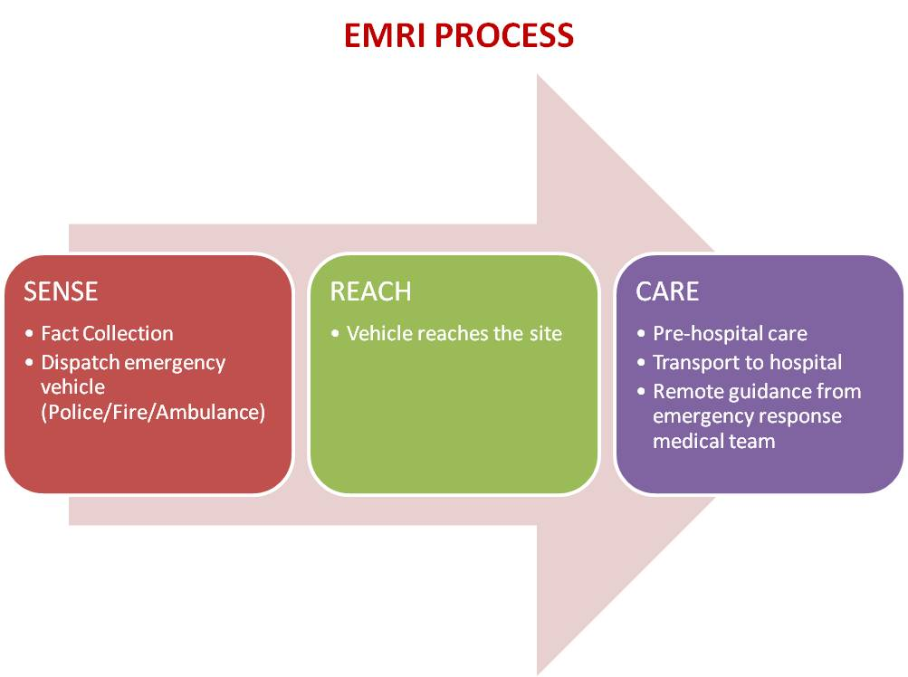
Figure 1: GVK Emergency Management and Research Institute (EMRI) process model [13]

However, this approach is more suited to personal emergencies such as accidents, fire emergencies etc and with current infrastructure cannot scale up to encounter large scale emergency situations. In subsection 5.1, the requirements put forth by the Government of India in its National Telecom Policy are described.

5.1 National Telecom Policy 2012 (NTP-12)
Government of India has published its National Telecom Policy 2012 (NTP-12) that outlines the policies governing the telecommunication sector in India. The below quoted relevant sections from NTP-12 clearly motivate a need to standardize ETS in India taking into consideration special requirements of Indian demography, languages, cultural background as well as infrastructural constraints. The following references for ETS are made in the final NTP-12 document [11]–

Para 15 of Preamble – 15-
“NTP-2012 recognizes the importance of creation of the robust and resilient telecom networks for adequately addressing the need for proactive support for mitigating disasters, natural and manmade.”

Para 5.12 of Strategies -
“To prescribe sectoral Standard Operating Procedures for aiding effective and early mitigation during disasters and emergencies.”

Para 5.13 of Strategies -
“To create appropriate regulatory framework for provision of reliable means of public communication by Telecom Service Providers during disasters.”

Para 5.14 of Strategies -
“To encourage use of ICTs in prediction, monitoring and early warning of disasters and early dissemination of information”

Para 5.15 of Strategies -
“To facilitate an institutional framework to establish nationwide Unified Emergency Response Mechanism by providing nationwide single access number for emergency services.”

5.2 TRAI Consultation paper on Telecom Network Failures during Emergencies
TRAI released a consultation paper [12] to all stakeholders regarding the support for preferential access to authorities in case for an emergency scenario created due to natural or manmade disaster. It further classifies the nature of losses caused to the telecommunication infrastructure during disasters and emergencies as follows:
a. Physical destruction of network components – Towers, network elements, end points
b. Disruption in supporting network infrastructure – electrical grid, power backups
It also identifies the problem of congestion in telecommunication services after a disaster strikes as a spike in traffic after initial wave of disaster (Tsunami / Earthquake / Bomb attacks have shown this) causing non availability of the telecommunication services to its subscribers.

Some of the technical solutions as suggested by TRAI [12] are focused to avoid telecom networks to get congested thus becoming futile in face of disasters:
a. Over provisioning core networks
b. Over dimensioning of Points of Interconnections (POIs) between telecom operators
c. Priority call routing for personnel involved in ‘response and recovery’

5.2.1 Solutions Proposed by Stakeholders
The TRAI consultation paper also describes briefly the solutions proposed by stakeholders to the paper. The solutions are briefly described below as Model A, B, C and D.

Model A – Solution which is a combination of MTPAS of UK and GETS of US
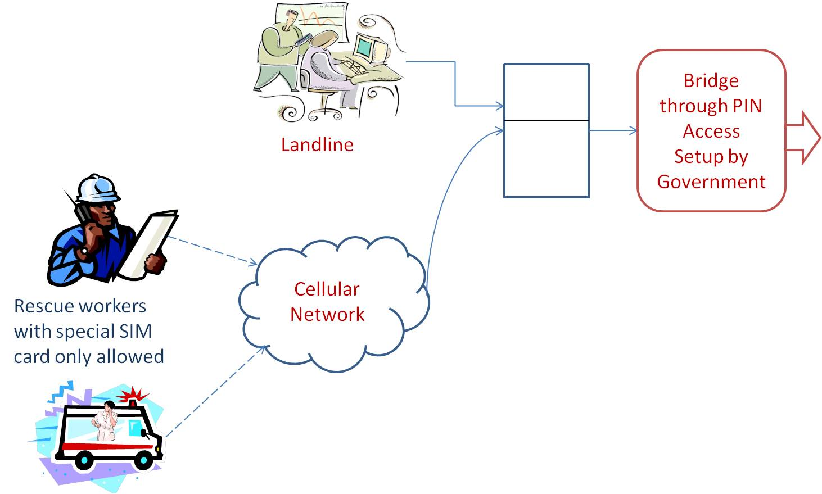
Figure 2: Model A proposed by TRAI stakeholders

Model A is combination of the United States system of Government Emergency Telecommunications Service (GETS) and European system of Mobile Telecommunications Privileged Access Scheme (MTPAS). The MTPAS completely bars the civilian use of cellular service after disaster and only authorized personnel with access to special Subscriber Identity Module (SIM) cards may place priority calls. Whereas, the system deployed in USA prioritizes calls based on a code and Personal Identification Number (PIN) combination and routes the call overriding the queues. This however is primarily designed for Public Switched Telephone Network (PSTN) networks. In India, cellular telecom service is more accessible to common citizens and has to be supported without any requirements for special SIMs. In USA, there is another cellular service for emergency calls known as Wireless Priority Service (WPS) [14], which needs to be subscribed by the caller in advance and can be used to place calls to any wired or wireless number.

Model B – Solution based on MVNO concept
In this proposal the Emergency network may operate as MVNO with dedicated resources and can be accessed by authorized users through any of the public network service providers. This virtual operator shall have subscriptions from among their regular subscribers as approved by a central committee. The capacity of this virtual operator shall be dynamic and the percentage share of the total capacity will depend upon the severity of the emergency and its impact.

Model C – Solution based on Enhanced Multi-Level Precedence & Preemption” (as per 3GPP TS 23.067)
Here every authorized user is provided a maximum precedence level (totally seven levels) and he/she can place a call within the range. In case of emergency the call is routed with a default emergency precedence level. For additional services over GSM, it uses MAP Mobile Application Part) protocol to exchange subscriber information with operator.

Model D ITU-T Recommendation E.106 International Emergency Preference Scheme (IEPS) for disaster relief operations
This solution describes an international preference scheme for disaster relief by national authorities. This is needed during a crisis situation emerging due to damage to infrastructure and congestion over the International Telephony Service. There is a single IEPS calling class and the service providers providing IEPS provide assured service to the IEPS users. The users are personnel belonging to the various disaster management and recovery organizations.

5.2.2 Cellular Operator’s views on priority routing of calls for response and recovery personnel
In response to [12], the cellular operators wrote to the TRAI, their view on establishing priority routing of calls for response and recovery personnel during emergencies. There were six major issues addressed in their letter to TRAI [19], [20], [21], [22], [23] and [24], which are listed below:

Issue 1: Should there be a direction from regulator on the network Dimensioning - both for operating in normal as well as emergency situations?
Issue 2: Which model is suitable and why?
Issue 3: Is eMLPP possible in intra-operator and inter-operator scenario in your network?
Issue 4: Major bottleneck in Emergency service delivery
Issue 5: Charges on users to access services?
Issue 6: How should the service delivery model for implementing the priority call routing be designed?

A summary of their observations on the above six issues is provided in the below Tables 1a to 1f in a chronological order.

Table 1a Response to Issue 1
Issue 1 | Should there be a direction from regulator on the network Dimensioning - both for operating in normal as well as emergency situations?
BSNL | No. Over-dimensioning network elements involves costs to the TSPs, and the network may be lying unused for most of the time.
Airtel | There should not be any direction from the regulator on the network dimensioning- both for operating in normal as well as emergency situations. Dimensioning of network should be left to the operators. The operator should be free to design the network while adhering to the Quality of Service parameters.
TATA | We strongly feel that there should not be any regulatory intervention on network dimensioning either on normal or emergency conditions
MTS | No, as during the disasters the call attempts may increase up to 7 times.
Reliance | No, there should not be any direction from regulator or licensor on network dimensioning
COAI | There should not be any direction from the regulator on the network dimensioning- both for operating in normal as well as emergency situations. The operator should be free to design the network while adhering to the Quality of Service parameters.

Table 1b Response to Issue 2
Issue 2 | Which model is suitable and why?
BSNL | Solution based on MVNO concept is better as it will ensure communication for all priority users even if any 1 network is functional in the area.  The solutions to the issues associated with this option may be worked out and cost of implementation of the same may be borne by the Govt.
Airtel | A combination of both MTPAS of UK and GETS of USA, usage of which can be governed by the extremity and the requirement of the situation, is the best suited solution for India.
TATA | Solutions based on eMLPP better. But CDMA networks not yet ready for this.
MTS | In CDMA network, the priority subscriber configuration in the HLR is the best suited approach for India
Reliance | GSM: We suggest a solution based on eMLPP would be best suited for implementation in India.  CDMA: WPS solution as it is being used in USA
COAI | A combination of both MTPAS of UK and GETS of USA, usage of which can be governed by the extremity and the requirement of the situation, is the best suited solution for India.

Table 1c Response to Issue 3
Issue 3 | Is eMLPP possible in intraoperator and inter-operator scenario in your network ?
BSNL | Information is being collected from vendors.
Airtel | No, the priority call routing for certain users based on Enhanced Multi-Level Precedence and  pre-emption service (eMLPP) is not possible in an inter-operator/intra operator scenario in the  network. Hence, this is not suggested for India where there are 8-10 operators in each circle.
TATA | Detailed study required. CAPEX of upgradation to be borne by government.
MTS | At present not available and to be tested
Reliance | Inter-operator is possible once there is standards based implementation. Inter-operator between CDMA and GSM/ 3G does NOT appear to be feasible
COAI | No, the priority call routing for certain users based on Enhanced Multi-Level Precedence and  pre-emption service (eMLPP) is not possible in an inter-operator/intra operator scenario in the  network. Hence, this is not suggested for India where there are 8-10 operators in each circle.

Table 1d Response to Issue 4
Issue 4 | Major bottleneck in Emergency service delivery
BSNL | Nil, in case, MVNO concept is decided
Airtel | There will definitely be some bottlenecks in the service delivery of priority call routing. Moreover, it is not possible to enlist the bottlenecks till the details are spelled out. However, it should be ensured that the priority call routing should be restricted to relief agencies and workers only.
TATA | CAPEX and OPEX requirement. Need for subscription based usage.
MTS | Needs to be ensured on all networks irrespective of technology used and cost involved.
Reliance | The requirement of “Specialized Mobile Stations” be considered. Modification is required in SIM for additional table of priorities as per standard. Inter-operator in multi-vendor Network Element environment.  Inter/ Intra-operator between CDMA and GSM/3G may not be technically feasible.
COAI | There will definitely be some bottlenecks in the service delivery of priority call routing. Moreover, it is not possible to enlist the bottlenecks till the details are spelled out. However, it should be ensured that the priority call routing should be restricted to relief agencies and workers only.

Table 1e Response to Issue 5
Issue 5 | Charges on users to access services?
BSNL | The reply for this will be determined from the cost of the solution decided to be implemented. However, charges for priority call routing should be borne by the respective user agencies.
Airtel | Yes, there should be a charge levied from the users for availing the facility of priority call routing. However, the costing and other modalities can only be indicated once the details of the implementations are finalized.
TATA | Regulator to issue directions
MTS | This may depend on the service finalized for implementation
Reliance | - One time activation fee  - Monthly service fee  - Additional per min call charges
COAI | These calls should be charged at Rs. 3 per minute.

Table 1f Response to Issue 6
Issue 6 | How should the service delivery model for implementing the priority call routing be designed?
BSNL | We may follow the method used in USA and UK as stated in para 4.26 of the consultation paper along with fulfilling the CAF requirement as per DOT guidelines.
Airtel | The priority call routing should be restricted to relief agencies and workers only and should not be made available for any other agency, as breakdown of civil mobile services can create even more chaos.
TATA | -NA-
MTS | Working group creation  Scope of service  Solution identification  Cost estimation and government share  Implementation schedule
Reliance | These personnel should have mobile phones supporting the eMLPP.
COAI | The priority call routing should be restricted to relief agencies and workers only and should not be made available for any other agency, as breakdown of civil mobile services can create even more chaos.

5.3 TRAI Consultation paper on Integrated Emergency Communication and Response System (IECRS)
TRAI released a consultation paper [44] to all stakeholders regarding the issues related to the implementation of integrated emergency communication and response system in India. The consultation paper details the current status of the emergency communication and response system in India and challenges faced by citizens and authorities. Further, it provides an overview of the internationally deployed IECRS systems such as in the North America, Europe and Asia-Pacific countries. The consultation paper also discusses the issues involved in implementation of universal single number based Integrated IECRS system in India and raises various issues for stakeholders’ comments.

Some of the major issues raised by TRAI [44] are listed below:
- What are the types of emergency services that should be made available through single emergency number?
- What universal number (e.g. 100,108 etc) should be assigned for the integrated emergency communication and response system in India?
- Should there be primary / secondary access numbers defined for the integrated emergency communication and response system in India? If yes, what should these numbers be?
- For implementing single number based Integrated Emergency Communication and Response System in India, should the database with information of telephone users be maintained by the individual service providers or should there be a centralized database?
- In case of centralized database which agency(one of the designated telecom service provider, a Central Government department or a designated third party) should be responsible for maintaining the database?
- What are the technical issues involved in transfer of location of a mobile user in real time?
- What accuracy should be mandated for the location information to be provided by the mobile service provider?
- Should emergency number access be allowed from inactive SIMs or handsets without SIMs? Please justify your answer.
- Should emergency access be allowed through SMS or email or data based calls? If yes, what will be the challenges in its implementation?
- Is it technically possible to get Location information in case of SMS or data based calls on real time basis? If yes, please elaborate the process and technical challenges if any.
- How to build redundancy in operations of Centralized response centers or PSAPs as they may be vulnerable to attack – both Physical and Application software related (Virus, Malware, denial of service, hacking) or to Network failures or Congestion i.e. Call Overload?
- Should all the calls made to universal emergency number be prioritized over normal calls? Please justify your answer.
- What legal/penal provisions should be made to deal with the problem of Hoax or fake calls to emergency numbers?
- How should the funding requirement be met for costs involved in implementation of IECRS? Should the cost be entirely borne by Central/State Governments or are there other possible ways to meet the funding requirements?
- Should Key Performance Indicators (KPIs) related to response time be mandated for PSAPs? If yes, what should be the KPIs? Please justify your suggestions.
- Should use of language translation services be mandated for PSAPs?
- In your opinion, what issues related to interconnectivity and IUC may come up in implementation of IECRS in India? What are the suggested approaches to deal with them?
- Should a separate emergency number for differently able persons be mandated in India? How the use of this number be administered?

5.3.1 Cellular Operator’s views on IECRS system
In response to [44], the telecom operators wrote to the TRAI [45], [46], [47], [48], [49], [50], [51], [52], [53], [54] and [55] , their view on the issues listed in Section 5.3. There were eighteen major issues addressed in their response to TRAI, which are listed below:

Table 2a Response to Issue 1
Issue | What are the types of emergency services that should be made available through single emergency number?
Idea | Police, Fire, Ambulance, Women helpline etc
MTNL | Police, accident, child, women helpline, fire, ambulance
Reliance | Police, Fire Ambulance, Emergency disaster management, airway accident, railway accident, road accident helpline
TATA | Individual or communities experiencing emergency situations with need to call police , fire , rescue, ambulance , natural disasters, terrorist and other disruptive activities
Vodafone | All distress scenarios
Aircel | Level-1 Emergency Services: Police, Fire, Ambulance, Women’s helpline
Airtel | We are therefore of the view that any emergency service that involves danger to life should be made available through single emergency number including Police, Fire brigade, Ambulance, Disaster management, Women in distress etc.
AUSPI | All emergency services should be implemented through single emergency number. Implementation should be in phased manner considering the emergency services like Police, Fire, Ambulance, Disaster Management and Accidents in the first phase and others in subsequent phases. Considering the geographical diversity, the Government may implement such emergency services progressively and in different phases as per the need of the population at large and category of emergencies.
COAI | Level-1 Emergency Services: Police, Fire, Ambulance, Women’s helpline
LOOP | Police, Doctor, Fire Brigade. Scalable in future to support disaster management, natural calamities and womens helpline etc
MTS | We believe that all the support services should be accessible through single emergency number as required by a user in case of emergency, be it police, fire brigade, Ambulance, women help line, child help line or approaching security agencies for intimation of unidentified articles or antisocial elements etc.

Table 2b Response to Issue 2
Issue | What universal number (e.g. 100,108 etc) should be assigned for the integrated emergency communication and response system in India?
Idea | 100
MTNL | 108
Reliance | 100
Tata Tele | 100
Vodafone | 100
Aircel | 100
Airtel | 100
AUSPI | 100
COAI | 100
LOOP | A new number like 911 or 112 could be assigned for the IECRS and let the existing numbers continue for the police and fire until successful implementation of the IECRS
MTS | One number among 100, 101, 102 or 108

Table 2c Response to Issue 3
Issue 1 | Should there be primary / secondary access numbers defined for the integrated emergency communication and response system in India? If yes, what should these numbers be?
Idea | -NA-
MTNL | 100,101,102
Reliance | 101,102,108
TATA | 101,102
Vodafone | -NA-
Aircel | No. Only primary number 100
Airtel | Present emergency numbers may be continued as secondary access numbers for some definite time duration and may be routed to single/primary universal number.
AUSPI | The primary number may be 100 and other numbers would be secondary numbers.
COAI | Only primary numbers should be defined
LOOP | No
MTS | No, there should be one access number for IECRS

Table 2d Response to Issue 4
Issue | For implementing single number based Integrated Emergency Communication and Response System in India, should the database with information of telephone users be maintained by the individual service providers or should there be a centralized database?
Idea | Centralized database at circle level
MTNL | Centralized database should be managed this database needs to be updated a frequency say daily or every 3 hours or real time automatically by all service providers
Reliance | Centralized database maintained by DoT/TRAI
TATA | With operators
Vodafone | TBD
Aircel | Maintained by Government, under support from a body like NIC, etc., with adequate security and data privacy measures
Airtel | A Service area wise centralized database should be there to maintain the information of telecom users.
AUSPI | Centralized database maintained by DOT or TRAI should be appropriate.
COAI | Centralized database at circle level  Maintained by government agency
LOOP | Centralized database which should be maintained by government appointed agency as has been done in case of MNP
MTS | The above mentioned options being complex in nature, would require feasibility study, data work flow & routing, corresponding IT development and POC by the Government before finalizing the recommendations.

Table 2e Response to Issue 5
Issue | In case of centralized database which agency(one of the designated telecom service provider, a Central Government department or a designated third party) should be responsible for maintaining the database?
Idea | -NA-
MTNL | The two PSU should be entrusted this job all service providers to pay for its OPEX/CAP EX. These PSU already routing and connected to all service providers and will exist in India forever and represent Govt.
Reliance | TRAI/DOT
TATA | Central government agency
Vodafone | -NA-
Aircel | Maintained by Government, under support from a body like NIC, etc., with adequate security and data privacy measures. We (telecom operator) can provide the database of MSISDN, subscriber’s name and address on a fortnightly basis.
Airtel | Centralized database should also be maintained by the Government, under its bodies like NIC, with adequate safeguards to maintain the confidentiality and privacy of data.
AUSPI | DoT, TRAI
COAI | NIC, Third party through public tendering
LOOP | Government should appoint the agency with expertise in managing databases and which has a prior experience in dealing with emergency situations in order to make an effective and robust system
MTS | Centralized database maintained by DOT or TRAI should be appropriate

Table 2f Response to Issue 6
Issue | What are the technical issues involved in transfer of location of a mobile user in real time?
Idea | Location of roaming subscriber not feasible
MTNL | With enhancement in web technology. It is not difficult to implement a automated centralized system connected to service providers via web services for updating of records in real time.
Reliance | Initially TSPs may be mandated to provide the PSAP with the location of the cell site or base station transmitting the call. When handsets are GPS enabled TRAI may consider handset based location system which has location
TATA | Technical feasibility to be studied in detail. Going forward AGPS should be mandated
Vodafone | Present interfaces not capable of transferring location in real time, not feasible for roaming subscribers, recommend ISUP based Cell ID information to find tentative location.
Aircel | It is not technically possible to provide the real time transfer of location with current technical systems & architecture. The current technical systems involve a parallel location management system (LMS) having GMLCs/SMLCs integrating with the BTS etc in the access system and MSCs are not involved in any stage. Presently & considering legacy systems, neither the interfaces deployed are capable of transferring this information to MSC nor can MSC transfer this to IECRS.  We recommend that location information from the current systems can be provided on a pull based approach from PSAPs, which can be near real time as well.
Airtel | However, the transfer of location of a mobile user can be done in near real time by using pull based mechanism. When call reaches the Public Safety Answering Point (PSAP), operator/automated application can query the location of the subscriber through the location interface and the location can be queried in 30-60 seconds. PSAP will also be required to have an interface with the MNP database to know which operator to send the location query request to.
AUSPI | Service providers maybe directed to provide to PSAP location of cell sites of base station which are handling the calls. Service providers would require implement the solution for real time transfer of cell data. For GPS enabled handsets, it would be possible to transmit location with more accuracy. However at this stage this solution may not be implemented as many handsets are without GPS capabilities.
COAI | Presently, none of the interfaces deployed are capable of transferring this location information to the MSC. Location details of roaming subscribers technically not feasible
LOOP | The transfer of location of a mobile user may be incorporated by suffixing the global cell id to the dialed emergency number digits. In case emergency services donot have the updated cell id to location mapping information, the location of the subscriber will not be known. The dialed emergency digits with suffix of global cell id will also have to be supported by subsequent transit exchanges
MTS | Interface with network nodes & query format  Response format to query & information in query response  Integrating the response content with IECRS system database(i.e., coordinate mapping to map database to locate the mobile user)  API integration & bandwidth cost to be borne by central/state agency

Table 2f Response to Issue 7
Issue | What accuracy should be mandated for the location information to be provided by the mobile service provider?
Idea | Supports the location information standards desired under the ECGI methodology
MTNL | Location information with accuracy as permissible by triangulation method for normal phones and lat-long via GPS of smart mobile phones should be mandated. Smart phone software while interacting with BTS/Node-B should send GPS parameters to network which should be recorded in CDR.
Reliance | Network based solutions, Handset based solutions
TATA | At present the cell ID and enhanced Cell ID based technology is the only possibility for the CDMA/GSM technologies and accuracy is based on inter cell site distance amongst other dependencies.
Vodafone | Accuracy based on ECGI methodology  Urban 250 mts to 500 mts  Semiurban and rural 500 mts to 2 kms  Remote/highways 3kms to 5 kms
Aircel | We alongwith industry have proposed to provide the accuracies that can be achieved through ECGI methodology. These accuracies are acceptable to various Law Enforcement agencies and we believe that these accuracies would also be helpful for emergency situations.
Airtel | Location accuracy may vary for different network deployments and may depend on network topology, inter – site distance, handset capability etc. In Phase I, Cell Id may be provided to Public Safety Answering Point (PSAP) as per the methodology stated above.  In Phase II, all handsets may be mandated to have GPS, wherein a precise location may be provided. A similar methodology is also used in US for enhanced 911 which is an emergency response system.
AUSPI | -NA-
COAI | ECGI Methodology  Urban 250 mts to 500 mts  Semiurban and rural 500 mts to 2 kms  Remote/highways 3kms to 5 kms
LOOP | The location information based on the CELL ID positioning may be provided by the service provides. Moreover the accuracy of the location information majorly depends upon the network architecture and the positioning of the cell sites. It will also vary based on the geographical conditions and other factors.
MTS | The accuracy would depend upon the available/deployable network technology for location information of the user.

Table 2f Response to Issue 8
Issue | Should emergency number access be allowed from inactive SIMs or handsets without SIMs? Please justify your answer.
Idea | No
MTNL | Yes, but the information should also be possible to differentiate that the source is inactive sim or handset without sim. It should be responsibility of the PSAP to decide further course of action.
Reliance | No
TATA | No
Vodafone | May be considered subject to technical feasibility
Aircel | Mobiles without SIMs or with inactive SIMs, should not be allowed
Airtel | Emergency number access should not be allowed from inactive SIMs or handsets without SIMs handsets. The access to emergency number should be only for handsets with valid SIMs. However, access to emergency service may be allowed in case if Prepaid SIM validity is finished and SIM is in grace period.
AUSPI | Emergency number access should not be allowed for inactive SIMs and handsets without SIMs.
COAI | No. Only for prepaid in grace period possible for inactive SIM
LOOP | No. Call be allowed from a valid SIM with zero balance however.
MTS | Inactive SIMs: Emergency access may be allowed.  Handsets without SIMs: Not to be allowed

Table 2g Response to Issue 9
Issue | Should emergency access be allowed through SMS or email or data based calls? If yes, what will be the challenges in its implementation?
Idea | Can be allowed through SMS and PSAP can use the pull based mechanism to get location details, whenever required. Emails should not be allowed
MTNL | It should be allowed via SMS as it can authenticate the mobile sender. Also if email is sent via mobile it should contain mobile number of sender as is available in SMS.
Reliance | SMS yes. But not through Email and data calls.
TATA | Yes, but should be implemented in second phase after exhaustive testing and vendor support with additional CAPEX requirement
Vodafone | SMS yes. But not feasible technically through Email.
Aircel | An access to the Integrated Emergency Communication via the non-voice based access would involve a detailed study of feasibility and capabilities offered by each system in terms of : support for duplex and/or two way communication, real time communication, extending location details, identity verification & extension to IECRS. This can be done once detailed architecture & functionalities are shared.
Airtel | There may be emergency situations such as Hijacking, Kidnapping etc. where a person may just be able to SMS and may not be able to make a voice call. Thus emergency access should be allowed through SMS. Not for Email and Data Calls
AUSPI | Emergency access be allowed through SMS in the first phase.  Email access should be implemented insubsequent phase as it will need exhaustive testing and support at all ends. However location based services would not be possible for Emails.
COAI | Can be allowed through SMS. PSAP can use the pull based mechanism to get the location details. Not possible for EMAIL
LOOP | No. In beginning voice only emergency service should be provided
MTS | It can be tested in phase-2 depending upon development/integration time/cost

Table 2h Response to Issue 10
Issue | Is it technically possible to get Location information in case of SMS or data based calls on real time basis? If yes, please elaborate the process and technical challenges if any.
Idea | PSAP can use the pull based mechanism to get location details whenever required
MTNL | At present location info can not be sent in SMS/Data due to protocol limitation This should be modified technically by manufacturers of core network elements
Reliance | At present not feasible. For SMS, it may be technically possible to get location information. But for data calls not possible.
TATA | Presently not supported
Vodafone | PSAP can use pull based mechanism to get location details of SMS. For data calls not feasible.
Aircel | SMS communication also does not support transfer of location information.  For SMS & data calls, offline pull based location information needs to be followed as in case of voice calls
Airtel | Public Safety Answering Point (PSAP) can use the pull based mechanism in the same way as for voice calls to get the location details.
AUSPI | For SMS, it is technically possible to get location information, however, for data based calls, we understand that it is not possible to get location information on real time basis . The current handsets do not recognize emergency text as an emergency communication; therefore, it may not be possible to get location information in the case of SMS as well as data calls. In view of that, initially, location based testing of emergency service may not be possible.
COAI | Possible for SMS using pull mechanism. Not possible for Email and data calls
LOOP | It is not technically feasible to transfer location information in real time for the SMS and data based calls.
MTS | It is not technically available & this would need additional development & implementation cost based on the architecture.

Table 2i Response to Issue 11
Issue | How to build redundancy in operations of Centralized response centers or PSAPs as they may be vulnerable to attack – both Physical and Application software related (Virus, Malware, denial of service, hacking) or to Network failures or Congestion i.e. Call Overload?
Idea | -NA-
MTNL | It should have centralized as well as distributed architecture In case of attack on centralized system the distributed ones will take over and vice versa. The regular real time updating between centralized and distributed system to be made
Reliance | Redundancy required in operations of centralized response centers or PSAPs as they may be vulnerable to attack
TATA | Establish disaster recovery site based on BCMS principles with clear roles and responsibilities of stake holders. Once centralized architecture is chosen, any site location could be geared up as a DR site for the other and critical service priority could be allocated based on the gravity of the need.
Vodafone | Adequate security measures and data privacy should be taken care of by the Government. Further clarity on the architecture and functioning of the PSAP required
Aircel | Government should put in place adequate measures for security and data privacy. We as telecom operator would be able to provide comments when architecture and functioning of the PSAPs are clearly specified.
Airtel | PSAP level, Technology level, People level and Process level steps need to be taken
AUSPI | Redundancy in operations is required regarding centralized response centre, which may be vulnerable to attack. Telecom operators to have redundancy through connectivity built in for point of connections through different switches. Hardware and software network elementsare ‘safe to connect’ certified by the operators. There should be periodic audit of the emergency response system. Disaster recovery site based on clear roles and responsibilities of stake holders is desirable.
COAI | Adequate secutity measures and data privacy should be taken care of by the Government . Moreover most of these can be discusses when there is clarity on the architecture and functioning of the PSAP
LOOP | Phased manner. Data be used only by authorized person, stringent laws should be made to make the system more refined, effective and fool proof
MTS | The geographical redundancy needs to be built at Centralized Response Center in terms of disaster recovery site in active-standby or active-active load sharing configuration to take care of physical or network failure or congestion or call overload.  The suitable firewalling or security measures (anti-virus software) to protect the IECRS set up from unauthorized access or virus attacks.

Table 2j Response to Issue 12
Issue | Should all the calls made to universal emergency number be prioritized over normal calls? Please justify your answer.
Idea | Subject to technical feasibility. Interface to PSAP should be dimensioned to provide no congestion for emergency calls
MTNL | Yes
Reliance | We suggest that there is no need for prioritized calls made to universal emergency number over normal calls.
TATA | The emergency levels are generally tagged in the respective network elements like MSCs as emergency calls for routing in the network. Issues:  a. In CDMA, issue with the old legacy systems which do not support EPACA  b. Need of development of this feature at RAN side  c. EMLPP tag may not be carried by transit switched for prioritize calls (end to end) in case of congestion  d. NLD network does not support of prioritization of call. This needs further study
Vodafone | Subject to technical feasibility and required outcome. However, interface to PSAP should be dimensioned to provide no congestion for emergency calls. For radio access priority, available solutions donot yield required results in case of overloads are not recommended
Aircel | Prioritization of calls to emergency access number is subject to technical feasibility and required outcome that too based on the specific details of architecture and functioning of the IECRS. However, interface to PSAP should be dimensioned to provide no congestion for emergency calls. For Radio Access priority, available solutions do not yield required results in case of overloads and are not recommended.
Airtel | No. The solutions available for prioritization in Radio Access do not yield required results in case of overloads and is therefore not recommended. However, the interface to PSAP may be dimensioned to provide no congestion for emergency calls.
AUSPI | We feel that there is no need of prioritization of calls made to Emergency Communication and Response System. PSAP level only congestion may happen due to limitation of manning the position.
COAI | Subject to technical feasibility and required outcome. However, interface to PSAP should be dimensioned to provide no congestion for emergency calls. For radio access priority, available solutions donot yield required results in case of overloads are not recommended
LOOP | For genuine calls there should be priority
MTS | This would be a bit challenging & would require EPACA/MLPP implementation in the network which is not yet available for end to end implementation.

Table 2k Response to Issue 13
Issue | What legal/penal provisions should be made to deal with the problem of Hoax or fake calls to emergency numbers?
Idea | Some deterrent for callers making hoax or fake calls to emergency numbers
MTNL | If user can not hide himself he can not make Hoax /fake calls. Verification based on UID.
Reliance | Apt legal or penal provisions to curb such hoax calls
TATA | TRAI may advise
Vodafone | Desirable to have a legal / penal provision based on international practices
Aircel | Adequate deterrent measures should be put in place by Government to deal with problems of hoax calls to emergency numbers which has the potential to affect emergency services to genuine callers.
Airtel | There should be strict legal provisions to deal with such issues and if someone found guilty, there should be criminal liability may be subjected to stiff fines or imprisonment.
AUSPI | Hoax calls should be considered as an offence and TRAI may decide suitable legal provision for addressing hoax calls.TRAI should bring out legislation to make hoax call a criminal offence.
COAI | Adequate deterrent measures should be put in place by Government
LOOP | Criminal offence and rules in other countries where such a system exists may be followed
MTS | The hoax calls should be considered as an offence and TRAI may decide suitable legal provision for addressing hoax calls. TRAI should bring out legislation to make hoax call an offence a s per the applicable legal framework.

Table 2l Response to Issue 14
Issue | How should the funding requirement be met for costs involved in implementation of IECRS? Should the cost be entirely borne by Central/State Governments or are there other possible ways to meet the funding requirements?
Idea | -NA-
MTNL | Centralized system in control of center . distributed system should be with corresponding states. Funding their own part. Further the extra tax on citizens to be imposed to pay for it
Reliance | Charge appropriate amount to subscribers
TATA | Should be borne by the central and state governments
Vodafone | Should be borne by the central and state governments
Aircel | This cost should be entirely funded by Government. Providing emergency services to citizens is a sovereign state requirement and Government should fund this entirely.
Airtel | Emergency response system should be completely Central /State Government funded and the cost involved in deploying, maintaining the integrated emergency communication and response system must be entirely borne by the Government.
AUSPI | We suggest that the funding requirement based cost should be entirely borne by Central/ State Governments. It should also include the interconnection cost that will be borne by the operators for provision of such emergency services.
COAI | Should be borne by the central / state governments
LOOP | Cost should be entirely borne by central or state government
MTS | The entire cost should be borne by Central/State Governments.

Table 2m Response to Issue 15
Issue | Should Key Performance Indicators (KPIs) related to response time be mandated for PSAPs? If yes, what should be the KPIs? Please justify your suggestions.
Idea | -NA-
MTNL | Yes,  All calls landing on PSAP should be either  1 calls successful at PSAP.  2 calls dropped in queue.  3 Missed calls to PSAP.  4 calls disconnected at PSAP during conversation.  There should be different KPI for different situations like for calls of 2 and 3 type the PSAP to have feature to do outbound calls to find out the real problem with caller. This OBD should be within 30 sec For calls of type 4 above the OBD should be done within 10 sec All calls/SMS/data should transmit location and mobile CLIR and time and time zone to PSAP. PSAP should have KPI related to work flows like passing and retrieving other info related to call/sms/data
Reliance | KPI based on response time for PSAPs. This requires to be decided based on practical conditions in the country, over a trial period. The KPI needs to be tightened progressively for better emergency response services
TATA | KPIs related to rrepsonse time should NOT be mandated for PSAPs. TRAI may decide KPI based on various factor like available manpower, average call volume, response time for the PSAP operator, distributing correctly the responsibilities to right service agencies based on callers need by the PSAP operators, security of the data in the custoday of the PSAP agency etc.
Vodafone | KPIs should be left to the SLAs or agreements between the state governments and the PSAPs
Aircel | We agree that KPIs should be mandated for PSAPs. However, we can provide specific suggestions once specific details on architecture & functionalities are provided to us.
Airtel | Proposed KPIs  1. Answer to Seizure ratio of the calls handled by the PSAP system  2. Uptime of the PSAP PoI’s with the service provider directly connected to the PSAP system  3. Response time of emergency calls answered by the Emergency call dispatcher  Proposed KPIs Targets  1. Answer to Seizure ratio of the calls handled by the PSAP system should be minimum 95% as it depends upon the dimensioning of the manpower at the PSAP system, no of emergency calls and load on the PSAP system  2. Uptime target of the PSAP PoI’s with the service provider directly connected to the PSAP system should be 99.999%  3. Response time target should be that 80% of all the emergency calls shall be answered by the PSAP within 20 seconds and 95% of calls shall answered by the PSAP system in not more than 30 Seconds.
AUSPI | KPI related to response time for PSAP may be regulated. Before finalizing KPI, the situation must be observed practically over a trial period based on various factor like available manpower, average call volume, response time of the PSAP operator etc.
COAI | Yes, KPI should be prescribed for the PSAPs for quick turnaround time
LOOP | Currently to start with KPI/SLA that are in place for the current emergency numbers like 100 may be followed
MTS | The KPIs to be finalized based on the implementation and conducting trials for observing the situation practically.

Table 2n Response to Issue 16
Issue | Should use of language translation services be mandated for PSAPs?
Idea | -NA-
MTNL | Language translators should be mandatory and it should be possible to conference with translator. The all calls should be recorded and retrievable offline also
Reliance | Yes
TATA | Should not be mandated for PSAPs as the same will be funded by the government
Vodafone | No, should be based on PSAP and state administration requirements as when need arises
Aircel | Language translation services would be definitely required.
Airtel | Use of language translation may be mandated for PSAPs.
AUSPI | Yes, language translation services be mandated.
COAI | Yes, language translation services should be available with the PSAPs
LOOP | Operator could speak in English, Hindi and one regional language at the time of managing calls
MTS | Yes, suitable arrangement to be done at PSAPs end either automated or manual.

Table 2o Response to Issue 17
Issue | In your opinion, what issues related to interconnectivity and IUC may come up in implementation of IECRS in India? What are the suggested approaches to deal with them?
Idea | PSAP should be mandated toprovide opportunity of connectivity separately to each operator since emergency services are license conditions for all operators.
MTNL | For mobile the IECR implementation is related to routing .The redundant routes should be available for all. As these are toll free and national level importance numbers there should be no IUC related matters in it.
Reliance | Connectivity to PSAPs should be allowed directly or through any of the Telecom Operators on payment basis. In such cases charge should be reasonable
TATA | All operators should be accessible to PSAP with redundancy to other operator network for handling emergency calls. Once the IECRS is fully functional and all the operators are connected to it with redundancy then all the calls relating to all type of emergency should be routed to PSAP and operators should not be charged. Also the operators should not charge each other for provision of such emergency services by way of using each other’s network as and when it is required.
Vodafone | a. PSAP should be mandated to provide opportunity of connectivity separately to each operator since emergency services are license conditions for all operators  b. Any operator desirous of direct connectivity with the PSAP should not be refused to connect.  c. Direct connectivity would ensure minimal issues related to inter operator billing, charging and settlements and would also avoid an extra leg of connectivity which could lead to interoperator call congestion issues.  d. In case, if TRAI does not find direct connecitivity suitable, then the originating operator should be allowed to handover the emergency traffic at his preferred posint of interconnection within the circle and the terminating operator should only charge IUC on per minute basis for the emergency calls considering it to be inked with larger consumer interests.
Aircel | We would strongly urge that it should be made mandatory for these PSAPs to offer separate interconnectivity to each telecom operator since, provision of emergency services is a license condition for each operator and enabling environment has to be created for each operator to meet the condition in a fair, transparent & equivalent manner.  Option of Direct connectivity would ensure almost NIL issues related to inter-operator billing, charging & settlements and would also reduce problems of inter-operator call congestions. This would also help in delivery of sms & data calls.  While above is strongly recommended, however in case TRAI observes direct connectivity not to be suitable, then below is suggested to be followed with a fair & transparent approach:-  IUC (including fixed and/or recurring charges) for such calls should be prescribed on minimal cost considering it to be linked with larger consumer interests and  Detailed public consultation along with details of architecture should be floated for arriving at effective interconnection arrangements.
Airtel | IUC and interconnectivity will be dependent on PSAP deployment architecture, which may be nationalized or state level.  PSAP should be mandated to provide opportunity of connectivity separately to each operator as the same will avoid an extra leg of connectivity and will also have minimal issues pertaining to inter-operator billing, charging and settlement.  In case, TRAI does not find direct connectivity suitable, than the IUC (including fixed and recurring charges) for emergency calls be prescribed on a minimal costs considering it to be linked with larger consumer interests.
AUSPI | Based on reasonable charges, connectivity from the service providers to PSAP may be allowed directly as well as through any other telecom service provider.  Selecting one or two operators will lead to single point of failure therefore, all operators should be accessible to PSAP with redundancy to other operator network for handling emergency calls.  Once the IECRS is fully functional and all the operators are connected to it with redundancy then all the calls relating to all type of emergency should be routed to PSAP and operators should not be charged.
COAI | a. PSAP should be mandated to provide opportunity of connectivity separately to each operator since emergency services are license conditions for all operators  b. Any operator desirous of direct connectivity with the PSAP should not be refused to connect.  c. Direct connectivity would ensure minimal issues related to inter operator billing, charging and settlements and would also avoid an extra leg of connectivity which could lead to interoperator call congestion issues.  d. In case, if TRAI does not find direct connecitivity suitable, then the originating operator should be allowed to handover the emergency traffic at his preferred posint of interconnection within the circle and the terminating operator should only charge IUC on per minute basis for the emergency calls considering it to be inked with larger consumer interests.
LOOP | No IUC charges for emergency services
MTS | All operators to be mandated to connect directly with IECRS local PoP in respective telecom service area which does not require any IUC.

Table 2p Response to Issue 18
Issue | Should a separate emergency number for differently able persons be mandated in India? How the use of this number be administered?
Idea | -NA-
MTNL | No many numbers are already existing in India these can be made secondary numbers and PSAP to know which type of number is called
Reliance | -NA-
TATA | -NA-
Vodafone | We shall look forward to more clarity from the Authority on the need for a separate number
Aircel | Only single emergency number should be followed
Airtel | No
AUSPI | After sufficient experience in the first phase, this aspect should be considered for implementation. TRAI may decide appropriately.
COAI | Single emergency number for all
LOOP | No
MTS | A separate emergency number for differently able persons may be mandated & its administration needs to be further discussed.

5.4 GISFI view on ETS
GISFI framework [18] has the following recommendation on emergency service in Indian context:

Section 2.2.4 Emergency Telecom Service (ETS)
“The Telecom Regulatory Authority of India (TRAI) has not mandated emergency number dialing to ISPs. This should be examined further by GISFI whether emergency connections via telephony and/or IP should be mandated across the board. Response to natural or unnatural disasters can be greatly improved if the networks themselves provide for emergency connections, status updates, interconnects with disaster recovery or government agencies, etc.”

Section 2.6.5 Network and Service Surveillance
“The goal is to provide cost-effective survivable network. This may be limited to the power failure and terrorist attacks. Survivability should be built into the design and operation of the SeON, and should be based on open and interoperable standards rather than proprietary technologies. For example, in VoIP, the call server can be deployed in split or load-shared mode so that when disasters happen in one geographical location, customers can still obtain service from the call server in another location. Similar mechanism can be utilized for intra-and inter-domain transmission devices and gateways in both wire line and wireless networks.”

In response to [44], GISFI also provided comments to the TRAI [56], which are reproduced in the Annex <2>: GISFI Response to the TRAI Consultation paper on IECRS.

5.5 Recommendations of the National Institute of Disaster Management
The National Institute of Disaster Management (NIDM) setup under the National Disaster Management Authority (NDMA) has recommended the following relevant sections in its document on standard operating procedures for responding to natural disasters [25].

Communication Network of Emergency Operation Centre (EOC):
Under the National Communication Plan being implemented by the Government of India, the EOCs at all the three levels shall have a fail proof communication network with triple redundancy of NICNET of NIC, POLNET of Police and SPACENET of ISRO in addition to the terrestrial and satellite based communication to ensure voice, data and video transfer.
Emergency support function of communications is to be supported through the Ministry of Communications (Primary Agency) [25] and the responsibilities and activities are given as follows:
Responsibilities of Primary Agency:
Coordination of national actions to assure the provision of telecommunication support the centre, state and district
Coordinate the requirement of temporary telecommunication in the affected areas

Activities for Response:
Responsible for coordination of national actions to assure the provision of telecommunication support the centre, state and district response elements
Coordinate the requirement of temporary telecommunication in the affected areas

5.6 ETS in Transportation emergency in India

Though India currently doesn’t have ETS services support on the road transport specifically, the Indian Railways has a limited deployment of Emergency communication infrastructure. Apart from the VHF band Train Control System, there is now a limited deployment of GSM for Railway Communications (GSM-R) standardized by ETSI [15], [17] meeting the European Rail Traffic Management System (ERTMS) requirements. GSM-R has other additional facilities incorporated such as Railway Emergency Call (REC); e.g., the driver can call all the drivers of trains in his area and the controller by following means:
a. Red button: All phones have red buttons for the purpose of emergency calls.
b. Functional addressing: Instead of ringing the full mobile number (11 digits), a short code, say, the number of the train or engine can be dialled (prefixed by a digit for the function) to reach the desired functionary faster.
c. Location dependant addressing - the driver can reach the controller or station master of the region he is in, by either pressing a button or dialling a short code.
d. Multilevel precedence or preemption - there are seven priority levels depending on the status of user and the user with higher priority can preempt an ongoing call of a lesser priority user-emergency call having the highest priority.

5.7 IECS Reference Architecture based on NG-911 for India
The U.S. Trade and Development Agency (USTDA) provided a grant to the Ministry of Home Affairs (MHA), Government of India to partially fund a feasibility study to establish an Integrated Emergency Communications System (IECS) and supporting infrastructure in Hyderabad, Andhra Pradesh, India [134]. The MHA requested USTDA funding for a feasibility study to assess the current IECS communications architecture; analyze the operational, financial, and organizational aspects that would lead to a national IECS; and address the implications of project implementation focused on an initial pilot project in Hyderabad. MHA selected Optimal Solutions and Technologies, Inc. (OST) to perform the feasibility study in partnership with Winbourne and Costas. During the course of this study, OST was required to deliver reports covering various areas of IECS to Bureau of Police Research & Development (BPR&D) and MHA. Though the report is not available in public domain, OST participated in the consultation process of TRAI on IECRS and provided inputs on possible reference architecture for IECRS in India [135]. This document provides a detailed technical analysis of this reference architecture based on the NG 911 architecture in the USA by the National Emergency Number Authority (NENA).

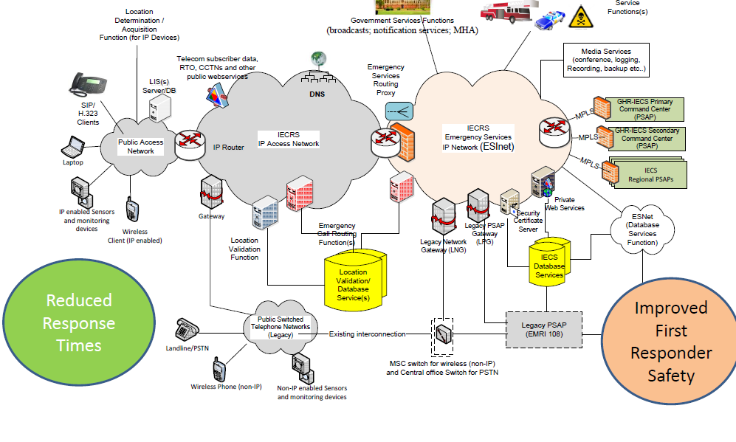
Figure 3. Initial Proposed Architecture based on i3 reference architecture for NG 911 service in USA [134]
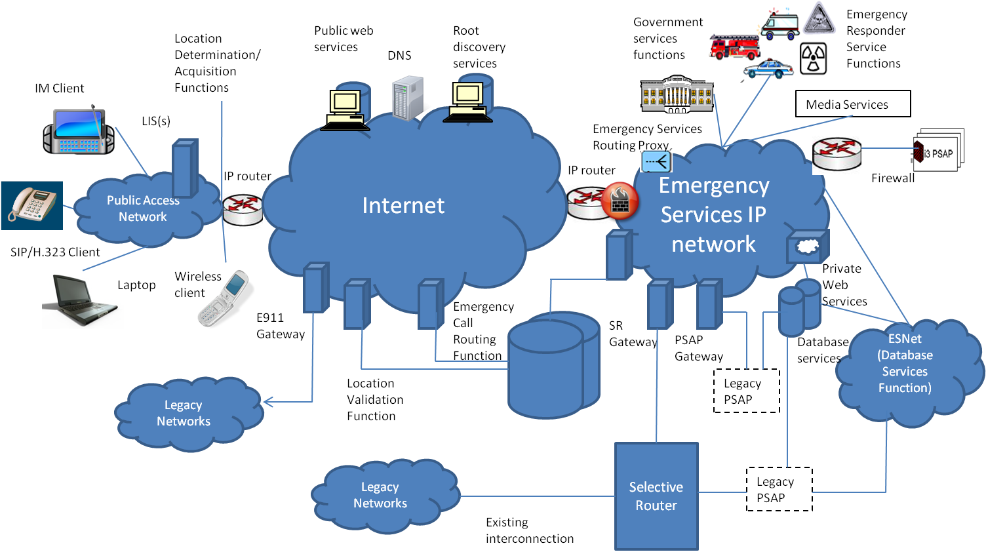
Figure 4. NENA i3 functional architecture for emergency services [67]
 | OST Recommendation on IEC | NENA i3 Technical Requirements Document | Notes
Public Access Network | - Location Determination/Acquisition Function (IP)  - LIS Server  - SIP/H.323 client, Laptop  - IP enabled sensor and monitoring devices  - Wireless Client (IP) | - Location Determination/Acquisition Function (IP)  - LIS Server  - SIP/H.323 client, IM client, Laptop  - Wireless Client (IP) | Proposed support for IP enabled sensor and monitoring devices in the OST recommendation.
IECRS IP Access Network | - Telecom Subscriber Data  - RTO, CCTNS and other public web services  - Gateway  - Location Validation  - Emergency Call Routing Function | - Public Web Services  - Root Discovery Service  - DNS, E 911 Gateway  - Location Validation  - Emergency Call Routing Function | Support to interconnect existing subscriber data, RTO and Police records in the OST recommendation
Emergency Service IP Network | - Emergency Services Routing Proxy  - Government Services Functions (Broadcasts, Notifications, MHA)  - Emergency Responder Service Functions  - Media Services (Conference, Logging, Recording, Backup etc)  - PSAP Gateway (Primary Command Center, Secondary Command Center, Regional PSAPs via MPLS)  - Legacy Network Gateway (LNG)  - Legacy PSAP Network Gateway (LPG)  - Security Certificate Server  - Private Web Services  - Emergency Call Routing Function | - Emergency Services Routing Proxy  - Government Services Function  - Emergency Responder Service Functions  - Media Services  - SR Gateway  - PSAP Gateway  - Private Web Services  - Emergency Call Routing Function | MPLS gateways to multiple PSAPs, security Certificate server in the OST recommendation within the ESI Net
Support for Legacy Networks | - PSTN and non-IP wireless phones  - MSC Switch for Wireless  - Central Office Switch for PSTN | - Legacy networks  - Selective Router | Support for MSC upgrades to support wireless circuit switched networks (GSM/CDMA)
PSAP | - GHR-IECS Primary Command Center  - GHR-IECS Secondary Command Center  - IECS Regional PSAPs, Legacy PSAP (EMRI 108) | - Legacy PSAP  - i3 PSAP | Support to interconnect hierarchical PSAPs and legacy PSAPs run by EMRI 108 service
Databases | - Location Validation/ Routing Databases  - 911 Database services  - ESNet Database service Function | - Location Validation/ Routing Databases  - IECS Database services  - ESNet Databse service Function
Table 3: Comparison of the OST proposed reference architecture for IECS with the i3 reference architecture from NENA
Since the functional architecture of the proposed IECRS system is based on the NENA i3 architecture for NG 911 services, in this section the NENA i3 architecture [136] is described in detail.
The i3 solution (Figure 4) encompasses the definition of:
- The architecture of the emergency calling system;
- External interfaces between PSAPs and public/private networks delivering 9-1-1 calls to the ESInet;
- External interfaces to systems and databases not in the PSAP that supply data and assistance in processing a call;
- External interfaces to systems that handle a call past the point where a call taker has exclusive control over it, such as the handoff to the Computer Aided Dispatch system;
- External interfaces to upper level management systems, such as disaster management systems, as well as peer PSAPs;
- Functions such as location-based routing, data creation and maintenance.

The scope of i3 architecture includes call routing and location validation functions which are used by the origination network. Origination networks can be built using a generic SIP architecture, or IMS-based SIP architecture. In the subsection 5.7.1, brief description of each of the functional elements depicted in Figure 4 of the NENA i3 architecture and terminology used in this context is provided.

5.7.1 Description of Functional Elements

- IP client – This term is used to refer to the IP endpoint communications equipment or application that is used to originate a voice or text request for emergency services (e.g., by calling 9-1-1). The term IP device or IP endpoint may also be used.

- Routing Proxy – A term used in SIP to describe a SIP server that receives SIP requests and forwards them on behalf of the requestor. A routing proxy determines that next hop for a SIP message and forwards the message.

- User Agent (UA) – Terminology used in the context of SIP to identify the IP device. In SIP, a UA is a network element that is capable of generating SIP requests (e.g., INVITE) and is capable of generating responses for received requests.

- Legacy PSAP – This term is used to PSAPs that are not capable of communicating with VoIP protocols or of supporting the i3-based interfaces specified as part of the i3 Solution.

- PSTN Gateway – This term is used to refer to a signaling and media interconnection point between callers in the PSTN and the i3 architecture, so that i3 PSAPs are able to receive emergency calls from the PSTN and are able to communicate with legacy PSAPs (that are not equipped with a Legacy PSAP Gateway).

- Time Division Multiplexing (TDM) Gateway – This term is used to refer to the signaling and media interconnection/interworking point between the conventional Selective Router and i3 PSAPs.

- Domain Name Server (DNS) –The DNS is used to resolve Domain Names. The input to a DNS is a domain name (e.g., gisfi.org); the response is the IP address of the domain. The DNS allows people to use easy to remember text-based addresses and the DNS translates those names into routable IP addresses.

- Web Services – Web Services identifies an industry standard protocol for exchanges of information. In the i3 architecture, this term is being used to refer public and private data services to which i3 PSAPs may desire to have access.

- Location Determination Functions – Location determination includes the functions to accurately and automatically (without input from the user) determine the position estimate of the IP endpoint device and associate that location information uniquely with that device.

- Location Acquisition Functions: Location acquisition refers to the functions necessary to make that location information available to the device on request, or in the case of devices that are not location-aware, to make that location information available to a Proxy acting on behalf of that device so that the location information can be used for emergency calling.

- Location Information Server (LIS) – The LIS stores the relationship between a unique identifier for a physical endpoint termination and a location, described as either geo-coordinates or a civic address). The administrator/owner of the LIS is responsible for creating and maintaining this relationship, and for ensuring that civic location data is pre-validated by a Validation Function. The LIS may be used during location determination and acquisition. The LIS may also support assignment of a location query key to a particular IP device, and download of this key to the IP device to support subsequent queries for the location from other elements in the IP domain.

- Validation Function (VF) – The VF is used to validate civic location objects against the next generation of the Master Street Address Guide (MSAG). Pre-validation of the civic location information ensures that the calls can be routed to the appropriate PSAP and that emergency services can be dispatched to the correct location.

- Emergency Call Routing Function (ECRF) – The ECRF receives location information (either civic address or geo-coordinates) as input and uses this information to provide a Uniform Resource Identifier (URI) that can be used to route an emergency call toward the appropriate PSAP for the caller’s location. Depending on the identity and credentials of the entity requesting the routing information, the response may identify the PSAP, or an Emergency Services Routing Proxy that acts on behalf of the PSAP to provide final routing to the PSAP itself. The same database that is used to route a call to the correct PSAP may also be used to subsequently route the call to the correct responder, e.g., to support selective transfer capabilities.

- Root Discovery Function – The i3 databases are distributed. The Root Discovery Function is used by entities to discover the appropriate Location Validation Function or Emergency Call Routing Function for a given location.

- Emergency Services Routing Proxy (ESRP) – This ESRP is a routing proxy that may act on behalf of a group of PSAPs, to provide final routing to the PSAP, based on the caller’s location.

- Emergency Services IP Network – This term is used to refer to a private IP network or IP Virtual Private Network (VPN) that is used for communications between PSAPs and among other entities that support or are supported by PSAPs in providing emergency call handling and response.

- Public Safety Answering Point (PSAP) – The i3 PSAP is a PSAP that is capable of receiving IP-based signaling for delivery of emergency calls and for originating calls. The internal functions are not being specified in the i3 requirements, but the i3 PSAP is expected to be able to use SIP signaling for calls and IP-based data protocols for exchange of other information.

- Legacy PSAP Gateway – This term is used to refer to the protocol and media interworking functions necessary to allow a Legacy PSAP to interface with i3 PSAPs and other entities on the Emergency Services IP network.

- Responder Services Functions – This term is used to refer to the agencies that provide emergency response in conforming i3 implementations, e.g., Police, Fire, Emergency Medical Service, Poison Control, HazMat (hazardous materials response teams), Coast Guard, etc.

- Database/Media Service Functions – This term is used to refer to the Databases and Database Access Services that provide information requested by PSAPs and other entities on the Emergency Services IP network in support of emergency services handling. Media Service functions might include such things as conference bridge resources, or logging recording services.

- Government Services Functions – This term is used to refer to government services that might be involved in emergency call handling or escalation. Examples might include: escalation of emergency incidents that require coordination among multiple government agencies, beyond PSAPs; broadcasts; notification services; Homeland Security.

- An Emergency Services IP Network (ESInet) is a unique instance of a communications network dedicated for public safety use. An ESInet delivers emergency requests and corresponding data to emergency services providers and facilitates communication between emergency service providers and other supporting entities. An ESInet is typically deployed to support a set of PSAPs and other public safety agencies on a geographic basis. A given PSAP, or other appropriate entity, may connect to one or more ESInets. ESInets may be interconnected to facilitate emergency event handling and other related interactions.

- Back to Back User Agent (B2BUA) – This is a logical entity that receives a request and processes it as a user agent server (UAS). In order to determine how the request should be answered, it acts as a user agent client (UAC) and generates requests. Unlike a proxy server it maintains dialog state and must participate in all requests sent on the dialogs it established.

- Border Control Function (BCF) – The BCF provides a secure entry into the ESInet for emergency calls presented to the network. The BCF incorporates firewall, admission control, and may include anchoring of session and media as well as other security mechanisms to prevent deliberate or malicious attacks on PSAPs or other entities connected to the ESInet.

- Policy-based Routing Function (PRF) – This functional element applies techniques to determine alternate routing addresses based on policy information associated with the destination PSAP. The PRF uses its state knowledge, such as PSAP registration state or time of day and the policy for a PSAP to make a route determination. The PRF resides in the terminating ESInet.

- Originating ESInet – The originating ESInet is the first emergency services network in the call flow. Originating networks (those initiating 9-1-1 calls) deliver their emergency calls to this network. An originating ESInet will make routing decisions and forward the emergency call to another ESInet for routing to the PSAP.

- Intermediate ESInet – The intermediate ESInet is a network that may exist between the originating and terminating ESInets. An Intermediate ESInet receives a call from an originating ESInet (or another intermediate ESInet) and forwards the call to another intermediate ESInet or the terminating ESInet.

- Terminating ESInet – A terminating ESInet does the final routing to the PSAP. If there is only one ESInet in the call flow then the terminating ESInet has the role of originating ESInet as well.

5.7.1.1 Terminology used in the context of NG 911

Agency: An organization that is a client of a database or service.

Agent: A person employed by or contracted by an agency.

Call: A single communication to a PSAP that results in a defined action by a call taker. A call does not have to be a literal phone call. It could be an Instant Message, a SMS text message, an Automatic Crash Alert, etc. The life cycle of a call includes: call origination, call abandonment or completion, call duration, call clearing, and post-call processing of indefinite duration.

Incident: A defined public safety event that incurs a response within the domain of a PSAP. Examples include a traffic accident (including subsequent secondary crashes), a hazardous material spill, etc. Multiple Calls may be associated with an Incident. An Incident may include other Incidents in a hierarchical fashion. The life cycle of an Incident includes: Incident declaration, Incident processing, Incident clearing and post-incident processing of indefinite duration.

Call Identifier: An identifier assigned by the first element in the first ESInet which handles a call. The form of a Call Identifier is a Globally Unique Identifier (GUID). Call Identifiers are globally unique.

Incident Identifier: An identifier assigned by the first PSAP which declares an incident. The form of an Incident Identifier is a URI GUID. Incident Identifiers are globally unique.

5.7.2 Call Architecture
A Location Acquisition Function is used in the access network to obtain the location of a caller, which is retrieved on demand from a LIS. Locations in civic address form are validated prior to being stored in the LIS by the Location Validation Function. A 9-1-1 call includes location information with the call. A carrier, enterprise or other call presenter uses the location (included with the call) with the ECRF to determine a URI to route to. Calls are presented by the origination network to the ESInet, possibly through a BCF, either directly to a PSAP or to an ESRP.
Within the ESInet, the ESRP, if used, will (logically) use the same ECRF to further onward route the call. If the ESInet is hierarchical in nature, an ESRP instance may be used at each level of the hierarchy. The call would then traverse multiple ESRPs from the access network to the PSAP. The final proxy is a PSAP proxy, which forwards the call to one of its User Agents. The PSAP may use ECRF to determine the proper responders.

5.7.3 Relationship of NENA i3 to IETF Standards
The NENA i3 system boundary is at the ESInet. Callers will be presented to this network by carriers, enterprises or other entities following many of the Internet Engineering Task Force (IETF) protocol standards. The overall description of the IETF approach to emergency calls is detailed in Framework for Emergency Calling in Internet Multimedia [70]. The specific recommendations for telephones and proxy servers (carrier softswitches) are detailed in Best Current Practice for Communications Services in support of Emergency Calling [125].
The IETF standards based solution delivers location information to the endpoint (the “phone”) or have available a reference to the location. The endpoint is, directly or indirectly, a subscriber to the access infrastructure provider (AIP) and it is, directly or indirectly, a subscriber to the communication service provider (CSP). The AIP tells the endpoint where it is, the endpoint tells the CSP where it is. The CSP can then route the call based on the location. The subsection 5.7.4 outlines the applicable IETF standards for transfer of location information and its usage thereafter by the i3 network architecture.

5.7.4 Location Information
NENA Technical Requirements Document for Location Information to Support IP-Based Emergency Services [128] outlines NENA’s generic technical requirements that should be accounted for by standard bodies involved in IP Location. Also, NENA Recommended Method(s) for Location Determination to Support IP-Based Emergency Services - Technical Information Document [129] specifically addresses the residential broadband access network topologies in relation to IP Location.
IETF standards define the following mechanisms:
- Representation of Location-by-Value;
- Representation of Location-by-Reference;
- Acquisition of Location Information by the endpoint from a Server (this is called a “Location Configuration Protocol” (LCP);
- Communication of Location Information to downstream elements;
- Exchange of Location-by-Reference with Location-by-Value by a LIS.

The i3 location architecture is based on the following IETF standards:
- Geopriv requirements [71]
- A Presence-based GEOPRIV Location Object Format [72], with an update to the document [130]
- Dynamic Host Configuration Protocol Option for Coordinate-based Location Configuration Information [73]
- Dynamic Host Configuration Protocol (DHCPv4 and DHCPv6) Option for Civic Addresses Configuration Information [74] and an update [131]
- HTTP Enabled Location Delivery (HELD) [75]
- Session Initiation Protocol Location Conveyance [76]

5.7.4.1 Location-by-Value (LbyV)
Location-by-Value is defined as location information readily consumable by the recipient of the location without transformation. It is formatted in a Presence Information Data Format Location Object (PIDF-LO) document as per RFC-4119 and following the recommendations of the PIDF-LO profile Internet draft [130]. The location can be expressed in a civic form as per the Revised Civic LO Internet Draft [131] or in a geodetic form as per RFC4119 as modified by [130].

5.7.4.2 Location-by-Reference (LbyR)
Location-by-Reference is defined as a URI that, when de-referenced in the correct manner by an authenticated and authorized entity, will yield the location value of the endpoint. The construction of the user part of the Location-by-Reference URI should follow strict privacy and confidentiality rules so the identity and/or the location of the target cannot be derived from the identifier by an unauthorized party. The IETF Internet Draft describing LbyR requirements [132] provides guidance as to how to construct a valid location URI for Location-by-Reference.
A successful de-reference of the identifier will result in providing a Location-by-Value to the requester. De-reference mechanisms are currently being defined within the IETF, one using SIP [97] and one using HELD [133].
The i3 call signalling architecture is based on the following IETF standards, a summary of which can be found in [77]:
- SIP: Session Initiation Protocol [78]
- RTP: A Transport Protocol for Real-Time Applications [79]
- SDP: Session Description Protocol [80]
- SIP: Locating SIP Servers [81]
- An Offer/Answer Model with the Session Description Protocol (SDP) [82]
- SIP-Specific Event Notification [83]
- The Session Initiation Protocol UPDATE Method [84]
- A Privacy Mechanism for the Session Initiation Protocol (SIP) [85]
- Private Extensions to the Session Initiation Protocol (SIP) for Asserted Identity within Trusted Networks [86]
- Session Initiation Protocol Extension for Instant Messaging [87]
- The Reason Header Field for the Session Initiation Protocol (SIP) [88]
- The Session Initiation Protocol (SIP) Refer Method [89]
- Grouping of Media Lines in the Session Description Protocol (SDP) (RFC3388) [90]
- An Extension to the Session Initiation Protocol (SIP) for Symmetric Response Routing [91]
- Real Time Control Protocol (RTCP) attribute in Session Description Protocol (SDP) [92]
- Control of Service Context using SIP Request-URI [93]
- Connected Identity in the Session Initiation Protocol (SIP) [94]
- Indicating User Agent Capabilities in the Session Initiation Protocol (SIP) [95]
- Caller Preferences for the Session Initiation Protocol (SIP) [96]
- Early Media and Ringing Tone Generation in the Session Initiation Protocol (SIP), G. Camarillo, H. Schulzrinne, Internet Engineering Task Force [97]
- A Watcher Information Event Template-Package for the Session Initiation Protocol (SIP) [98]
- The Session Initiation Protocol (SIP) "Replaces" Header [98]
- The Session Initiation Protocol (SIP) Referred-By Mechanism [99]
- The SIP Referred-By Mechanism [100]
- Best Current Practices for Third Party Call Control in the Session Initiation Protocol [101]
- Using E.164 numbers with the Session Initiation Protocol (SIP) [102]
- Early Media and Ringing Tone Generation in the Session Initiation Protocol (SIP) [103]
- Presence Information Data Format (PIDF) [104]
- Session Timers in the Session Initiation Protocol (SIP) [105]
- Internet Media Type message/sipfrag [106]
- The Session Initiation Protocol (SIP) "Join" Header [107]
- Transcoding Services Invocation in the Session Initiation Protocol (SIP) Using Third Party Call Control (3pcc) [108]
- Basic Network Media Services with SIP [109]
- An Extension to the Session Initiation Protocol (SIP) for Request History Information (RFC4244) [110]
- Actions Addressing Identified Issues with the Session Initiation Protocol's (SIP) Non-INVITE Transaction ( [111]
- Actions Addressing Identified Issues with the Session Initiation Protocol's (SIP) Non-INVITE Transaction [112]
- Extending the Session Initiation Protocol (SIP) Reason Header for Preemption Events [113]
- Communications Resource Priority for the Session Initiation Protocol (SIP) ( [114]
- Suppression of Session Initiation Protocol (SIP) REFER Method Implicit Subscription [115]
- Conveying Feature Tags with the Session Initiation Protocol (SIP) REFER Method [116]
- Addressing an Amplification Vulnerability in Session Initiation Protocol (SIP) Forking Proxies [117]
- Session Initiation Protocol Call Control - Conferencing for User Agents [118]
- Obtaining and Using Globally Routable User Agent (UA) URIs (GRUU) in the Session Initiation Protocol (SIP) [119]
- Managing Client Initiated Connections in the Session Initiation Protocol (SIP) [120]
- SDP: Session Description Protocol [121]
- Session Initiation Protocol Package for Voice Quality Reporting Event [122]
- Interactive Connectivity Establishment (ICE): A Methodology for Network Address Translator (NAT) Traversal for Offer/Answer Protocols [123]
- A Uniform Resource Name (URN) for Services [124]

5.7.5 Routing of IP-based Emergency Calls in a generic IETF SIP originating network
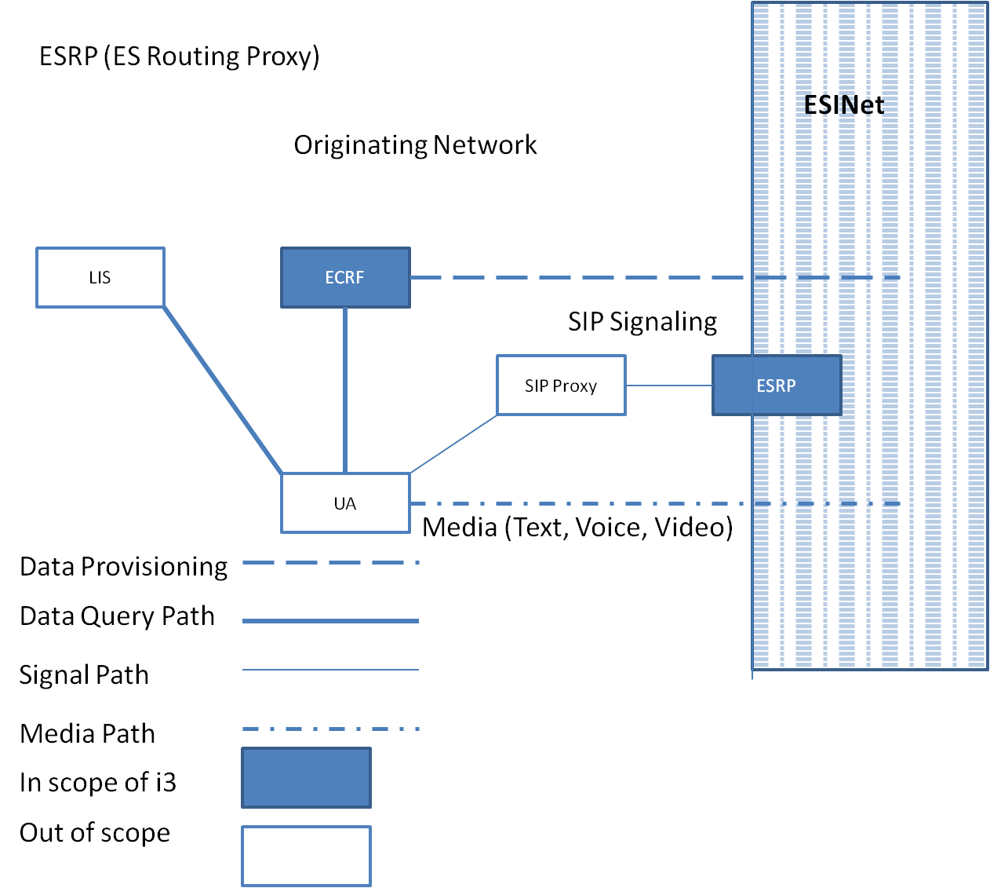
Figure 5. Generic SIP Edge-based Call Routing Architecture – Origination Network Example
Emergency Context Resolution with Internet Technologies – ECRIT defines a database query (“mapping”) where location information and a Service URN is sent in the query and a URL of where to deliver the call is returned. In i3, this is called an Emergency Call Routing Function (ECRF). The call would then be routed using normal SIP (or other protocols supported) to the indicated destination. The protocol defined by the IETF that provides the mapping is called Location to Service Translation (LoST) [127].
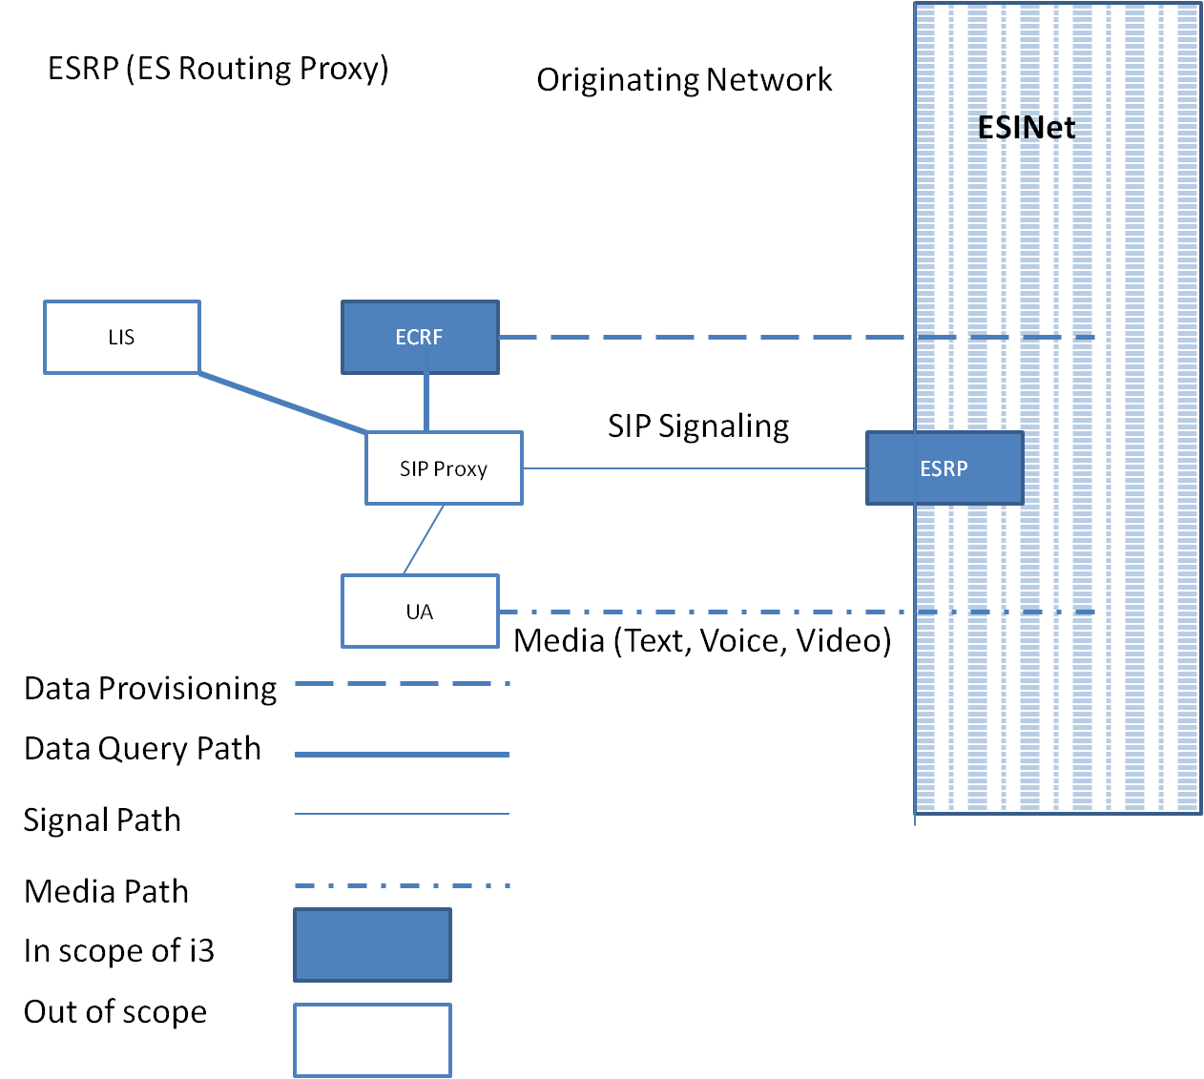
Figure 6. Generic SIP Proxy based call routing architecture – Originating Network Example

Calls will be routed to an ESRP due to the route taken as a result of ECRF mapping. This element, which might be operated on behalf of, for example, a state agency, would take all calls for that state, and make another routing decision to send them to the appropriate PSAP. The reason for deploying an ESRP is to position robust firewalls and other protective devices (such as the BCF), with large amounts of IP bandwidth between the sources of calls and the PSAP. This provides an outer defensive perimeter for malicious calls or Denial of Service attacks against the PSAP. i3 envisions that the same ECRF, using LoST as the interface protocol will be able to be queried by the ESRP to determine how to onward route to the PSAP.
Similarly, the ECRF mechanism may be used by the PSAP to determine how to route a call to the correct responder. The ECRF will allow civic and geo boundaries for PSAPs (and ESRPs) as well as any number of responders to be stored. This allows any PSAP to route a call to any responder based on the location of the caller. This mechanism directly encodes service boundaries.

5.7.6 Generic SIP as an Emergency Services IP Network
The ESRP is a normal SIP proxy server with additional functionality. The ECRF and LVF use the LoST protocol. The call taker in a PSAP has a UA that terminates calls (User Agent Server according to RFC3261).

5.7.6.1 Simple ESInet
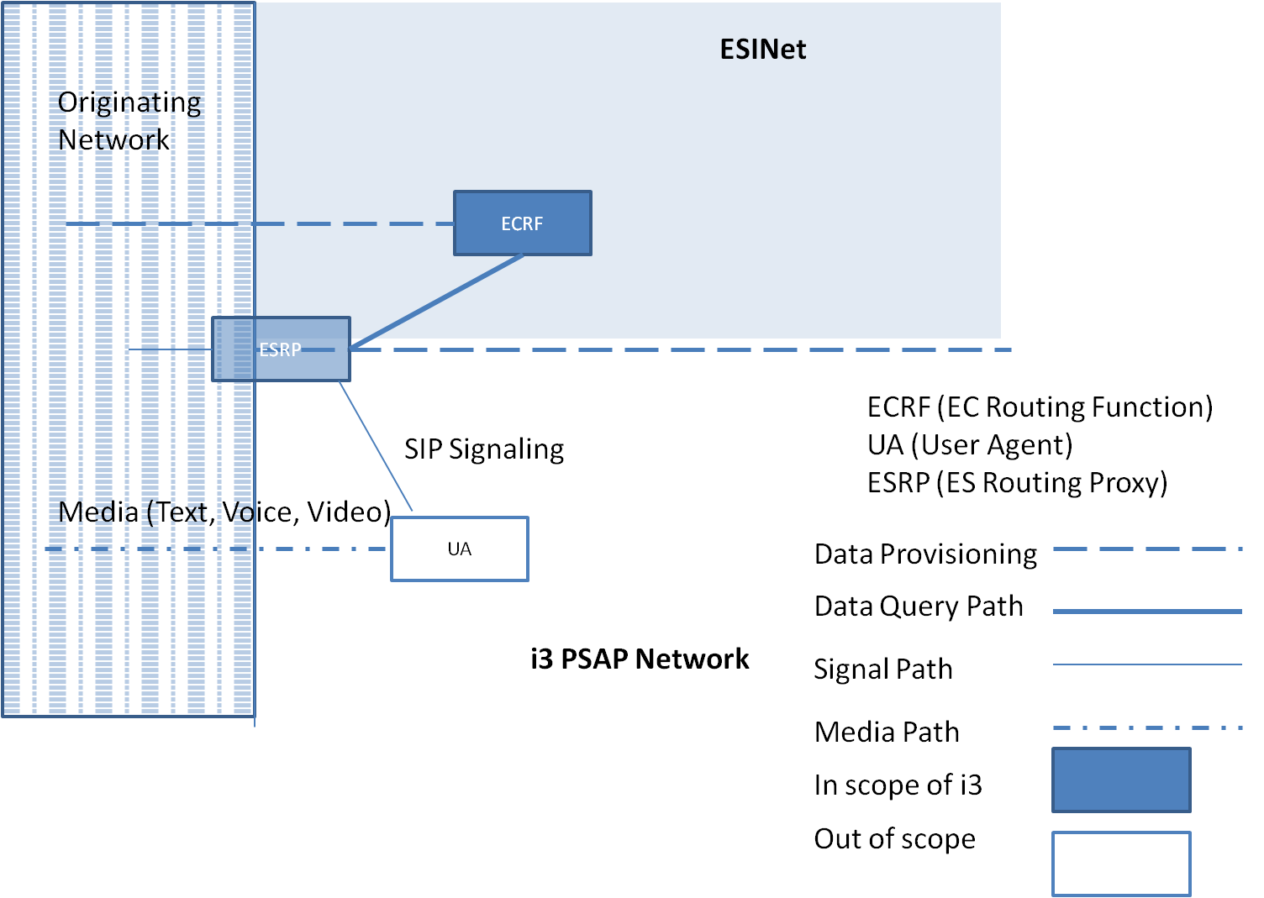
Figure 7. Generic SIP ESINet Architecture – Single ESRP Example shown

In this simple architecture (Figure. 7), a single ESRP and ECRF component are involved to process the call to the appropriate User Agent. The call may go through a series of transactions between the ESRP, ECRF and UA in order to reach the final destination UA within the ESInet.

5.7.6.2 Multiple ESRPs in ESInet Architecture
Typically, the PSAP would have an ESRP of its own at the entrance to its Local Area Network (LAN). The ESRP at the ESInet edge would route to the PSAP ESRP which would route to the call taker (Figure. 8). The ESRP at the edge of the ESInet might be operated at the state level. In some areas, the local operator of the ESInet may be at a county or region level, and it may choose to run an ESRP. The state ESRP routes to the county/regional intermediate ESRP, which routes to the PSAP ESRP. Each of the ESRPs has access to the ECRF, and has a PRF that together guide the selection of the next hop. In this case, each ESRP will invoke the ECRF for determining the next hop until it resolves to the destination UA.
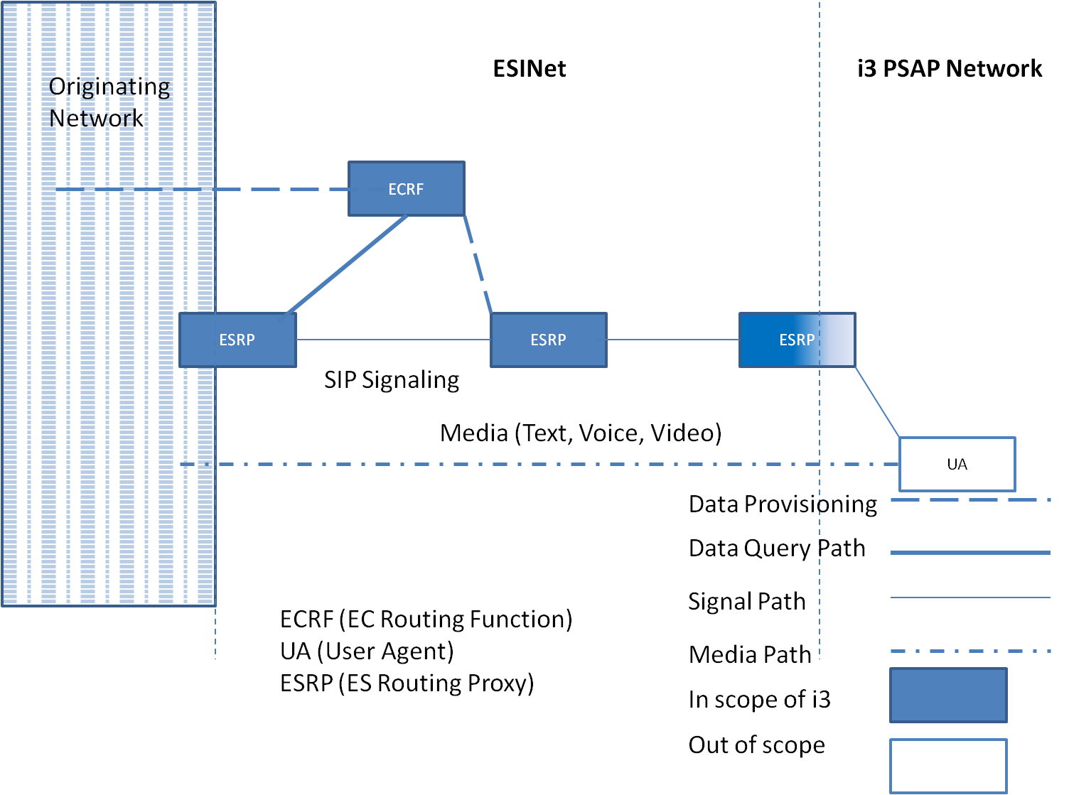
Figure 8. Generic SIP ESINet Architecture-Multiple ESRPs example

5.7.6.3 Internal ESRP functions
A representative view of general functions that an ESRP must include is shown in the following Figure 9.
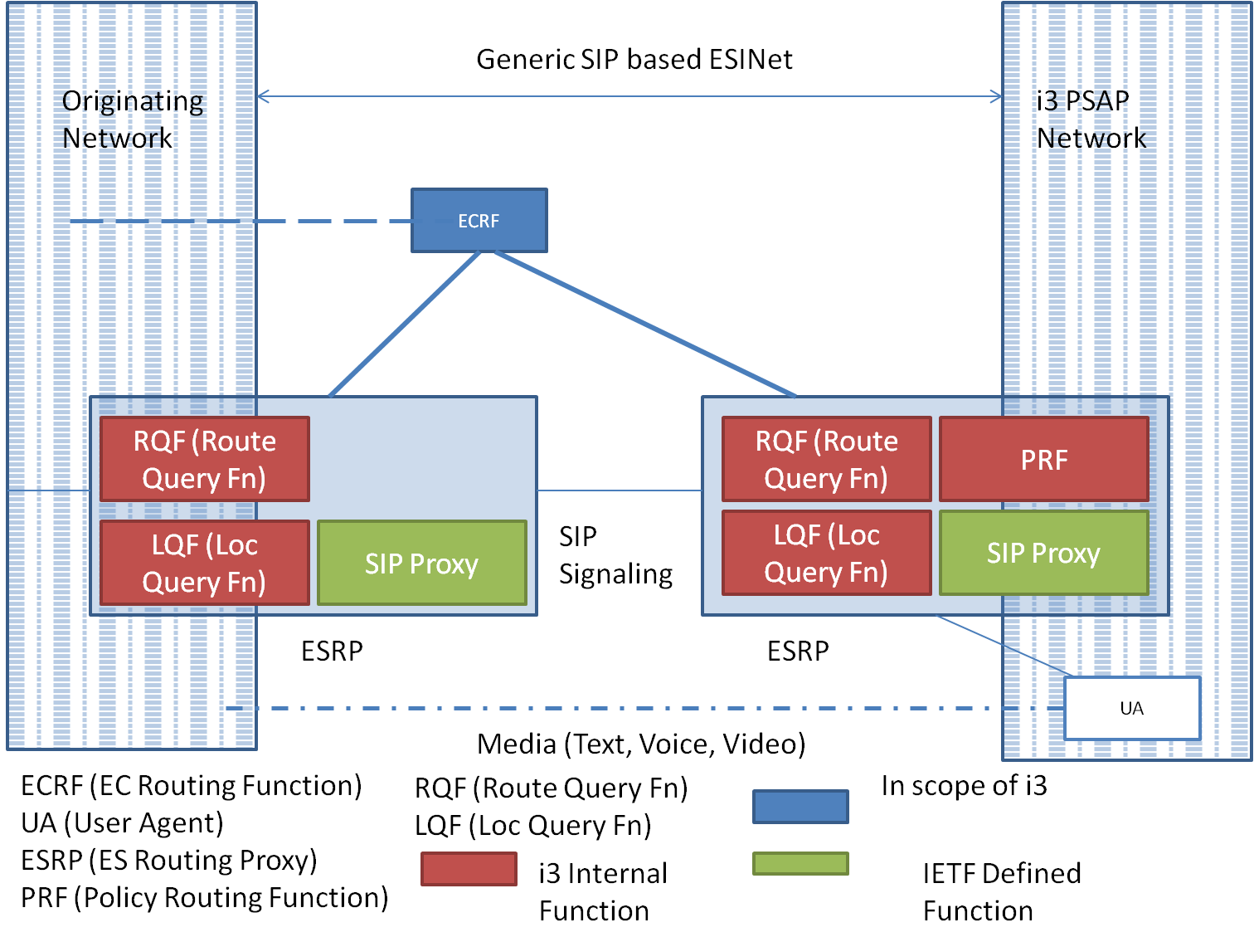
Figure 9. Generic SIP ESInet architecture- Detailed ESRP Functional View

Emergency Service Routing Proxy – By definition, an ESRP is fundamentally a SIP Proxy, but with some added features required for the receipt, querying, and egress handling of an emergency call. The SIP Proxy part of the ESRP function is expected to behave as per RFC 3261 [78].
Location Query Function (LQF) – Uses a dereferencing protocol (SIP or HTTP) to exchange a location reference (LbyR) for location information (LbyV).
Routing Query Function (RQF) – Uses the LoST protocol to find a tentative list of next hops given the location information.
Policy Routing Function (PRF) – Uses the policy of the destination PSAP, PSAP state, congestion state, time of day, etc to determine choose one of the next hops that will receive the call.

5.7.7 End to End generic SIP emergency call architecture
The following Figure 10 shows an end-to-end functional architecture based on a generic SIP solution.
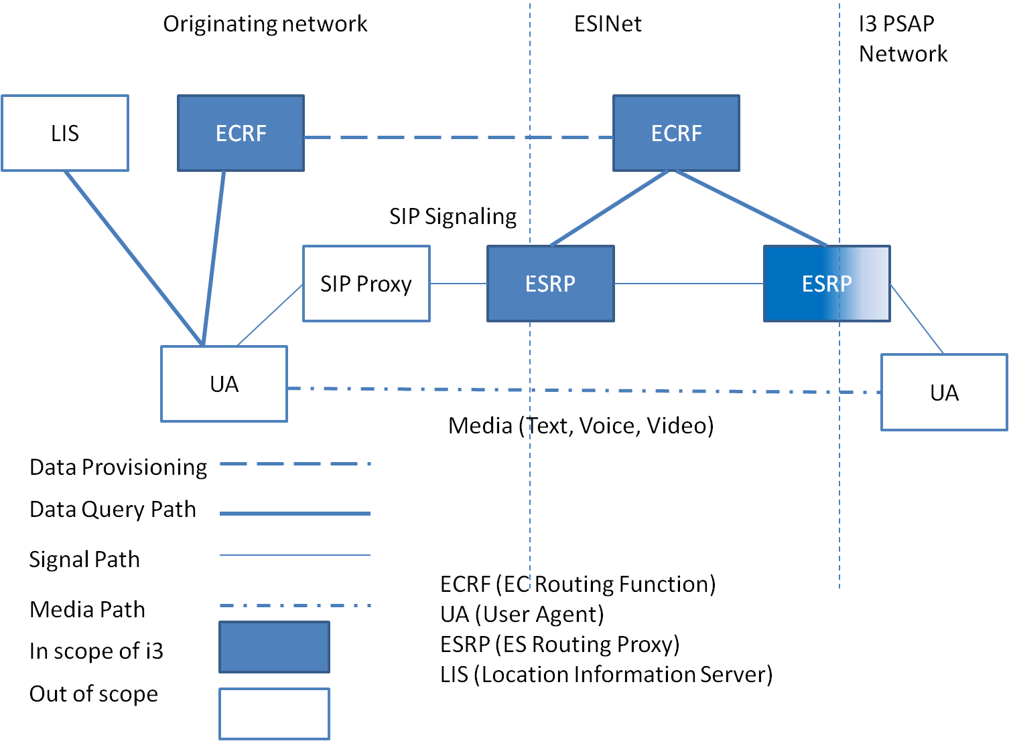
Figure 10. Generic SIP ESInet Architecture- End to End Example

A user agent will use a Location Acquisition Protocol to access a LIS for location information. The user agent queries the ECRF using LoST to obtain a PSAP/ESRP URI, the local dial string for that location (e.g. 9-1-1) and a confirmation that the location provided by the LIS is valid.
A high level call flow within this functional architecture is as follows:
1. The calling UA requests its location information from the LIS;
2. The calling UA requests routing and dial string/service URNs information based on the provided location from the designated ECRF within the Origination Network;
3. The calling UA recognizes the dial string in the dialed digits as an emergency call;
4. The calling UA requests current location from the LIS, and re-queries the ECRF using the updated location to get new routing information.
5. The calling UA attaches location and service URN to the signaling message and forwards the call to the designated SIP Proxy;
6. The Origination Network SIP Proxy forwards the call to the designated ESRP;
7. The near-end ESRP uses the provided location and service URN to request further refined routing and services information within the ESInet through the ESInet’s ECRF ;
8. The near-end ESRP forwards the call to the far-end ESRP as per ECRF directives;
9. Far-end ESRP requests final routing and services information from the ECRF and forwards the call to the terminating UA (an i3 PSAP, Responder, Government or any other supported service);
10. Media is established between originating and terminating UAs. The call is processed.

5.7.8 Legacy Gateway Architectures -- Examples in i3
Though i3 is commonly defined as IP end-to-end, it is understood that there will continue to be a percentage of wireline and wireless (circuit switched) originating networks deployed after emergency service networks and PSAPs have evolved to support the i3 Solution. Since any i3 PSAP will need to be able to receive emergency calls which originate on these legacy networks, there is an acknowledgement that gateways will be required.

5.7.8.1 Legacy Wireline Origination Network
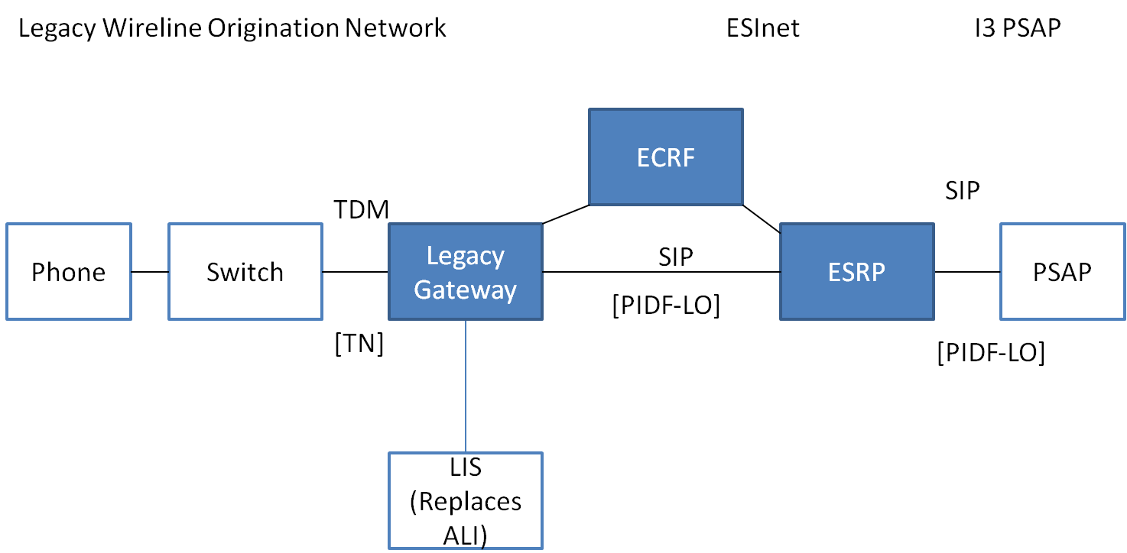
Figure 11. Example legacy wireless origination network to ESInet (LbyV)

In this case, all calls (including legacy wireline originated calls) are routed (using the LoST mechanism), and arrive as IP with location and caller information (e.g., callback number) in the signaling (Figure. 11). This means there is a legacy gateway with a PSTN interface towards the origination network, and an IP interface towards the ESInet. Logically, the legacy gateway resides between the origination network and the ESInet. The PSTN side has trunk interfaces equivalent to a selective router, commonly SS7, but allowing Centralized Automatic Message Accounting (CAMA)/ Integrated Services Digital Network (ISDN). Unlike an IP origination, the legacy wireline signalling will not have location information attached in PIDF-LO form. The legacy gateway must obtain the location information based on the calling number/ANI it receives with the call. To support legacy wireline origination, a LIS will logically replace the ALI database. The LIS will store location information keyed by TN and provide a PIDF-LO to the gateway. The relationship between the gateway and LIS is static and provisioning will be used to introduce the LIS to the gateway.
The legacy gateway takes the location it obtains from the LIS, submits it to the ECRF via LoST and obtains an ESRP URI to route the call onward. Again, the relationship between the legacy gateway and the ECRF is provisioned. The legacy gateway inserts the PIDF-LO into the SIP signalling, along with the ESRP URI and routes the call as it would for any IP origination. The signalling will also include caller information in the From: and/or P-Asserted-Identity headers. While location by value is preferred, the LIS may return a location reference, which would be used in an analogous way as a location reference would be used in IP origination networks. The gateway would dereference to obtain a location value, use that value to query the ECRF, and pass the reference in the SIP signalling towards the ESRP.

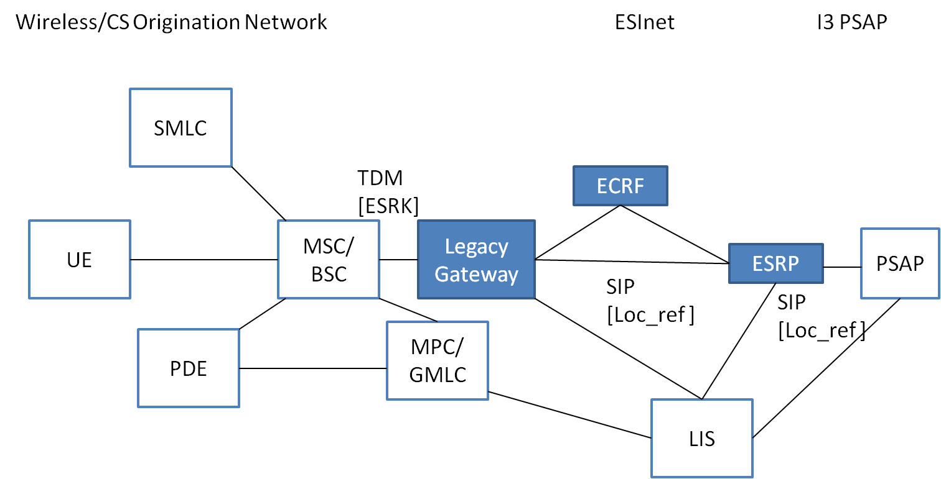
Figure 12. Example Wireless/CS Origination Network to ESINet (LbyR)

In case of legacy wireless/CS call origination, the legacy gateway takes the location it obtains from the LIS, submits it to the ECRF via LoST and obtains an ESRP URI to route the call onward (Figure. 12). Again, the relationship between the legacy gateway and the ECRF is provisioned. The LIS is responsible for determining if the wireless/CS network is Phase II capable. If it is, the location returned by the LIS may be just a reference, which the gateway must dereference to obtain a value it can use to query the ECRF; it may include the value as well as the reference. The dereferencing function is expected to involve interaction with elements in the legacy wireless network (e.g., MPC/GMLC) where Phase II location information is maintained. The reference will be added to the SIP signalling. The gateway routes the call as it would with any IP origination. The signalling would include call-back number in the From: and/or P-Asserted-Identity headers. ESRPs that are traversed by the call must repeat the dereferencing process, using the resulting location value to query the ECRF. They will then route the call forward. The PSAP must also perform dereferencing and final routing, potentially involving an interaction with the ECRF. If the LIS determines that the origination network is Phase I capable only, then it will return a location value, which will be used to query the ECRF and placed in the SIP signalling. This location value (formatted as civic location information in a PIDF-LO) will be included in outgoing SIP signalling, and will be used by ESRPs in the call path to interact with the ECRF to determine subsequent routing for the call. The location value will also be delivered to the PSAP with the call, along with call-back number.

5.7.9 Description of Call Flow

5.7.9.1 Basic 9-1-1 call
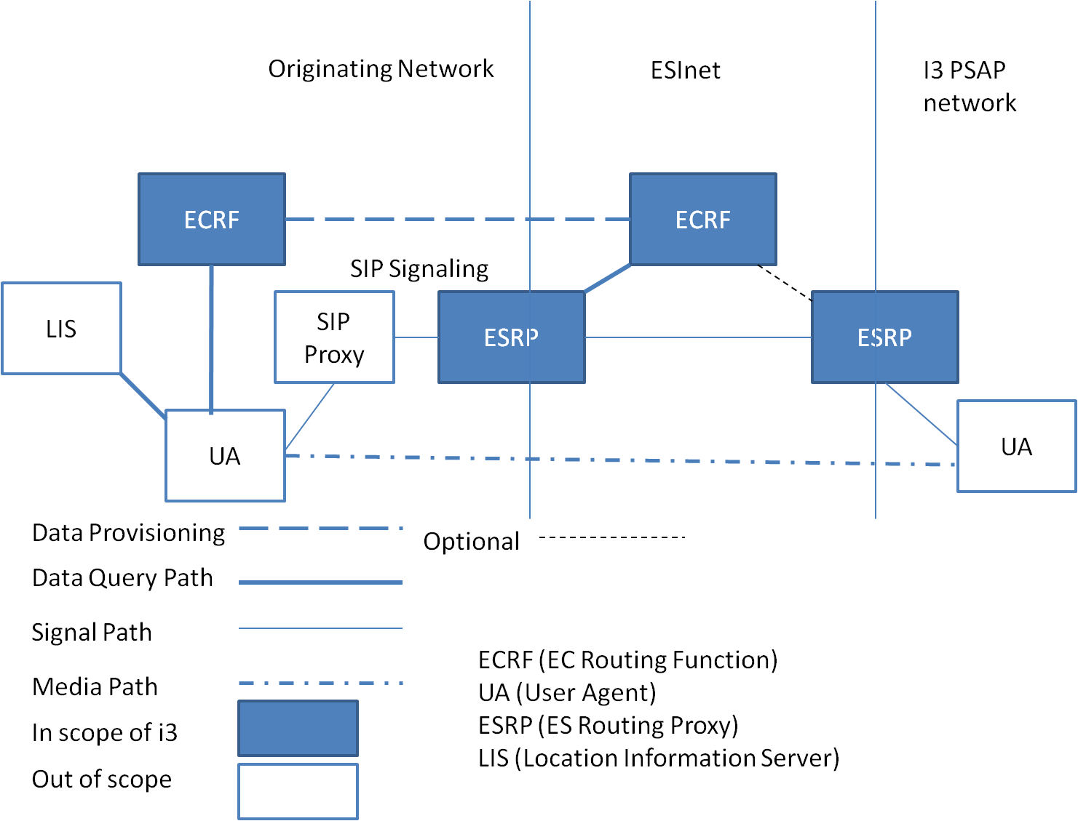
Figure 13. Generic SIP call architecture
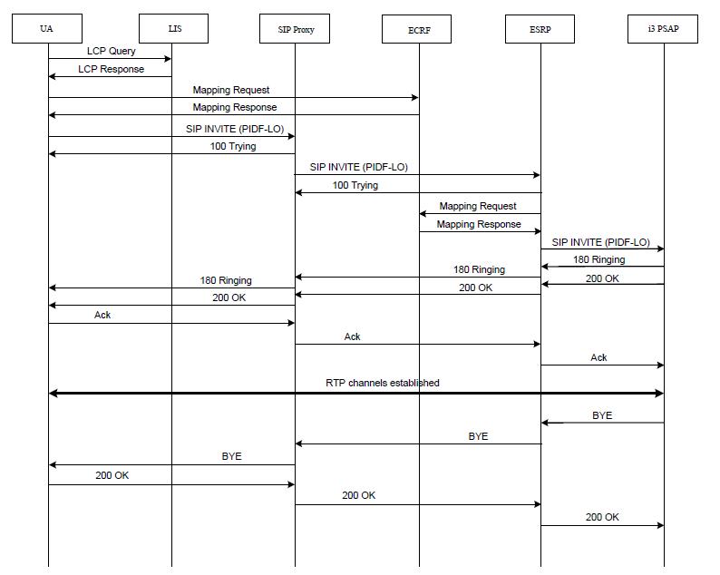
Figure 14. Generic SIP emergency call flow between UA and PSAP

The procedures for initiating a 9-1-1 call at a user agent and processing the call at the carrier, enterprise or other entity is defined in [125]. Following these procedures will result in an ECRF authoritative for the location of the caller providing a URI which ultimately routes to the proper PSAP. The i3 solution provides for one or more intermediary proxies (ESRPs) between the call origination emergency call routing element and the final ESRP. These proxies use the location of the caller, and (logically) the same ECRF to further route the call. This is accomplished by provisioning the ECRF to provide routing information to requestors based on the identity used for authentication of the requestor to the ECRF. A carrier, enterprise or unknown query for most services would receive a URI which routes to the (top level or entry) ESRP corresponding to the location presented. The ESRP, which would make the SAME query (same location, same service) would receive a more precise route, which may be repeated if there is more than one level of ESRP and the final ESRP would receive the URI of the PSAP. In this manner, the ECRF returns different results for the same query depending on the identity of the element making the request. Calls are presented to the first ESRP through a Border Control Function (BCF). The BCF provides front-line defense against deliberate attack on the Emergency Services IP Network. The PSAP would have a BCF between it and the ESInet; although the network is managed, it should not be assumed secure.
The PSAP receives the call, with the location information attached, from an ESRP. The PSAP proxy server may route the call to an available call taker. It may be necessary for the PSAP to transfer the call to a secondary PSAP (or PSAPs) for dispatch of responders based on the location of the caller. The PSAP may use (logically) the same ECRF, but possibly a different service request, and, because it is authenticated to the ECRF as a PSAP, it will receive the URI of the secondary PSAP appropriate for the service requested. In this context “service” is the service request in the LoST protocol. The ECRF provides routing from the carrier to the ESRP, from one level of ESRP to another, from the lowest level ESRP to the PSAP and from the PSAP to the dispatcher(s). The LoST protocol uses location + service as input, and provides URI(s) output, and the i3 architecture makes use of this function for all routing.

5.8 Gap analysis based on survey of the NENA standards
The current reference architecture (Figure 3) is based on NENA i3 architecture (Figure 4). It is found that this architecture may not be suitable for adaptation to Indian network conditions in the present form. Some of the reasons are as follows:
a. IECRS IP access network architecture needs to be defined. Since there is no currently deployed emergency / disaster relief and recovery network in India, the architecture and performance features of this national backbone network needs to be defined.
b. Location Information Server (LIS) – The LIS stores the relationship between a unique identifier for a physical endpoint termination and a location, described as either geo-coordinates or a civic address. The NENA standards recommend IETF protocols to query this element to obtain location details, which is assumed to be obtained from the applicable access network. The challenge in India is that most of the deployed cellular networks are based on circuit switched technologies like GSM and CDMA. In such networks, the Gateway Mobile Location Center (GMLC) would be the node that can obtain location information of any UE. Therefore, for the current reference architecture to be adapted, either an appropriate protocol to map the requested information between IETF and cellular network positioning protocol would be necessary. Otherwise the location determining function within the emergency network needs to be redesigned. Secondly support for self positioning technologies on the user equipment such as GPS is not mandatory in India currently and hence the UE will not be in a position to communicate its location along with the emergency request call.
c. An ESInet delivers emergency requests and corresponding data to emergency services providers and facilitates communication between emergency service providers and other supporting entities. An ESInet is typically deployed to support a set of PSAPs and other public safety agencies on a geographic basis. A given PSAP, or other appropriate entity, may connect to one or more ESInets. Since emergency responders are a state subject in India, every state might need a different ESInet. A hierarchical ESInet architecture may be needed to support all the requirements of stakeholders.

6 Indian Requirements for Emergency Telecom Services

6.1 Broadcast Emergency Services
Currently the NDMA authority in India specifies the following means to disseminate warning information to general public on the occurrence or anticipation of imminent disaster [25]:

“Warning is disseminated through the following means:
(i) Police Wireless
(ii) Warnings through All India Radio (AIR) Bulletins
(iii) Doordrashan News
(iv) Press Bulletins
(v) Aviation Warning”

“Dissemination of warning to common people may range from alarms (fires), sirens (industrial disaster), to public announcement system like radio, television, loud speakers, hoisting of flags (cyclones, floods, and landslides).
While warning is issued warning messages shall be user friendly: The warning protocols shall be designed in simple and local languages easily understandable to a common man”

Thus it can be seen that, though there is a definite requirement for providing timely alerts and warnings to public in face of disasters, the current system in place does not make use of mobile telephony through means such as Cell Broadcast Message, SMSs, automated call with message playback or automated caller tunes etc. Further fixed telephone lines can also be used to disseminate messages through the fixed line dial tone. Due to the wide reach and penetration of telephony systems, the messages may be delivered to public to supplement the other means of public broadcasts. Various aspects such as message formats, authentication, support for Indian languages are open issues in this regard. This is also a potential area of standardization in the Indian context.

6.1.1 Early Warning System based on Cell Broadcast System with support for Indian languages
Cellular communication systems, such as those defined by 3GPP GSM/GRPS, UMTS, LTE and 3GPP2 CDMA family of standards make it possible to provide early warning notifications to public in disaster affected zones. More specifically, standard compatible mechanisms such as Cell Broadcast System (CBS) have provided secure and low latency data-path to deliver the alert messages to public.

However, the character set supported by these systems are limited and do not support the multitude of languages prevalent in written form across the globe. In country like India, there is a specific requirement of providing support to a large number of language scripts which are not supported by the current CBS systems. According to the Census of India of 2001, 30 languages are spoken by more than a million native speakers, 122 by more than 10,000. The Eighth Schedule to the Indian Constitution contains a list of 22 scheduled languages. This clearly indicates the insufficiency of data coding mechanism currently used in CBS standards for cellular systems for the Indian situation.

Moreover, due to the nature and purpose of an Early Warning System (EWS), the latency requirements for the transmission of the primary notification to the users in a certain area are as strict as few seconds. The EWS system must be able to reach the affected public within this time limit. Further, in a given geographical area; there may be a need to support multiple languages/scripts simultaneously. This constraint can violate the latency requirements for the delivery of EWS messages when these messages have to be delivered in multiple scripts/languages.

Thus there is a clear need to develop technologies that can support the Indian languages and scripts while meeting the latency requirements of a nationwide Early Warning System.

6.1.2 Known Solutions

6.1.2.1 EU-Alert system
Europe is good example for a group of nations with different official languages adopting a common standard for EWS. The EU-Alert service [58] is based on the Cell Broadcast Service as specified in TS 123 041 [59] and is supported on 2G as well as 3G technologies. The user terminals are able to maintain user EU-Alert language preferences. If the user has opted-in to receiving EU-Alert messages then these will be presented in the local language. The user may wish to receive messages in other languages than the local language as well. A typical example would be the additional selection to receive messages in English for those users that do not understand the local language, provided that messages in English are broadcast next to messages in the local language.

6.1.2.2 3GPP Cell Broadcast System
The 3GPP began a project in 2006 to define the requirements of a EWS system. The resulting technical specification document [60] gives general criteria for the delivery of alerts, the content of messages and user terminals. The specifications also include the additional requirements of Earthquake and Tsunami Warning System (ETWS) in Japan and the Commercial Mobile Alert System (CMAS) in North America.

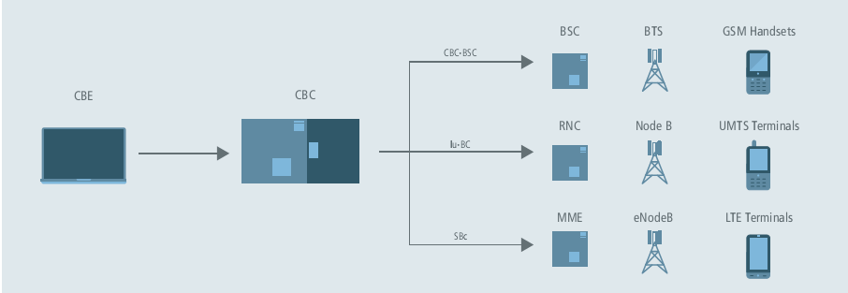
Figure 15: Cell broadcast system realization in 3GPP systems.

The Cell Broadcast Entity (CBE) is the messaging interface to the Cell Broadcast Centre (CBC) (Figure 15). The CBE is a user interface used by the message creator to both compile the message and then specify the location (or locations) of message recipients. Once defined, the message is sent to the CBC, which maps the target area to the mobile network cells and then sends the cell broadcast message to the required radio access network (GSM, 3G, LTE), which will manage the message broadcast to the end user.
A CBS message consists of 88 Octets (1 Octet = 8 Bits of Data) of information. The first 6 Octets are used to identify and define the message characteristics, the next 82 are used to carry the message payload itself. This allows for a total number of 93 Characters (7 bit encoding defined in [61]) to be used in a single message page, a total message may consist of 15 concatenated pages.

CBS data coding scheme supports the following GSM 7 bit default alphabets:

0000 German
0001 English
0010 Italian
0011 French
0100 Spanish
0101 Dutch
0110 Swedish
0111 Danish
1000 Portuguese
1001 Finnish
1010 Norwegian
1011 Greek
1100 Turkish
1101 Hungarian
1110 Polish
1111 Language unspecified

GSM 7 bit default alphabet extension mechanism allows further national languages to be used within CBS framework but with reduced payload for the data messages.
Language code b7……b0 Language
00000000 Reserved
00000001 Turkish
00000010 Spanish
00000011 Portuguese
00000100 Bengali
00000101 Gujarati
00000110 Hindi
00000111 Kannada
00001000 Malayalam
00001001 Oriya
00001010 Punjabi
00001011 Tamil
00001100 Telugu
00001101 Urdu
00001110 to 11111111 Reserved

6.1.2.3 Japan: NTT Docomo Area Mail Service
This service allows public to receive Earthquake Early Warnings issues by the Japan Meteorological Agency as well as disaster and evacuation information broadcast by national and local governments.
The alert is delivered through the CBS mechanism. However, Japanese character set is not supported by the GSM 7 bit default alphabet set. The Japanese text support is through the JIS standards for text messaging. Enhancements to the Area Mail service have been adopted within the ETWS system of 3GPP Release 8 [62].

6.1.2.4 USA: The Commercial Mobile Alert System
In the US, the Commercial Mobile Alert System (hereafter termed CMAS) delivers these NOAA alert messages to cell phones through CBS. Consider example notifications generated in the USA by National Oceanic and Atmospheric Administration (NOAA) which is a federal agency in USA that is focused on the condition of the oceans and the atmosphere.
Examples of Alert messages from NOAA [66]:
Warning Type | CMAS Message
Tsunami Warning | Tsunami Warning in this area. Avoid coastal areas. Check local media. –NWS
Tornado Warning | Tornado Warning in this area til hh:mm tzT. Take shelter now. –NWS
Extreme Wind Warning | Extreme Wind Warning this area til hh:mm tzT ddd. Take shelter. –NWS
Flash Flood Warning | Flash Flood Warning this area til hh:mm tzT. Avoid flooded areas. Check local media. -NWS
Hurricane Warning | Hurricane Warning this area til hh:mm tzT ddd. Check local media and authorities. -NWS
Typhoon Warning | Typhoon Warning this area til hh:mm tzT ddd. Check local media and authorities. -NWS
Blizzard Warning | Blizzard Warning this area til hh:mm tzT ddd. Prepare. Avoid Travel. Check media. -NWS
Ice Storm Warning | Ice Storm Warning this area til hh:mm tzT ddd. Prepare. Avoid Travel. Check media. -NWS
Lake Effect Snow Warning | Lake Effect Snow Warning this area til hh:mm tzT ddd. Avoid travel. Check media. –NWS
Dust Storm Warning | Dust Storm Warning in this area til hh:mm tzT ddd. Avoid travel. Check local media. -NWS

It may be noted that, for the purpose of alerting the civilians of a possible natural disaster/ severe weather the above messages are sufficient. Further information can be collected from other sources of information such as news, internet, public announcement systems etc.

6.1.2.4 Gap analysis of global standards on CBS for Indian requirements
1. The GSM default 7 bit character set doesn’t support any Indian languages for CBS based alerts.
2. GSM 7 bit default alphabet extension mechanism supports 10 Indian languages. However, the shift mechanism requires one extra character space for every shift character inserted and hence effectively reduces the usable payload to half the original capacity of 93 characters.
3. The Japanese standard of Area Mail and ETWS provide a means to deliver alert messages in languages other than those supported by the GSM standard. However, they are specific to Japanese language and the various scripts supported by Japanese language.
4. The EU-Alert provides a mechanism to deliver Alert notifications in multiple languages within the EU. However, this is achieved through broadcast of additional language messages next to messages in the local language. This however would imply increase in latency of delivery of Alert messages to needy public due to sequential broadcast which could be crucial latency in disaster times.
Ex: The CBS system in GSM can generate a page of 93 Characters every 2 seconds. If there are let us say, 5 languages to be supported in a given location the average turn-around time for a given language message (single page) would be 10 seconds. In case of disasters such as earthquake and Tsunami, the requirements of EWS systems are to deliver the message within 4 seconds. Thus the timely delivery of alert message is hampered due to the multiple language broadcasts.
5. Also the present CBS encoding format (Figure 16) does not provide a method to specify the mapping between the alphabet script and the language. In Indian languages, it is common to find many languages using the same alphabets and script. Devanagari script is used to represent at least 18 languages. Sometimes, multiple scripts are used to represent the same language too. For example, the Konkani language (spoken by around 1 million people) uses Devanagari script in the Indian state of Goa; but uses the Kannada script in the Indian state of Karnataka.

Octet | Bits
 | 7 | 6 | 5 | 4 | 3 | 2 | 1 | 0 | 7 | 6 | 5 | 4 | 3 | 2 | 1 | 0
1-2 | Serial Number
3-4 | Message Identifier
5-6 | Data coding scheme |  |  |  |  |  |  |  | Page parameter
7-88 | Message content
Figure 16: The CBC message format used in GSM

6. Availability of other character encoding schemes for Indian languages.
Current solutions available in the SMS messaging technologies for Indian languages can be applied to the CBS with limited advantages. There are three major standardized alternatives.
a. The ISCII standard [63] uses a 7 bit representation contributed by the Center for Development of Advanced Computing (C-DAC) and recognized by the Government of India as the Indian standard. The standard itself uses an ASCII like 8 bit representation, where in the lower 128 codepoints are plain ASCII, the upper 128 codepoints are ISCII-specific. However, there is no support in the international cellular communication standards for this encoding.
b. The 3GPP standard contributed BWCI [64] uses the 7 bit encoding also described in the GSM 7 bit default alphabet extension (Point 2 above). Hence the disadvantage of limited language support for Indian scripts is an issue in this case too.
c. The Unicode standard UTF-8 [65]. This is the current most widely accepted standard globally and supported on majority of operating system platforms for personal computers as well as the mobile platform. However the bandwidth requirement for Indian language representation is 3 Octets per character (2:1 ratio of overhead to actual alphabet).

6.1.3 GISFI Proposal
As the requirements of EWS based on CBS are unique, the proposed solution should address these needs. In this section, the proposed solution is described.

1. CBS is a one – way broadcast mode communication technology. The notifications are generated in the control room of the appropriate authority and delivered to subscribers in the cellular networks. Hence, the vocabulary can be based on standard information fields:

Type of Event
Intensity
Location (“ in this area”)
Expiration Time (until hh:mm IST)
Action (Response Type)
Originator (police, fire, meteorology dept etc)

Type: Cyclone | Appropriate Intensity Scale | Location: This area | till hh:mm IST dd/mm/yy | Action: [ Response Type ] | Source : MET Dept
Figure 17: Proposed CBS message content structure [Octet # 7 to 88 of CBS message structure Figure 16] dedicated for mapping between languages and scripts used to represent them

Each User Terminal (Mobile Phone, Tablet, Computer etc) capable of receiving the CBS broadcast stores the user preference for language within a list of supported languages for the country. The support would be based on availability of suitable character encoding toolset such as UTF-8, ISCII etc on the user terminal [63, 65].

The transmitted message thus would be only an encoded indicator of the actual rendered message to user. Based on the language support preference in the user terminal the appropriate message would be suitably displayed.

Table 4: Example of proposed assignment of Message Code based on intensity of the disaster
Type | Nature of Emergency | Intensity Scale | Response Type (4 binary digit code) | Detail Message Alert
1 | Tsunami | 1 to 12 | 0000 to 1111 | Appropriate text such as:  Imminent large waves. Move to high ground immediately
2 | Cyclone | 1 to 6 | 0000 to 0110 | Appropriate text such as:  Super cyclonic storm. High wind and rain. Take shelter now
3 | Flash Flood  Snow Storm | Watch  Warning  Imminent threat | 0000 to 0010 | Appropriate text such as:  Imminent flood. Vacate the area immediately
4 | Earthquake | I to X | 0000 to 1010 | Appropriate text such as:  1-IV: Minor earthquake in your area. Do not panic.  V-VII: Strong earthquake hits your area. Take shelter in sturdy building if close by. Stay outdoor if on road.  VIII and above: Destructive earthquake. Follow emergency rescue instructions
5 | Landslides | Watch  Warning  Imminent threat | 0000 to 0010 | Appropriate text such as:  Watchout for falling rock. Road damage ahead

For example: The Type 2 [Cyclone] Intensity [6] Location [this area] Till [hh:mm IST dd/mm/yy] Action [0110] Source [MET Dept]
Would be displayed at the user terminals in the following languages as follows:

English:
[Cyclone] Warning: [Super Storm] [in this area] till [hh:mm IST dd/mm/yy]. [Take shelter now]. –MeteorologyDept

Hindi: Devanagari Script
[चक्रवात चेतावनी] [सुपर तूफान] [इस क्षेत्र में] [hh: mm IST dd / mm / yy] तक. [तुरंत आश्रय ले लो]. - मौसम विज्ञान विभाग

Gujarati: Gujarati Script
[ચક્રવાત ચેતવણી] [સુપર સ્ટોર્મ] [વિસ્તાર] [hh: mm IST dd / mm / yy] હજુ સુધી. [તત્કાળ આશ્રય લઇ]. - મીટિઅરૉલજિકલ વિભાગ

Kannada: Kannada Script
[ಚಂಡಮಾರುತ ಎಚ್ಚರಿಕೆ] [ಸೂಪರ್ ಸ್ಟಾರ್ಮ್] [ಪ್ರದೇಶ] [HH: mm IST DD / MM / yy] ಈವರೆಗೆ. [ತಕ್ಷಣವೇ ಆಶ್ರಯ ತೆಗೆದುಕೊಳ್ಳಬಹುದು]. - ಹವಾಮಾನ ಇಲಾಖೆ

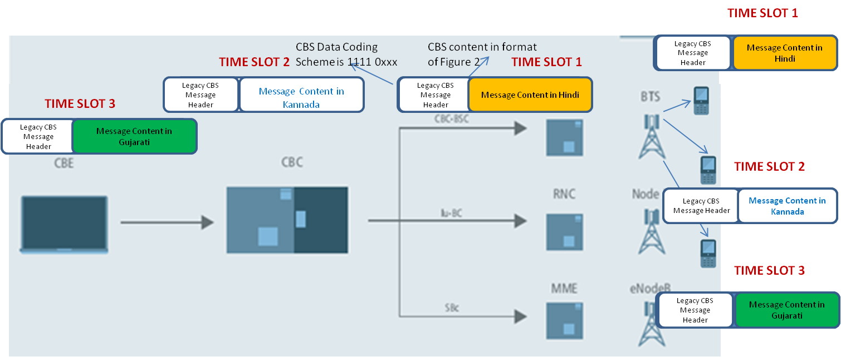

Figure 18: Existing CBS based Alert System architecture where three CBS broadcasts require three time slots to reach the handsets

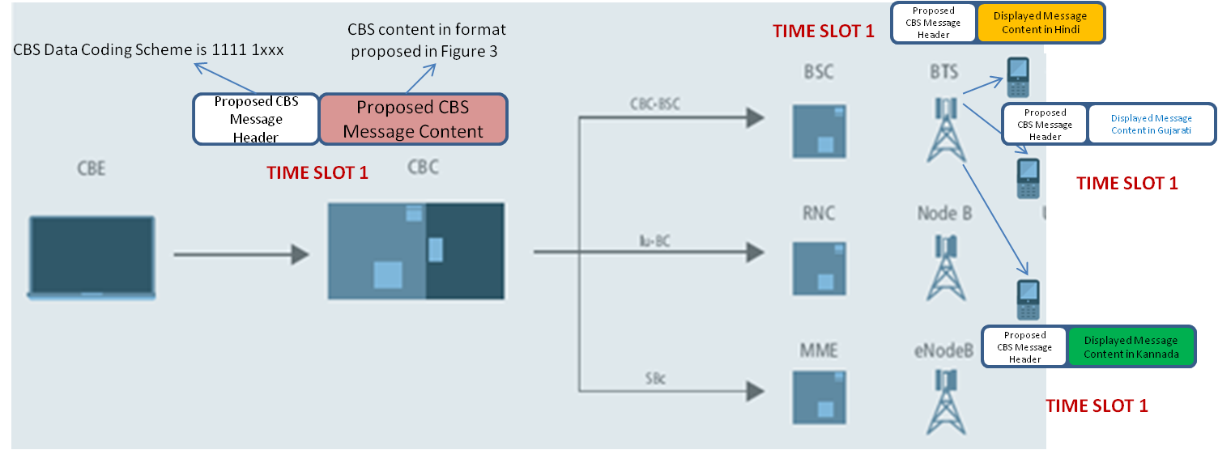

Figure 19: Proposed architecture where 1 time slot is sufficient to deliver the CBS message in three different languages to three handsets

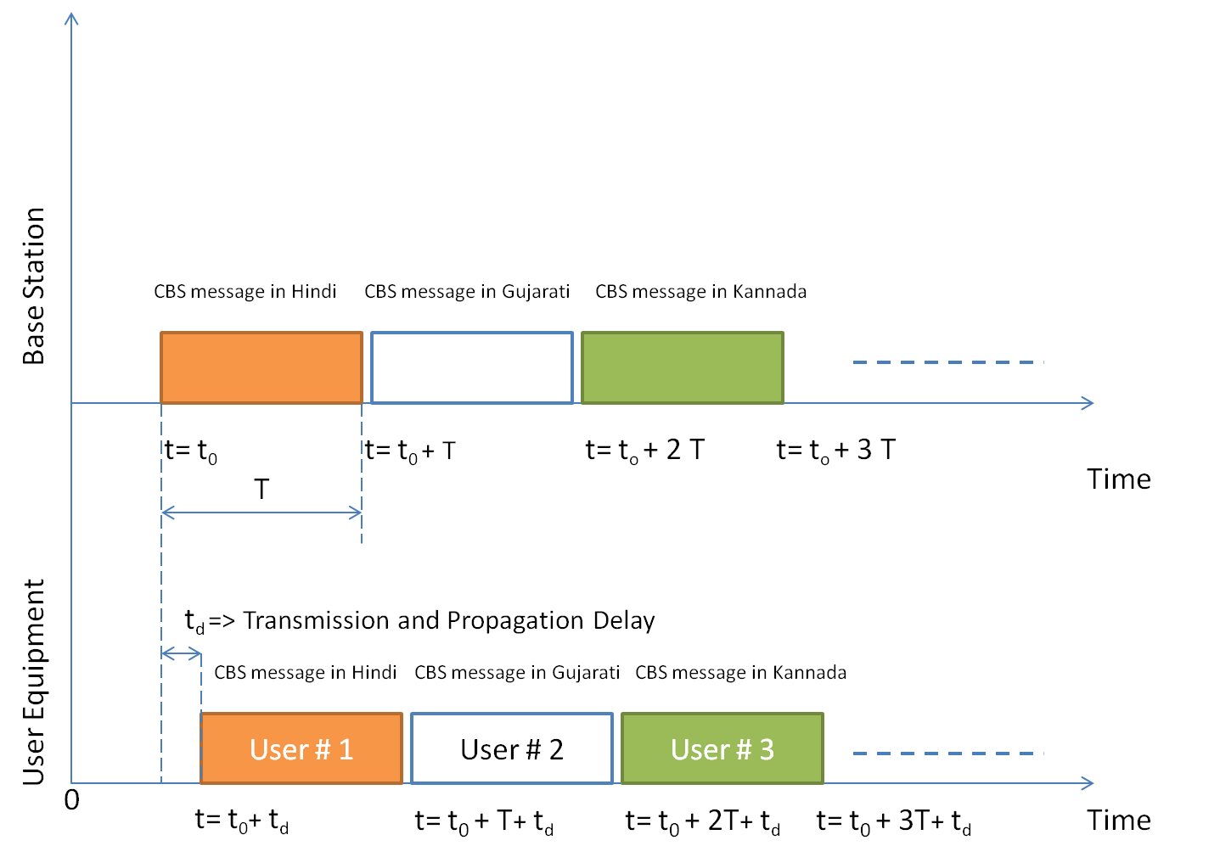

Figure 20: Existing CBS based EWS architecture => User # N receives the CBS message in the N^{th} language at time t = t₀ + N.T + t_{d}
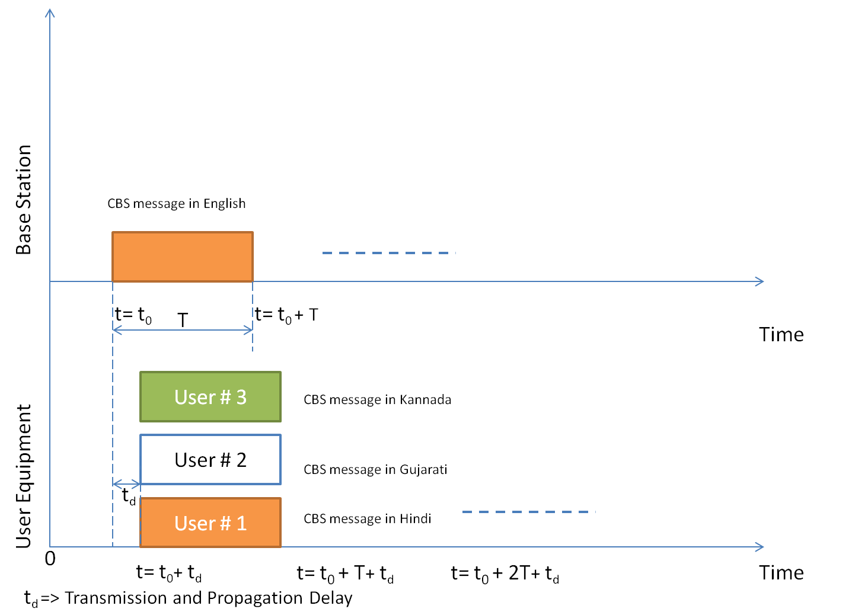
Figure 21: Proposed CBS based EWS architecture => User # 1 to User # N receives the CBS message in the N^{th} language at time t = t₀ + T + t_{d}

2. As described earlier, scripts in India have a Many-to-Many relationship with the languages supported. Many scripts can be used to represent a single language as well as many languages can be written in a single script. Since, the language coding scheme in CBS supported by 3GPP technologies like GSM do not consider this requirement; the user terminals may display the message in a way that is unsuitable to the user.

For example, User may be expecting to view the CBS Alert message in Nepali language which is also represented in Devanagari script. However, the CBS Data Coding scheme supports a single tag for Hindi (Code: 00000110) [61]. So the message would be displayed in all user terminals that have opted for receiving messages in Hindi. However, the grammatical and semantic information contained in the text may not be useful to the user.

Thus, there is a clear need to identify both the language and the script used to represent the language in the CBS message. We thus propose a modified, CBS message structure as shown in Figure 22.

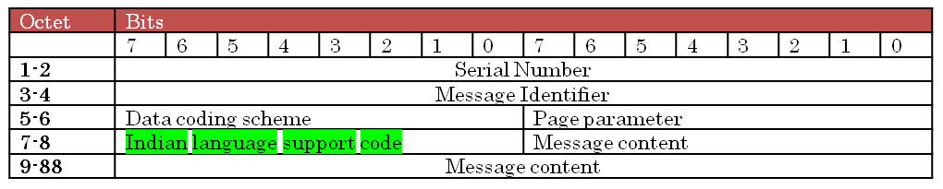
Figure 22: Proposed CBS message structure with Octet # 7 dedicated for mapping between languages and scripts used to represent them.

The Octet# 7 is dedicated for the mapping between the supported language and the script used. Every CBS message in an Indian language would need both this information, such that the message is rendered in the proper font and grammar structure on the user terminal. The Indian language support code would define unique codes for all other Indian languages that are not currently included within the 3GPP TS 23.038 [61], but can be represented using Data Coding Scheme of [61].

3GPP TS 23.038 [61] defines the way in which Indian language scripts are supported over CBS.
However, the user terminal may specify a combination of language and preferred script to view the message. In this proposed mechanism, the CBS message is only received and displayed if the preference of language and script set by the user terminal matches the Data Coding Scheme and Indian language support code as specified in Figure 22.
The CBS alert message is received at the user equipment from the base station through its radio interface. After the radio signal is decoded and converted to the bit stream, the CBS message content is interpreted in the proposed software module. The appropriate bit fields are interpreted and translator engine is invoked that translates the text field of the message payload as outlined in one of the possible ways in Figure 17.

6.1.4 Benefits
1. Unlike the existing EWS systems, where a separate message with a language indicator is transmitted for every supported language; in the proposed mechanism only one broadcast message is converted to the desired language and script at the User Equipment. This requires less number of time slots for transmission (one CBS transmission every 2 seconds) as compared to the existing method.
2. The proposed mechanism encodes the information into codes that can be accommodated within the 93 character limit of the single CBS broadcast message. This ensures that the primary notification is transmitted to the user terminals within 2 seconds [Time to transmit a single CBS broadcast].
3. The proposal is standard compatible with 3GPP TS 23.041 and can fall back to the legacy GSM 7 bit character encoding structure and message format when required. Provision of fallback to legacy system allows existing CBS based systems to coexist with the proposed EWS system.
4. Since the proposed system reduces the number of GSM frames needed to be received/monitored by the user terminal before successfully deciding a CBS message, it saves crucial battery power of the user terminal. This is critical in disaster scenarios to minimize the transmit/receive activity of the user terminal.
5. Further, the current 3GPP CBS standard 3GPP TS 23.041 [59] uses a shift code mechanism where in every character encoded in a language other than those specified in 7 bit GSM default character set is preceded by a special character to identify the language of the next character. This effectively reduces the payload of characters to half the original payload size when the National Language Single Shift Table is used. In our proposed system, there is no requirement to precede every text character with a special character to identify the encoding and hence allows for much higher payload. The only overhead is the utilization of 1 Octet of data payload to identify the language used for encoding. Thus, our proposed CBS system is more efficient in payload capacity irrespective of the language used for public alert systems.

6.2 Numbering Plan
The National Numbering Plan was last reviewed in 2003. The main goal of this new plan was to meet the challenges of multi-operator, multi-service environment and be flexible to scale up in the future without fundamental changes. According to this plan, the Emergency Services are included in the Special Services with a pre-allocated prefix of “10”. Police, Fire, Ambulance, Hospital Related, Emergency Information Services, Emergency Disaster Management Services, Police Related Services are the major categories included within the 3 Digit numbering plan. Further sub-categories under this numbering plan are included within these major categories allotting one extra digit (4 digits totally). The detailed plan may be accessed at [26].
This numbering plan and the implementation in India did not adequately address the issue of emergency telecom services. Any call to the listed emergency numbers are routed to a dispatcher and handled by the particular department which was not by design an emergency response department. Due to a large number of separately managed emergency reporting numbers, the system is clearly inefficient to handle large number of interconnected emergencies. The Justice Verma report [27] has also outlined a solution based on third party managed single number emergency response control centre that dispatches the appropriate emergency team coordinated by a well trained staff to take the call. Thus, for standardizing the single number emergency service, the numbering codes needs to be defined.

6.3 Location Tracking and Caller Identification Issues
Indian operators have currently not installed any form of mobile location tracking systems. DoT has set the deadline of year 2014 to install such a mobile location tracking system that is much more precise than the current system that provides the Cell ID of the subscriber. Indian operators have expressed their reservation in this aspect due to the huge costs of upgradation [28]. For efficient implementation of emergency response systems, locating and identifying the caller online when the emergency call is placed is very important. The situation is further complicated because mobile phones are not locked with cellular operators in India as in some other countries. Due to this, the users frequently switch their networks by changing the SIM cards. Hence, it becomes difficult to trace handsets across all operators and in the roaming networks without centralized database of numbers. There are few other issues related to the location tracking solutions to be standardized in India:
i. Low GPS penetration in Indian subscribers implies that the solution needs to depend on triangulation and other similar mechanism of localization supported by the network infrastructure.

ii. Overhead associated with transfer of caller identification & location information in real time. Spare capacity in public networks to be reserved for handling of emergency traffic.

iii. Confidentiality related issues that may arise due to access of personal contact information and location through centralized database maintained by the government or third party agency. 3GPP standards specify that position information shall be provided to the Emergency Services Network as an authorized LCS client. Target UE authorization checks normally performed for value added services are not applicable (privacy is over-ridden). Also, for Emergency Services (where required by local regulatory requirements) Target UEs making an emergency call may be positioned regardless of the privacy attribute value of the subscriber associated with the Target UE (or ME) making the call. This leads to the issue of guarding the privacy of the subscriber (identity, location details etc) while transferring the information to the PSAP, storing the information at appropriate databases within the IECS network or communicating with the point of contacts within the emergency responder organizations. This issue must be studied in detail and regulatory as well technical challenges identified.
iv. Standards compatible location tracking solutions in case of SMS, data calls, SIM-less emergency calls etc.

6.4 Emergency Calls without Subscriber Identity Module
Mobile communication standards provide facility to place Emergency Calls to preprogrammed numbers in the handset without SIM cards to emergency response numbers. However, this is an optional facility that can be blocked by service providers based on Government policies to disallow them. The primary reason being non-traceability of location and subscriber details, unavailability of call back numbers to verify the origin of the call etc.
Many other countries have blocked SIM-less emergency calls due to non-traceability of location, call back facility. Ex: Australia [29].
In India, central database to store all active phone numbers (MSISDN) is under consideration by Department of Telecom (DoT). The design considerations and the manner each operator has to synchronize with this central database needs standardisation. DoT considering mandatory sourcing of SIM cards from Indian manufacturers to prevent cloning and compromising security. It also plans to trial central International Mobile Equipment Identifier (IMEI) registry [31] for all mobile phones in India. Mobile Standards Association of India (MSAI) [30][31] is the official body to allocate IMEI numbers to handsets in India and accredited by GSMA. Indian mobile operators want the Government to take ownership of Central Equipment Identity Register (CEIR). Once, information of all the active mobile phones is available in a centralized database, it should be possible to verify the source of the call without the SIM card as well as locate the UE in real time.
Indian cellular market is dominated by prepaid customers and a significant portion of this segment frequently faces insufficient balance and service deactivation. In this context, it is important to address regulatory and operational challenges while providing emergency telecom services to subscribers with no SIM card or inactive SIM cards.

6.5 Location and ownership of Public Service Access Points
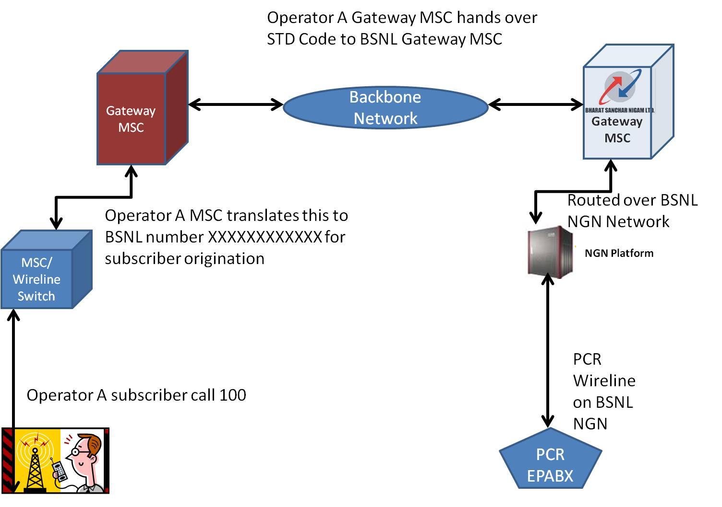
Figure 23 : Current Routing of the Emergency Calls in India
The Figure 23 shows the current architecture of emergency telecommunications in India [33]. The call may originate from any fixed or mobile telephony network in India. The call goes through the home MSC/Wireline switching center and forwarded to the Gateway-MSC. The Gateway-MSC forwards the call to the incumbent operator (BSNL) Gateway-MSC. Further BSNL routes this call to the BSNL NGN service delivery platform and finally terminates on the PBX situated in the emergency control room.
The data shared by the cellular operators shows that there are two forms of charges for operators [33]:

Annual Charges:
For the calls terminating in emergency services i.e. destination number 100, 101. 102 and 108, the Unified Access Service License (UASL) licensee pays a fixed charge per annum to the BSNL for the entire service area,

Usage Charges: In addition to the above Interconnect Usage Charge(IUC) is also payable by UASL to BSNL at the rate applicable for the termination of the calls into BSNL fixed line network.

This architecture needs revision and a through standards based approach may be adopted to design a Centralized / Distributed Public Service Access Point (PSAP). This PSAP would be controlled by an independent authority and should be reachable over all telephony networks within the country with dedicated resources provisioned.

6.6 Local Language Support and Social Inclusion
Since India is a country with over a thousand different languages [34], it is a challenging task to support all languages in emergency response and rescue conditions. However, it is important to provide regional language services for emergency callers due to the low literacy rate and lack of comfort while communicating in official languages (Hindi and English) in various parts of the country. In certain countries, provision of language translation services are mandated – e.g. In USA, most PSAP use third party conferencing services for language translation for calls from users who can’t speak English.
Another aspect is that of providing facility for differently abled citizens access to emergency services. Standard bodies such as the ETSI are developing specifications for support of text and gesture based emergency communication for differently abled citizens. It should be considered whether a separate code for disabled persons like deaf and dumb who cannot use voice calls – e.g. ACMA in Australia determination mandates 106 for persons who are deaf or have a speech or hearing impairment and use text-phone. Special requirements in this regard should be obtained from the stakeholders [36].

6.7 National Security Implications
Nation’s emergency telecommunication infrastructure is a direct measure of national security readiness of the country. In light of contemporary challenges of terrorism and threat from adversaries facing the nation, it is important that the emergency telecommunication services be designed to deal with such disasters. Certain countries, such as the USA have a separate program that authorizes national security and emergency preparedness (NS/EP) organizations to receive priority treatment for vital voice and data circuits or other telecommunications services.
Further the PSAPs may be a target of sabotage during terrorist operations, cyber espionage and attacks on critical infrastructure of the country. Centralized response systems can be vulnerable to:
1. Attacks – Physical or application software related (virus, malware, denial of service, hacking etc)
2. Network failures due to infrastructure damage, power failures, software/hardware problems etc.
3. Congestion - Call overload due to sudden surge created in event of disasters.
4. Hoax calls to generate panic and misdirect the emergency response systems
These requirements must be appropriately addressed in the PSAP standards.

In appropriate situations, it may also be required to provide critical users the ability to eliminate the capture of call detail records and caller identification, making calls non traceable. Further, emergency services delivered to Indian citizens may be differentiated to those delivered to visitors to India from other countries. For example, According to DoT's guidelines [38], any mobile connection issued to a foreigner should not have validity beyond that of a visitor's visa and to a maximum period of three months. In such situations, the visitor may not have access to mobile phone with active and verifiable SIM card during emergency. This issue also needs to be appropriately addressed by the ETS service provider.
Also, existing networks setup by various stakeholder organizations in the country such as the Crime and Criminal Tracking Network & Systems (CCTNS) setup by Ministry of Home Affairs (MHA) [37] needs to be integrated with the emergency telecommunication services through appropriate interfaces. National Emergency Telecommunications Standards need to be developed to address these above described special requirements for national security on the lines of NENA standards [35].

6.8 National e-Governance Plan
Government of India is currently working on the National e-Government Plan (NeGP) [39]. As part of this initiative, to provide citizen services through mobile phones, the Government has notified the three digit number 166 for single number access of all non emergency government services. Further, the NeGP standards on data exchange, service localization, mobile governance framework and Mobile Service Delivery Gateway (MSDG) are being evolved [43].
In the context of single number access for non emergency services, a number of common requirements for ETS are being addressed by NeGP standards such as the local language support and data exchange formats. Also, some of the reference applications hosted by the m-Governance App Store by the Government of India overlap with the Emergency Telecom Services [41].
For instance, Rakshak is a mobile application hosted by the m-Governance portal [42] that can be used in case of emergency where-in, on click of a button this application will send SMS having current location to four different (Relatives/Friends) numbers and will also initiate a voice call to an emergency number. The numbers can be specified by the user at the time of installation and can be updated. Thus, it is important to identify common requirements of the m-Governance framework [43] and ETS services to evolve interoperability between the two service delivery platforms.

6.9 Issues related to call routing
As outlined in the Section 1.5 of the consultation paper [44], the jurisdictional information of appropriate Emergency Responders such as Police, Ambulance, Fire etc need to be considered while routing the call to the PSAPs. The current standards such as NENA in America mandate the routing be carried out based on the geo-location information of the caller. This automated routing if followed in India may raise the issue of call terminating at a PSAP, which routes the request to a responder who does not have jurisdictional rights for the area from where the call originated.
For example, on state boundaries a mobile phone frequently gets connected to the operator in the neighboring state and if the call is routed based on the Cell-ID information; the call maybe redirected to the nearest PSAP in the other state. At this PSAP, the call-taker based on visual judgment on the GIS platform may route the call to the Police control room of the neighboring state delaying the service to the needy caller.
This issue should be studied in detail and appropriate mapping between the location, mobile operator coverage and the jurisdictional details of emergency responders be carried out.

6.10 Machine Initiated Emergency Calls
Human initiated emergency calls for availing emergency services like Police, Fire, Ambulance, Natural Disaster, etc. may be a REACTIVE method. In the REACTIVE method, the damage is already initiated and the time for providing the emergency service to the human gains utmost importance to rescue the human in emergency. There is a need for JIT (Just-In-Time) and PROACTIVE methods for initiating emergency calls. These types of emergency calls are beyond the detection capabilities of human. Hence, machines need to be involved in such cases.
The following examples illustrate the benefit of machine initiated emergency calls.
- Fire breaks out due to short circuit in a high rise building: A human is able to detect and react to this emergency after considerable damage has been done. If machines are designed to detect emergency situations based on Fire Sensors and Electrical Relay states and communicate the same to the IECRS network, the emergency services can be quickly provisioned. In the former case, even though emergency services are delivered, it still results in considerable human and economic loss. Whereas the latter can further minimize this loss to a greater extent.
- Vehicle Accidents: These are the most common emergency situations in India and many lives are lost due to delayed delivery of emergency service. The delay is usually accounted in several hours. Most of these emergencies are detected by humans who basically pass by this emergency situation. To improve efficiency of service delivery to these emergencies, machine initiated emergency calls are very crucial. In Europe, a project called eCall [57] is being developed to handle this particular scenario.

7 Perceived open areas for standardization in Emergency Telecom Services in India

7.1 PSAP Standards
A PSAP is an agency or group of agencies designated and authorized to receive and respond to emergency calls requiring one or more emergency public services (Police, Fire, Hospital etc). For a nationwide single number emergency telecommunication service, a number of national requirements emerge. These requirements need to be appropriately addressed through national standards for PSAP architecture, operations and technology.
Some of the key areas for standards requirements may emerge are:

a. Architecture and functionality of PSAPs
b. Routing, transfer of caller and location information
c. PSAP interfaces and protocols
d. Database standards and KPIs

Conclusions
In this study, we have surveyed the state of art in standards, deployments with respect to ETS services. In addition, a detailed study is done regarding the scope of standardization of ETS in India w.r.t guidelines in National Telecom Policy and TRAI consultation papers. Emergent open issues are discussed and possible solutions are outlined which may be further developed w.r.t scope of standardization at GISFI in the Indian context.

Annex <1>:
Proposed Classification of ETS and their service requirements

Figure 24 is a proposed classification of services immediately required in face of a disaster.
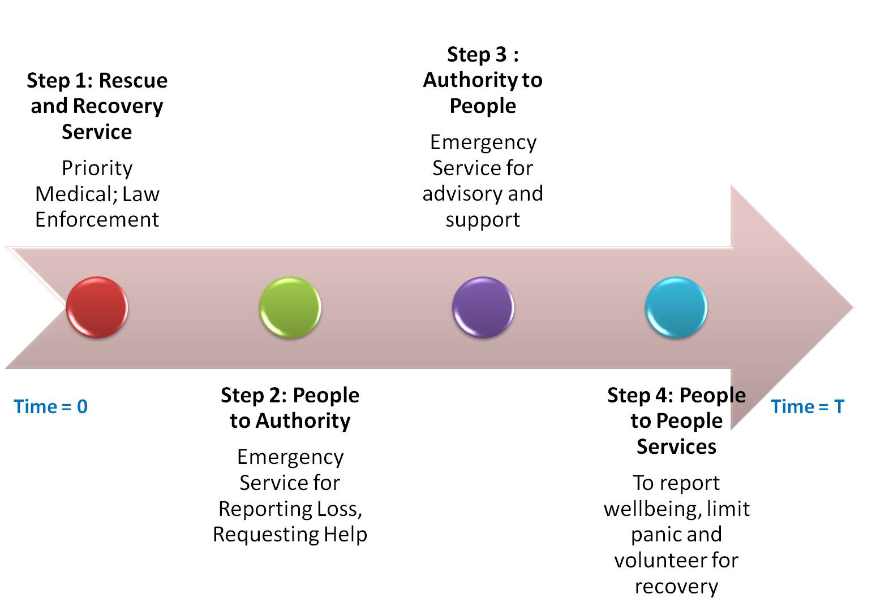

Figure 24: Telecom services in priority order with timeline once disaster strikes (at Time = 0)

1) It may be observed that, certain priority rescue and recovery ETS services amongst authorities may require preference and preemption capabilities over regular public telephony service in case of congestion following a disaster. These may be enabled first. The time of activation of these services must be as close as possible to the reference Time =0, when the actual disaster would have occurred.
2) People to Authority and vice-versa services may be activated next based on the infrastructure capability of the network, once the configuration procedure for the resilient telecom infrastructure is performed.
3) Finally People-to-People services can be activated with certain regulation such as duration limit of personal calls (as deployed in Peru after 2007 earthquake [16])

It may be noted that the time of activation of a service following a disaster in one of the key aspects of timely deployed ETS service. Either the total time taken T to activate all the services progressively be specified or a more granular requirement may be specified for each category of the service in Figure 24.

Also, geographical limits of the disaster place a major role in the nature of ETS service to be deployed in the area. It may be noted that in India, the National Disaster Management Agency [25] is the central authority for disaster recovery and response activity. However, as per the standard operating procedures described, there are various central and state Government authorities that are responsible for generating predictive warnings as well as post disaster action plan. Due to this reason, the ETS services to the appropriate agencies and affected regions must be enabled intelligently in face of a disaster. Method of determining the same may be worked out with reference to the procedures outlines in [25].
Consider, the proposed classification in Figure 25 of geographical limits of the impact of a disaster:

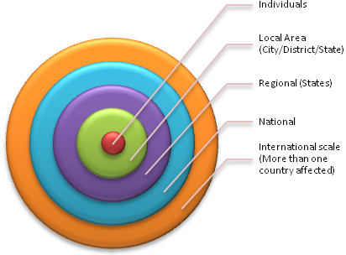
Figure 25: Proposed classification of geographical impact of disasters

It may be observed from Figure 25 that, at the center of the ETS service is the actual victim(s) of the disaster and is to be considered as the geographical center of ETS service enablement. Effective response and recovery services that the telecom and data infrastructure needs to provide should be graded based on the geographical impact of the same. The local area administration such as City/District/State where the disaster has struck comes next in this gradation. Further, if the disaster has affected (or expected to affect) larger geographical regions, the regional, national and international ETS services may be activated. The appropriate category of the ETS services may be provisioned in the limits of the geolocation which might be under the influence of the disaster.

In Figure 13, one move a radially outwards from the center of the impacted area, the nature of ETS service under utilization would change. For example, in the disaster zone People-to-Authority distress calls need prioritized network access. In other zones, Authority-to-Authority communication and People-to-People communication may be more preferred. Thus, based on the geo-location information certain ETS services may be provided prioritized resources.

Another significant requirement is provisioning ETS service resources based on predictive knowledge of emergency conditions:
Certain disasters start at a particular geolocation and then spread due to natures forces, systematic failures etc. For example, Cyclones/Tornados effect regions in their path and sometimes change their courses very quickly. ETS services provisioned in advance in the possible impact areas can help save lives. Thus the ETS infrastructure must provide provisions for dynamic adaptation of resources.

The nature of emergencies also play an important role in provisioning and activating the ETS services. Following are few examples of the emergencies that have special ETS requirements:
- Terrorist attacks, Wars and emergencies of concern for national security: May require over-riding civilian communication capabilities.
- Natural disaster at a global scale (e.g. Tsunami) [More than one country involved. International ETS service capability requirement]. In such rare but possible conditions of emergencies when support from International disaster recovery organizations are required, ETS services based on International Emergency Preference Scheme (IEPS) for disaster relief needs to be activated.
- Nuclear/Biological/Chemical emergencies that can spread over large areas [The impact may spread over large areas quickly, though the degree of impact may reduce with distance from the origin. Hence nature of ETS services required may change]
- Regional emergencies (e.g. Cyclones, Forest fires etc.) [ETS provisioning based on predictive knowledge of disaster impact]
- Localized emergencies (Transport accidents, Building collapses etc) [ETS services with focus on personal safety of the affected]

The emergency service must be focused towards personal safety of the affected people while addressing issues like:

  - In a country like India where most people have access to a mobile phone and are mostly prepaid customers with very limited balance amount of subscription, it should be ensured that the people in center of the disaster location should be able to reach out to authority (People to Authority Emergency Call) without any subscription requirement. Any SIM + Any Network Operator configuration must be supported.
  - It is unlikely that children, uneducated or less literate people、 would be able to remember long Unique code + PIN + Emergency Dial to reach out to authority. This requirement in International ETS services needs to be simplified in the Indian context.
  - Indian language support is a must for the solution to be successful in India. The system should be able to adapt its supported language based on the contextual information of the subscriber if available. Some of these could be the user input of preferred language, geo location and demography of the disaster area.
  - In certain emergencies such as terrorist attacks, it could be potentially unsafe for the survivors to make a call on the mobile phone, which could be located easily by the attackers and potentially, put the lives in to danger. Under such situations, text messaging (SMS or Chat), icon based touch screen or one-touch solutions on mobile phones that can upload both the geo-location and information are preferred. Standards need to be evolved to govern these non-voice requirements and make them interoperable.
Survivability of this service on occurrence of disasters will depend upon how this service infrastructure is designed (location of physical infrastructure i.e; Servers, Towers, Network elements). Terrestrial cell antennas and networks can be damaged by natural disasters. Satellite telephony can avoid this problem and be useful during natural disasters, but is banned for civilian use in India under Sec 6 of Indian Wireless Act and Sec 20 of Indian Telegraph Act. ETS services would require amendments in current regulations to support satellite telephony during disasters.

Annex <2>:
GISFI Response to the TRAI Consultation paper on IECRS

Issue 1: What are the types of emergency services that should be made available through single emergency number?
Reply:
Background:
As per the CMTS license reproduced in section 1.12 of the consultation paper “Emergency service means an emergency of any kind, including any circumstances whatever resulting from major accidents, natural disasters and incidents involving toxic or radio-active materials and emergency services in respect of any locality means the relevant public, police, fire, ambulance and coast guard services for that locality”.
As per the UAS license reproduced in section 1.13 of the consultation paper “the licensee shall provide independently or through mutually agreed commercial agreements with other service providers, all public utility services including TOLL FREE services such as police, fire, ambulance, railways/road/Air accident enquiry, police control, disaster management etc. While providing emergency services such as police, fire, ambulance etc. it shall be delivered to the control room of concerned authority for the area from where call is originated”.
Response:
As evident from the above description, emergency situations require services delivered to the affected people by public, police, fire, ambulance and coast guard services for that locality. While emergencies affecting individual(s) are mostly responded by these service providers on request; emergency situations arising from natural disasters, nuclear/chemical/biological accidents, outbreak of war are best dealt by public warning systems.

Further the offered emergency services may also include the following:
a. Emergency service cell of the cooking gas provider [LPG cylinders, piped gas] on gas leakage
b. Control rooms of Indian Railways, State Transport Corporations, and Airports.
c. Control rooms of National Disaster Management Authority (NDMA).
These may help to avert or manage potential emergencies which are best dealt by trained professionals belonging to the above organizations.

In the context of emergency telecommunication services, there are mainly four scenarios for services:
a. Alerting civilians (communication from authorities to public)
b. Alerting authorities (communication from public to authorities)
c. Communication between authorities
d. Communication between civilians

However, in the present context of the consultation paper the first two categories listed above i.e; communication from authorities to public and communication from public to authorities are recommended to be included within the scope of service delivered through single emergency number.
For the purpose of public warning systems, the communication from authorities to public needs to be delivered through a predefined emergency number, so that the people in distress recognize and trust the source of the warning or alert. This would help deal with the problem of intentional or mischievous spread of rumors or incorrect information. This information may be delivered through standards based technologies such as the Cell Broadcast System (CBS), Short Messaging Service (SMS) on cellular networks, E-Mail and other broadcast or multicast communication systems.

Communication between civilians can be hampered during large scale emergencies such as natural disasters. In such events, the citizens require some means to communicate with their close ones. It is essential to explore means to deliver such services such as common message portal or voice message gateways where people can leave message for their kin. Also, recent world events have shown the impact of social network media during emergency situations such as terror attacks. It would be appropriate to consider alternate means of emergency service delivery through platforms such as social networking.

Summary of GISFI Recommendations:
1. Include the following services within the purview of emergency services that should be made available through single emergency number:
a. Emergency service cell of the cooking gas provider [LPG cylinders, piped gas] on gas leakage
b. Control rooms of Indian Railways, State Transport Corporations, and Airports
c. Control rooms of National Disaster Management Authority (NDMA)
2. Communication from authorities to public and communication from public to authorities are recommended to be included within the scope of service delivered through single emergency number.
3. Public warning services: The communication from authorities to public needs to be delivered through a predefined emergency number. Especially in disaster conditions, when large volume of emergency calls are made, the public warning and alert services can deliver common information to all affected people.
4. Need to explore alternate means of service delivery for communication between civilians such as message gateways for text and voice, social networking interfaces over the Internet etc.

GISFI Standardisation Activity:
GISFI working group on Cloud and Service Oriented Networks (CSeON) is currently working to define the Emergency Telecommunication Services framework that would address the issues in service delivery through standardized interfaces.
Issue 2: What universal number (e.g. 100,108 etc) should be assigned for the integrated emergency communication and response system in India?

Reply:
Background:
In India, the numbers “100” and “108” have become synonymous with emergency response. Though “100” has been primarily a police emergency number, rapid modernization of police network along with the implementation of the new DIAL 100 network has made “100” a gateway to hospital and fire emergencies as well. At the same time, “108” Emergency service implemented in 12 states in India have made the number very accessible to common citizens to approach medical emergency response providers.
Response:
Thus, it is recommended that one of the above two numbers itself be designated as the universal number for IECS services. Any new number will take time to be acceptable by the citizens of India. Also, these two numbers belong to Level ‘1’ series in the National Numbering Plan 2003. They shall not be used as first digit for telephone exchange codes in basic telephony services. Level ‘1’ is used for accessing special services like emergency services, supplementary services, inquiry and operator-assisted services.
Further, the choice between the number “100” and “108” depends on the following issues:

1. National numbering plan:
Both “100” and “108” are Category 1 services: These are the mandatory services to be provided by all the Access Providers.
(i) According to the national number plan, 100 is categorized as Restricted. These are the services to be accessible at least within local area.
(ii) According to the national number plan, 108 is categorized as Unrestricted. These are the services, which shall be accessible from anywhere, national or international.
Thus, with the view of accessibility, 108 is more reachable from the common citizens on any of the access networks anywhere in India.

2. Uniqueness of the number:
The number “100” is used for emergency services in India, Israel, Nepal, Belgium, Greece, Argentina and Peru.
The number “108” is currently not utilized by any country as their emergency number.
Though, there is no international guideline of not using the emergency number used by another country, it may be a preferred practice to utilize a number which is unused by any other country for emergency purposes. This is especially because in future more Internet Calling Interfaces may be provided access to dial Emergency Telephone numbers. If there is another country with the same Emergency Telephone number as the number designated as universal emergency access number in India, it may potentially lead to misdialing and calls meant for another service terminating at the PSAP in India.

3. Implementation challenges:
The number “100” has been used by the Police Dept. from a long period and is serving the citizens for crime related emergencies. Implementation of a nation-wide single number IECS system will take time and may not be rolled out simultaneously in all places. In this intermediate period, if 100 is utilized for other emergency services such as medical/fire/natural disasters etc; it may cause overhead and deficiency of service rendered to the needy citizens.
The number “108” on the other had is currently dedicated for emergency medical services in 12 Indian states. Additionally there is an existing PSAP like infrastructure for handling of emergency calls and dispatching to other departments like the Police if necessary. So phase wise rolling out of service utilizing the same number (“108”) may not cause disruption of emergency services to citizens.

Summary of GISFI Recommendations:
1. Based on the above described three points, we recommend the number “108” to be utilized for Universal number for IECS in India.

GISFI Standardisation Activity:
1. GISFI CSeON WG is looking into issues in supporting calls originating from Internet or through VoIP gateways to the PSAPs. Some of the issues include location, establishment of caller identity, routing and security challenges.

Issue 3: Should there be primary / secondary access numbers defined for the integrated emergency communication and response system in India? If yes, what should these numbers be?

Reply:
Background:
As mentioned in the reply to Question 4.2; we recommend use of the number “108” as the Primary emergency number.
However, as mentioned in the consultation paper, the ITU Recommendation E.161.1
“A Member State that is planning to introduce a second alternative emergency number could use either 112 or 911, or both, which should be routed to the existing emergency number. A second alternative emergency number facilitates for example emergency calling by travelers visiting the country.”

Response:
India as a member state of the ITU, may support 112 and/or 911 as secondary alternative emergency number. This would not only facilitate foreign travelers to India; but also provide gateway for GSM phones in Emergency Mode to make calls to the proposed IECS network in India.

However, the following issues need due consideration:
(i) Numbers starting 911xxxxxxx are valid mobile subscriber numbers in Indian network. Dialing such numbers with more time gap between key presses may lead to routing this call to the PSAP. There is a need to consider this issue and bring out necessary regulatory amendment for not to allocate this number series to customers in India if 911 is supported as a secondary emergency number.
(ii) Apart from 911 and/or 112, there would be need to support the existing emergency numbers like 100/101/102 as secondary numbers till a nationwide unified IECS system starts operation.

Summary of GISFI Recommendations:
1. The primary emergency response number should be 108. The IECS network should support appropriate routing of secondary numbers such as 911, 112, other additional international emergency response numbers along with the currently used emergency numbers in India such as 100/101/102 to the nearest PSAP.
2. Appropriate technical solutions should be established that distinguish between genuine calls to the emergency PSAP in India and accidental calls due to misdialing a number prefixed with the emergency response number of other countries.

GISFI Standardisation Activity:
1. GISFI CSeON WG is studying the national numbering plan 2003 and issues related to supporting secondary emergency numbers are within the scope of study.

Issue 4: For implementing single number based Integrated Emergency Communication and Response System in India, should the database with information of telephone users be maintained by the individual service providers or should there be a centralized database?
Reply:
Although both the approach of keeping the database of the subscriber either with respective Service Providers or with centralized, there are few positive aspects if it is kept centralized. The response time for any data base query in Emergency Response System is absolutely critical. In case it is kept distributed with the Service Providers, the same may get compromised, unless there are very well defined response time performance criteria and a strict regulation to ensure compliance. If this database is kept centralized, system could be designed such that the database update is not operationally critical. Having centralized database and rightly updated from all the telecom network, gives tremendous strategic advantage provided it kept under safe mechanism and esure no business disadvantage to the service provider and no loss of individual privacy to lawfully unauthorized person.
From the perspective of standards, US Emergency service standards (NENA) has defined a role called as DBMSP (DataBase Management System Provider) and associated procedures with managing data along with Telecom Service Providers. Further study is required for the feasibility of such standards in Indian telecom scenario.
GISFI is also interested to carry out the detailed study of potential advantages and the operational efficiency in alternate scenarios when the database is kept distributed within the control of respective Service Providers.

Issue 5: In case of centralized database which agency(one of the designated telecom service provider, a Central Government department or a designated third party) should be responsible for maintaining the database?
Reply:
DoT may keep it under its direct control and responsibility. It could also ask BSNL, NIC to carry our safe and required operations and maintenance of this database. Any external outsourcing organization in private sector may be trusted with well defined matrix of role, responsibility and penalties on non-compliance or operating breach. GISFI will be interested in defining the technical and the operational framework to address this critical aspect.
Issue 6: What are the technical issues involved in transfer of location of a mobile user in real time?

Reply:

Background:
The technical standards addressing the location identification and transfer in 3GPP mobile communication systems like GSM/GPRS, UMTS and LTE is 3GPP 23.271.
Location Service (LCS) specifies all the necessary network elements and entity, their functionalities, interfaces, as well as communication messages, due to implementation of the positioning functionality in a cellular network. The position information shall be reported in standard, i.e. geographical co-ordinates, together with the time-of-day and the estimated errors (uncertainty) of the location of the user equipment (UE) according to specification TS 23.032. The LCS feature utilizes one or more positioning methods in order to determine the location of user equipment. The positioning methods for UMTS, GSM/GPRS are described in TS 25.305 and TS 43.059 respectively. The LCS Server provides the location service capabilities but the mechanism by which location is reported to an emergency service provider is not standardized within 3GPP.

Response:
Determining the position of a UE involves two main steps:
(i) Radio signal measurements; and (ii) Position estimate computation based on the measurements.
For India, it is recommended that the positioning be done through the network which doesn’t require handset specific support. This is due to the low adaptation of enhanced location support features in handsets such as the GPS.

One or more LCS Clients may access a Location Server via its Le interface. Location Servers, resident in the same or different networks, may communicate with each other, indirectly, via the Lg interface to their associated MSC/SGSNs. Optionally, the Lr interface, as specified for direct GMLC to GMLC messaging, may be used for this purpose.

Figure 1 : Generalized LCS Access Interfaces and Reference Points

Response Time is one of the negotiable QoS parameters for Emergency LCS services. For Emergency Services, there may be no requirement to support negotiation of response time. The network shall then provide a response as quickly as possible with minimum delay if dedicated LCS server for Emergency services is provisioned. The Gateway Mobile Location Centre (GMLC) contains functionality required to support LCS. A GMLC is the first node an external LCS client accesses in a PLMN (i.e. the Le reference point is supported by the GMLC).
Network Induced Location Request (NI-LR) applicable to 3GPP cellular standards reproduced for reference.
Figure 2 : Generalized call flow to obtain real-time location information from UE during emergency call

Overview of the call flow:
1) An initially idle UE requests radio connection setup indicating a request for an Emergency Service call to the VMSC/MSC server via RAN.
2) RAN shall convey the CM service request to the core network.
3) The emergency call procedure is applied. The VMSC/MSC server determines based on the serving cell the appropriate emergency services client.
4) At any time after step 2, the VMSC/MSC server may initiate procedures to obtain the UE's location and optionally, velocity. These procedures may run in parallel with the emergency call origination. The VMSC/MSC server sends a Location Request message to RAN associated with the UE's current location area. This message includes the QoS parameters required for an emergency call.
5) RAN determines the positioning method and initiates the particular message sequence for this method.
6) When a location estimate best satisfying the requested QoS has been obtained, RAN returns it to the VMSC/MSC server in a Location Report.
7) Depending on local regulatory requirements, the VMSC/MSC server may send a MAP Subscriber Location report to a GMLC associated with the emergency services provider to which the emergency call has been or will be sent. This message shall carry any location estimate returned in step 6 including the indication received from RAN whether the obtained location estimate satisfies the requested accuracy or not, the age of this estimate and may carry the MSISDN, IMSI and IMEI of the calling UE, the information about the positioning method used and the serving cell identity or SAI of the UE.
8) The GMLC acknowledges receipt of the location information. The GMLC shall store the location information for later retrieval by the emergency services LCS client.
9) The GMLC may optionally forward the information received in step 8 to the emergency services LCS client. The GMLC may also record charging information. The client is expected to obtain the location information by requesting it from the GMLC.
10) At some later time, the emergency services call is released.
11) The MSC/MSC server sends another MAP Subscriber Location Report to the GMLC. This message may include the same parameters as before except that there is no position estimate and an indication of emergency call termination is included.
12) The GMLC acknowledges the MSC/MSC server notification and may then delete all information previously stored for the emergency call per national regulation.

It should be noted that, many times the UE may be moving rapidly and may pass through one or more radio cells belonging to one or more network operators. Hence the location of a UE may need updating in real time during the emergency call period.

The protocol operation on Le interface between the LCS clients and the GMLC (Figure 1) has not defined by 3GPP as part of the cellular specifications. However, other standards like those defined by Open Mobile Alliance Mobile Location Protocol (MLP) can be applied on this interface.
(i) If the Emergency Operator at the PSAP decides to invoke a location request after having received an Emergency Call from a digital PLMN, the Emergency Location Immediate Service defined in MLP is used. This interface operates over the ISUP protocol.
(ii) The first part of the Global Title (identity of SCCP node) identifying the originating mobile network will be used by the IECS network for deciding which network to send the location request to.

Three kinds of location query over MLP are possible on the Le interface and are governed by national standards and regulations.
A. Ordinary Positioning [Support for HLR request]
- A MLP “Emergency Location Immediate Request” is sent from the LCS client of the IECS network to the LCS server in the PLMN. MSISDN and VMSC-identity are transferred.
- The MAP message “Send Routing Information for Location” containing MSISDN is sent to the HLR of the caller.
- The HLR answers by sending IMSI and the VMSC-identity. The HLR must recognize the MSISDN.
- The MAP message “Provide Subscriber Location” is sent to the serving VMSC. The calling terminal is addressed by the calling subscriber IMSI.
- The VMSC answers by sending the MAP message “Provide Subscriber Location ACK” to the LCS server.
- The LCS server sends the MLP message “Emergency Location Immediate answer” to the location client
B. Exclusive Emergency Positioning [Excluding the HLR request]
- A MLP “Emergency Location Immediate Request” is sent from the LCS client of the IECS network to the LCS server in the PLMN. MSISDN and VMSC address are transferred.
- The MAP message “Provide Subscriber Location” is sent directly to the serving VMSC.
- The VMSC answers by sending the MAP message “Provide Subscriber Location ack.” to the LCS server.
- The LCS server sends the MLP message “Emergency Location Immediate Answer” to the LCS client.
C. Cell-ID based location request [When UE positioning techniques are not implemented]
- A MLP “Emergency Location Immediate Request” is sent from the LCS client of the IECS to the cell-identity database in the PLMN. MSISDN and cell-identity are transferred.
- The cell-identity database converts the cell-identity to relevant coordinates and answers by sending the MLP message “Emergency Location Immediate Answer” to the LCS client.
Summary of GISFI Recommendations:
1. There are two aspects of transfer of location of a mobile user in real time in cellular networks:
a. Implementation of positioning technology within the cellular network governed by appropriate standards.
b. Standardize and implement the protocols such as MLP for obtaining the location information from the GMLC through appropriate mechanism. Appropriate query and response method over Le interface may need to be standardized to support Cell ID information initially.

GISFI Standardisation Activity:
1. GISFI CSeON WG is working on identifying the relevant international standards that govern the transfer of location information in real-time. Certain gaps are identified in this area with respect to the Indian network scenario and requirements. Further, the WG plans to address these requirements through appropriate technical standards and recommendations.

Issue 7: What accuracy should be mandated for the location information to be provided by the mobile service provider?

Reply:

GISFI appreciate the need for defining stringent locational accuracy requirement in Indian Telecom requirement. We acknowledge that the location accuracy requirement in 3GPP are less stringent than the one required in Indian Telecom Networks. GISFI plans to do feasible study and watch potential technology development to evolve suitable methods to build network capability to determine user location to the accuracy level as recommended by DoT. This enhance network capability will improve operational efficiency of the Emergency Communication and Response System. It will additionally improve the ability to localize unsocial elements as well as provide huge amount of business attractive location based commercial services with higher locational accuracy.

Issue 8: Should emergency number access be allowed from inactive SIMs or handsets without SIMs? Please justify your answer.

Reply:
Background:
There are three main issues with respect to allowing emergency calls from inactive SIMs or handsets without SIMs:
i. Experiences of emergency service operators in countries where SIM less calls were allowed was that a significant proportion of SIM-less calls are hoax, nuisance, malicious, obscene and predatory calls taking advantage of the anonymity associated with SIM-less mobile phones. This also includes the challenge of non-availability of a Call Back Number (CBN) to the PSAP to verify the authenticity and location of the caller.
ii. Determination of UE identity (since SIM identity is not available) through appropriate mechanism in cellular network during the emergency calls. This includes the challenge of establishing the location information during the emergency call made without a valid SIM card.
iii. Support for emergency calls from phones having inactive or barred SIM cards.

Response:
i. The first challenge outlined above is well recognized by emergency service authorities across the globe (Chapter 2 of consultation paper). The challenge is more a legal and regulatory issue than a technical one. However, solutions to screen an incoming call such as by asking the caller to provide additional inputs (key presses) through an IVRS, educating the public on this issue and legal provisions for punishments in case hoax calls are made are some of the ways to discourage the false calls.
The second challenge is related to the non-availability of CBN to the PSAP authorities to verify the authenticity and location of the caller is a very important one. There are standard compatible technical solutions available for IP Multimedia Subsystem (IMS) compatible core network environments to allot temporary CBNs. However, these solutions may not be available for all legacy networks.

ii. 3GPP TS 22.071 on LCS states “For Emergency Services (where required by local regulatory requirements), positioning shall be supported for all UEs (i.e. including legacy UEs) where coverage is provided, and also UEs without a SIM/USIM. In such a case, the location of the caller may be determined using the identity associated with the Mobile Equipment (ME) involved in the call.”
Thus the location identity is linked with the IMEI equipment identifier. However, this leads to an associated issue of availability of a Centralized Equipment Identity Register (CEIR) for the nation, where details of each active mobile handset in the multiple cellular networks is stored. Since, in India the handsets are not locked with the operator network, there is a need of considerable effort to establish such a centralized database.

iii. This issue is a regulatory challenge. Not only is this issue pertinent to Indian citizens with inactive SIM cards, but also can affect overseas visitors to India. According to DoT's guidelines, any mobile connection issued to a foreigner should not have validity beyond that of a visitor's visa and to a maximum period of three months. In such situations, the visitor may not have access to mobile phone with active and verifiable SIM card during any possible emergency situation.

Summary of GISFI Recommendations:
1. Emergency calls may be allowed from handsets without SIMs. This may however require additional support from the network to determine the position and equipment identity (which may be linked to user of the equipment) in the current networks.
2. Emergency calls may be allowed from handsets having inactive SIMs. This is to ensure that the stringent measures to reduce the burden of hoax or unintentional calls do not delay the delivery of emergency services to a needy citizen or even an overseas visitor.
3. GISFI understand that the challenges of allowing SIM-less or using inactive SIM for making Emergency communication will be handled adequately with the use of higher localization accuracy, alternate but enhanced mechanism for establishing identity , prompt response in the emergency situation and the associated strict legislation. Once these issues are addressed to a reasonable extent, it will open a huge opportunity to develop innovative personal safety enhancement devices to help in the prevailing not-so-safe environment.

GISFI Standardisation Activity:
1. GISFI is studying the issues (security, location and identity establishment) involved in supporting emergency calls from mobile phones having no SIM and inactive SIM cards.

Issue 9: Should emergency access be allowed through SMS or email or data based calls? If yes, what will be the challenges in its implementation?
Reply:

Background:
There are three issues in the above described question:
1. Emergency access through SMS
2. Emergency access through Email
3. Emergency access through data based calls.

Response:
As outlined above, there are three kinds of possible text mode interfaces to the emergency PSAP. Each of the above three has special requirements and associated challenges that need to be addressed.

1. Emergency access through SMS
SMS messages are sent to a short message service center (SMSC), which provides a “store and forward” mechanism. It attempts to send messages to the SMSC's recipients. If a recipient is not reachable, the SMSC queues the message for later retry. Thus, the delivery of the message is not in real-time thereby making it an unreliable mechanism to convey emergency situations. Also, if location information cannot be known at the PSAP along with the SMS, then it is not possible to provide emergency services.
However, especially for the speech and hearing impaired community, SMS could be the only accessible solution to reach the PSAP. Thus it is recommended that SMS based emergency access be provided to registered subscribers with hearing or speech disability. Further the following issues need to be addressed:
i. SMS to PSAP must be capable of supporting delivery of the message content to both in a text format that is specified by the PSAP. The translation of the SMS message to the format specified by the receiving PSAP is not feasible for providing emergency services on a nationwide basis.
ii. Coarse location information (e.g., cell site location) is available for the determination of appropriate PSAP for routing of the text message content. However, exact location of the needy person should be communicated in the text message.
iii. It is possible that one text SMS may not convey all required information. In that case, the system should support session continuity for exchange of SMS between the PSAP operator and the person in emergency.

2. Emergency access through Email
Email systems are based on a store-and-forward model. Email servers accept, forward, deliver and store messages. The user needs to connect to an email server through an internet capable device, for as long as it takes to send or receive messages. The PSAP would obtain the message in a PULL mode. The service is more reliable than the SMS; however the latency is unpredictable. Also, the location information is not transferred in the email system. Hence, it is not recommended to use Email as a way to access Emergency services.

However, Email is a very well accepted means of personal communication today and also a very reliable means of information dissemination. Especially in the aftermath of disaster situations etc, advisories from authorities can be sent to people in distress as well as to people and authorities in the vicinity of the disaster regions. This aspect of Email communication to provide Emergency related service needs to be considered in more detail.

3. Emergency access through data based calls.
The issue of supporting data calls or session mode text exchange services as a method to deliver Emergency services is being considered at various global standardisation bodies. More specifically, it is termed the Non-Voice Emergency Services (NOVES). 3GPP TR 22.871 Technical Specification Group Services and System Aspects; Study on Non-Voice Emergency Services address the requirements of such data based services. It provides the following use cases for emergency access through data calls –

Use case 1 Session Based Text Message to Emergency Services: A wireless services user with a NOVES device can use Non-Voice Emergency Services to send a message to the PSAP.

Use case 2 Multimedia Telephony communications with real time text to Emergency services: A hearing impaired user with a mobile device with Real Time Text capability can use Non-Voice Emergency Services to call the PSAP for a health problem.

Use case 3 Emergency Communication to PSAP with the Addition of Media: A NOVES call establishes a voice communication with a PSAP to report an emergency situation. The communication includes the transmission of media of an emergency situation to the PSAP using a NOVES device.

Use case 4 Delayed Transmission of Media of an Emergency Situation Associated with Voice Communications to a PSAP: A wireless services user with a NOVES device in an emergency situation can use both Voice Emergency Service and Non-Voice Emergency Service to the PSAP to exactly describe the fire situation in order for the PSAP to take proper actions.

Use case 5 Transmission of Media in a Non-Voice Interaction with a PSAP: Reporting details of an emergency situation where no voice communications is initiated but media of the emergency site is transmitted to the PSAP using a NOVES device.

Use case 6 Communication with PSAP when voice is inappropriate: In hostage situation where the use of a Voice call would endanger the person, one may use Non-Voice Emergency Services to send a message to the PSAP.

Use case 7 Menu / Short Cut service: In an Emergency situation where time or situation does not allow the person to make a voice call or type a message, one may initiate a NOVES Emergency Call (e.g. by use of a menu / short cut as described in 3GPP TS 22.101 Service aspects; Service principles
), with a user pre defined message which may also have location information provided.

Use case 8 Texting application communications to emergency services with one-way RTT: A NOVES user with a mobile device having Real Time Text capability in a potentially dangerous situation can put her phone into silent mode and initiates a Text Messaging session to the PSAP.

Use case 9. Differentiating Emergency Experiences and Adding Media to a Text-Initiated Emergency Call: During an emergency call initiated by the user as text, either the PSAP call taker or the user may wish to add additional media, such as an audio or video stream. For example, based on a text description of the situation, a call taker may want to add an audio stream to be able to hear what is happening. Because the user initiated the call as text, the user should be aware of the addition of other media, and should be able to permit or deny the addition.

Use case 10 Multimedia Telephony communications mainly in Sign Language to Emergency services
Agnes is a Multimedia Telephony communication user with a mobile device with MMTEL capability (Video, Audio and Real-Time Text). Being deaf and preferring sign language communication, she has her service set up so that a Sign Relay service is invoked as a three party call participant in emergency service calls and in calls to audio-only phones. That service translates between sign language and spoken language. She has seen an accident and wants to use Non-Voice Emergency Services to call the PSAP to report.

NOVES as defined by 3GPP focuses on Next Generation Network (NGN) technology and does not include legacy messaging services, such as Short Messaging Service (SMS). Hence, it may not be able to provide support to these services in the initial phase of IECS in India. We recommend, use cases such as those described above be considered for India and appropriate technical standards be evolved and future roll out of such services be considered.

Summary of GISFI Recommendations:
1. It is recommended that that SMS/MMS based emergency access be provided to registered subscribers with hearing or speech disability after due consideration of technical challenges outlined in the above response.
2. Email based access to emergency services should not be permitted due to the issues described in the response.
3. Emergency access through data calls is a topic under consideration at various global SDOs. Some of the possible use cases are outlined in the above response. However, further technical feasibility studies are required to arrive at a concrete service delivery framework and standards.
4. GISFI plan to work closely with ISPs to evolve technical solutions for Emergency communication based on Internet based data services.

Issue 10: Is it technically possible to get Location information in case of SMS or data based calls on real time basis? If yes, please elaborate the process and technical challenges if any.
Reply:

Response:
SMS is not a session mode service and is implemented as a single store and forward message. Thus, it is not possible to PUSH the location information in real time along with the message. However, the location can be queried based on the TMSI of SIM or IMEI of the handset. This is supported by 3GPP Network initiated-location query procedure.
Refer details of response to Q4.6 where the details for location transfer in case of voice call is provided in detail.

Issue 11: How to build redundancy in operations of Centralized response centers or PSAPs as they may be vulnerable to attack – both Physical and Application software related (Virus, Malware, denial of service, hacking) or to Network failures or Congestion i.e. Call Overload?
Reply:

Response:

For a given PSAP, security provisioning could be similar to that of any commercial organization with more stringent security requirements. Thus commercially available solutions could be used. This includes (1) secure procedures in organization including security policies for staff, ref ISO 27k including enhancements by DSCI, (2) physical security for PSAP, (3) security for network, (4) security for devices being used in the network and (5) secure communication.

In addition to the above, one can also (1) perform security testing of key network elements to be used in PSAP before deployment, (2) perform regular security audits, (3) deploy sensors in all devices being used in PSAPs to identify any malware and (4) use services of security operations centre.

Redundancy solutions could be developed including fallback PSAPs, for this purpose further study needs to be done.

GISFI Standardization Activity:
GISFI has a Security & Privacy Working Group that is developing security solutions for all standardization activities. Thus emergency telecom services security solution will be developed by the GISFI Security & Privacy Working Group (S&P WG). The S&P WG will study PSAP security issues and develop solutions for gaps where identified. The S&P WG is also working on security testing aspects and plans to start an activity regarding cyber security.

Issue 12: Should all the calls made to universal emergency number be prioritized over normal calls? Please justify your answer.
Reply:
From the standards perspective, all the cellular networks based on GSM/ CDMA or 3G Mobile Networks technology as deployed in India, the mobile switching centers have provisions for treating Emergency call as higher priority call over the normal traffic with and without pre-emption. Therefore, it is recommended to treat calls made to Universal Emergency Number with higher priority over normal calls. This emergency calls normally gets routed to the PSAP in the same geographical area as of MSC. Activation of such network feature capability will address the Access part of the call priority. The end to end priority of the call is not addressed by this mechanism. However adequate capacity provisioning between MSC and PSAP would address the need to good extent.
GISFI plans to carry out study difficulties faced by the network service providers in treating emergency calls as priority call at access level and also intend to come out mechanism for addressing the same.
Issue 13: What legal/penal provisions should be made to deal with the problem of Hoax or fake calls to emergency numbers?
Reply: GISFI has no Comments on this issue currently.

Issue 14: How should the funding requirement be met for costs involved in implementation of IECRS? Should the cost be entirely borne by Central/State Governments or are there other possible ways to meet the funding requirements?
Reply: GISFI has no Comments on this issue currently.

Issue 15: Should Key Performance Indicators (KPIs) related to response time be mandated for PSAPs? If yes, what should be the KPIs? Please justify your suggestions.
Reply: GISFI has no Comments on this issue currently.

Issue 16: Should use of language translation services be mandated for PSAPs?

Reply:
Background:
Yes, especially in the Indian situation where over 22 languages are officially used in the states and many more regional languages widely spoken by people, it is necessary to support the major Indian languages (also few major international languages if necessary) through language translation services for the PSAPs. It would also be necessary to consider how a roaming subscriber in another state would be provided PSAP services. This is because if the primary language used by the PSAP call taker is different from the subscriber’s own language used widely in his/her state of origin; then appropriate language translation service needs to be provisioned to support the emergency services.

Response:
As outlined in the background, the following challenges need attention:
- PSAP Call taker unable to identify the language spoken by the subscriber: If a subscriber of South India has roamed to Eastern or Northern part of India and is unable to converse with the PSAP call taker in the native language of the roamed geography or in national language (Hindi) or in English, it is difficult for PSAP call taker to recognize the language spoken by the subscriber. Hence, the PSAP call taker may not be able to select and route the call to appropriate language translation service. Some possible solutions are:
- PSAP call taker can use the caller details like subscriber permanent address information or the Home operator information. Additional challenges occur if user has opted MNP and migrated to operator in the current roamed geography or enough subscriber information may not be available in case of a pre-paid subscriber which makes it hard to detect the subscriber language.
- Employ an automatic language detection system and notify the PSAP call taker about the spoken language so that correct language translator can be involved in this emergency communication.
- Continued spoken language communication support during service delivery: It may be required that the language translator be available for communication assistance even in the process of service delivery to allow efficient delivery of the emergency service.
- This poses challenges on the communication session duration and may reduce service availability for other emergency scenarios. Language translation communication during emergency notification and during emergency service delivery should be handled in different networks may be with same session continuity. The original PSTN/PLMN call may need to be migrated to Trunking call while delivering the emergency service by the rescue team.
Summary of GISFI Recommendations:
- To overcome language barrier for emergency service delivery PSAPs in both roaming and home network should be allowed in the conversation.
- Automatic language detection seems to be a feasible method but further study and relevant technology analysis is required. (e.g., E911 uses AT&T translation service)
- Usage of multiple communication channels like PLMN+Trunking with service continuity during emergency notification and emergency service delivery needs to be further evaluated.
GISFI Standardisation Activity::
GISFI CSeON WG is studying the issues on automatic translation service to be introduced for emergency communications and optimal use of telecom network resources during emergency service deliver. GISFI is also establishing collaborative study with the multi-lingual technology expert organizations like CDAC to address this issue in larger perspective.
Issue 17: In your opinion, what issues related to interconnectivity and IUC may come up in implementation of IECRS in India? What are the suggested approaches to deal with them?
Reply: GISFI has no Comments on this issue currently.

Issue 18: Should a separate emergency number for differently able persons be mandated in India? How the use of this number be administered?
Reply:
Background:
As per WHO estimates in India, there are approximately 63 million people, who are suffering from significant auditory impairment; this places the estimated prevalence at 6.3% in Indian population. As per NSSO survey, currently there are 291 persons per one lakh population who are suffering from severe to profound hearing loss (NSSO, 2001). According to WHO, 360 million people worldwide have disabling hearing loss. Around 17% of the affected citizens are from India. Hence, it is necessary to address this population with emergency services.
It is noted that from the Section 2.0 International Practices in the consultation paper that many other nations have special provision for emergency services to hearing and speech impaired citizens. A quick summary is as below:
Nation | Emergency Service Provision for hearing and speech impaired citizens
USA | In 2013, text-to-911 will be rolled out. Currently in trail phase. The universal number 911 is used for this purpose. Here text means SMS.
Canada | Text (SMS) messaging is started on trial basis by CRTC for registered hearing and speech impaired persons. The universal number 911 is used for this purpose.
UK | Text (SMS) messaging is started on trial basis by CRTC for registered hearing and speech impaired persons. The universal number 999 is used for this purpose.
New Zealand | Text (SMS) messaging is started on trial basis by CRTC for registered hearing and speech impaired persons. The universal number 111 is used for this purpose.
Australia | Text messaging is provided for registered hearing and speech impaired persons using Text Phones (TTY). SMS messaging is not allowed. A universal secondary number 106 is used for this purpose.  From Jul’13, People with hearing or speech impairments will be able to contact 000 via SMS under a new National Relay Service (NRS) with services in place progressively.

Response:
As discussed above it is required that in India we need to address the problem of providing emergency services to differently abled citizens. The following aspects need attention:
- Emergency services scenarios to be handled.
  - Speak and Read: For citizens who can speak but cannot hear. They can make emergency calls using Textphone/TTY where the PSAP is able to listen to the caller and is responding by text.
  - Write and Listen: For citizens who can hear but cannot speak. They can make emergency calls using Textphone/TTY where the PSAP is able to read the input text by the caller and is responding by voice.
  - Write and Read: For citizens who cannot hear and cannot speak. They can make emergency calls using Textphone/TTY, SMS, IM Chat, etc where the PSAP is able to read the input text by the caller and is responding by text.
  - Difficulty in communication: For citizens who may be unable to communicate effectively due to diseases like cerebral palsy, in which the person’s voice is slurred. In this situation, the PSAP may need to support understanding the emergency situation and also involved during the communication with the response team.
  - Handling incoming call during emergency: PSAP may need to be involved in the communication from an authority to the person with disability during some disaster where the person cannot sense the danger involved. Example, a blast might have occurred in a small area and all citizens in that area are to be alerted.
  - Communication using Sign language: People should be able to use video calls to make emergency services where they can communicate with PSAP in sign language. Use of visual signage (placard, screens, digital signage) during emergency service delivery is also an effective method like in large public areas (Airports, Railway Stations, etc).
It is important to note that PSAP call taker should possess some special skills to deal with the above scenarios.
- Availability of devices and relevant communication network for emergency communication in India.
  - Text Phones/TTY: These devices are not a well known within India. There is no specific communication provider within India offering such services.
  - Mobile Phones: These devices are available and also capable with real time text facility and SMS facility. They are also affordable. All mobile operators in India support the basic GSM communication network.
  - 3G Mobile Phones: These devices are available and can be used for video communication using sign language. Few mobile operators in India to provide the 3G services but do not scale beyond the metro cities. These services are not so affordable to public at large.
  - Computers with Internet connection: Internet applications like IM/Chat can be used to communicate effectively during situations of emergency. Both internet and computer devices are becoming affordable to public at large. There are many ISPs in India who provide internet facilities to Urban, Semi-Urban and partially to rural sectors.
It can be noted that mobile phones (2G/3G) and computer with internet connection may need to be supported for emergency communications for citizens with speech and hearing impairment.
- Administration of Emergency Services
  - A large population in India is suffering from this disability and has no effective means of communication amongst themselves or the authorities during emergency. Hence, this population should be addressed with a system specifically designed to offer services and especially during emergency.
  - The system provisioned to handle emergency communication with people with hearing and speech impairment should maintain the location and identification information separate from others, so that during emergency government is able to deliver emergency services with the same quality and efficiency.
  - The administration mechanism should be simple like registration through SMS and must include support systems through the programmes from the Ministry of Health and Family Welfare.
- Single Universal number for emergency communication: Most countries have started to provide emergency communications to the citizens with speech and hearing impairment on a single universal number. Australia has also extended it reach by allowing text communications on “000” besides “106” which is a dedicated network for Textphones/TTY.
Summary of GISFI Recommendations:
- It is recommended that the national universal number for emergency communication be used for emergency communication services to speech and hearing impaired citizens.
- It is recommended that a special PSAP/Relay Center be setup to handle emergency communications and be proficient in delivering services in voice, text, video (sign language), visual signage mode. It is also recommended that a database of location and identification be maintained for citizens with speech and hearing impairment availing emergency services. This aspect may need further analysis.
- It is recommended that emergency communication services for people with speech and hearing impairment be made available on SMS, Voice and Video. Further government can provide these devices and services to this population at subsidized rates under the government schemes supported by the Ministry of Health and Family Welfare, thus realizing the reach of emergency services to this population in India. Provisioning of emergency services using Textphone/TTY requires further study.
- It is recommended that all citizens with speech and hearing impairment should be able to register for emergency services using SMS, Online registration and authorized agency registration. Example of authorized agency can be government bodies like All India Institute of Speech and Hearing.
GISFI Standardisation Activity:
GISFI CSeON WG is pursuing analysis and recommendation of suitable standards for provision and operating telecom network for delivering emergency services for citizens with speech and hearing impairment.

Annex <3>:
Change history
Change history
Date | TSG # | TSG Doc. | CR | Rev | Subject/Comment | Old | New
2012-11 |  |  |  |  | First version of technical report on emergency Telecom Services. |  | 0.0.0
2013-05 |  |  |  |  | Second version of technical report on emergency telecom services with consolidated text from March meeting input. Moved Section 6 to Section 5.2.2. New Section 6 on Indian requirements for ETS introduced and moved the subsection  Section 7.1 on Proposed Classification of ETS moved to Appendix 1  Introduced Section 5.3 TRAI Consultation paper on Integrated Emergency Communication and Response System  Updated Section 7 to include PSAP Standards |  | 0.0.1
2013-09 |  |  |  |  | Add section 5.7 on survey of NG 911 based reference architecture for IECS in India. Added section 6.1 on CBS based broadcast emergency services |  | 0.0.1

NENA URL: http://www.nena.org/general/custom.asp?page=911DataManagement
3GPP TS 23.271: Technical Specification Group Services and System Aspects; Functional stage 2 description of Location Services (LCS).
3GPP TS 23.032: "Universal Geographical Area Description (GAD)".
3GPP TS 25.305: "Stage 2 functional specification of UE positioning in UTRAN".
3GPP TS 43.059: "Functional stage 2 description of Location Services (LCS) in GERAN".
3GPP TS 23.271: Technical Specification Group Services and System Aspects; Functional stage 2 description of Location Services (LCS).
Open Mobile Alliance OMA-TS-MLP-V3_2-20110719-A: “Mobile Location Protocol 3.2”, 2011
Swedish Standard SS636394, “Positioning of Mobile Terminals at Emergency Calls”, A Swedish National Standard for procedures and interfaces for the support of positioning of mobile terminals at Emergency Calls.
Swedish Standard SS636394, “Positioning of Mobile Terminals at Emergency Calls”, A Swedish National Standard for procedures and interfaces for the support of positioning of mobile terminals at Emergency Calls.
ACMA- Draft Amendment to the Telecommunications (Emergency Call Service) Determination 2002 – blocking of SIM-less calls, URL : http://www.acma.gov.au/webwr/consumer_info/sim-less_consultation_paper_oct07.doc
3GPP TS 22.071: Technical Specification Group Services and System Aspects; Location Services (LCS); Service description; Stage 1.
Instructions on verification of new mobile subscribers (Prepaid and Postpaid) URL: http://www.dot.gov.in/as/2012/DOC181012.pdf
http://transition.fcc.gov/pshs/docs-psap/nenaplan060705.pdf
. http://stg2.kar.nic.in/healthnew/NPPCD/part-1.pdf
http://www.who.int/mediacentre/factsheets/fs300/en/
http://www.seniorau.com.au/index.php/more-seniorau-news/3459-sms-access-to-000-for-hearing-and-speech-impaired
http://relayservice.gov.au/
http://deshgujarat.com/2011/08/20/deaf-and-dumb-people-talk-through-mobile-phone-in-gujarat/

