Title: Input document to GISFI draft TR on Emergency Telecommunication Services
Company: NEC
Purpose: For Discussion and Approval
Doc number: GISFI_CSeON_201309395
Meeting: GSSM #14, 23-25 September 2013, New Delhi

Abstract
This document provides input to Technical Report GISFI_CSeON_201212318 on Emergency Telecommunication Services. Specifically, this input document proposes a new sub-section within the TR titled IECS Reference Architecture based on NG-911 for India.

Proposed text for inclusion in the TR
In this section, the text proposal for inclusion in the TR on Emergency Telecommunication Services as Section 5.7 “IECS Reference Architecture based on NG-911 for India” is provided.

IECS Reference Architecture based on NG-911 for India
The U.S. Trade and Development Agency (USTDA) provided a grant to the Ministry of Home Affairs (MHA), Government of India to partially fund a feasibility study to establish an Integrated Emergency Communications System (IECS) and supporting infrastructure in Hyderabad, Andhra Pradesh, India [68]. The MHA requested USTDA funding for a feasibility study to assess the current IECS communications architecture; analyze the operational, financial, and organizational aspects that would lead to a national IECS; and address the implications of project implementation focused on an initial pilot project in Hyderabad. MHA selected Optimal Solutions and Technologies, Inc. (OST) to perform the feasibility study in partnership with Winbourne and Costas. During the course of this study, OST was required to deliver reports covering various areas of IECS to Bureau of Police Research & Development (BPR&D) and MHA. Though the report is not available in public domain, OST participated in the consultation process of TRAI on IECRS and provided inputs on possible reference architecture for IECRS in India [69]. This document provides a detailed technical analysis of this reference architecture based on the NG 911 architecture in the USA by the National Emergency Number Authority (NENA).

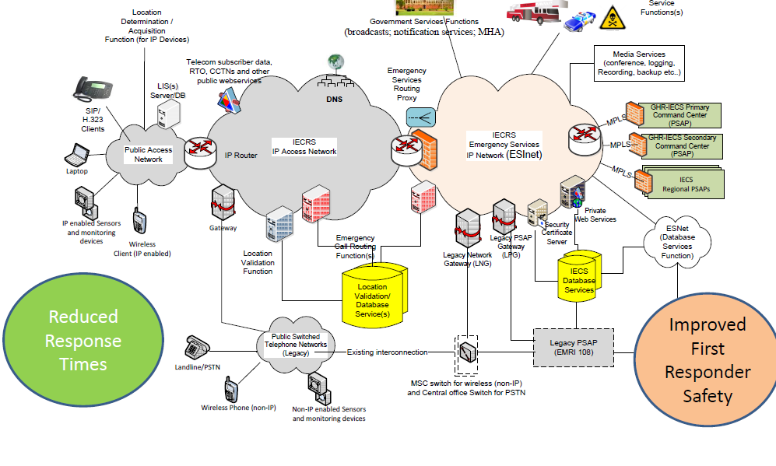
Figure 1. Initial Proposed Architecture based on i3 reference architecture for NG 911 service in USA [68]
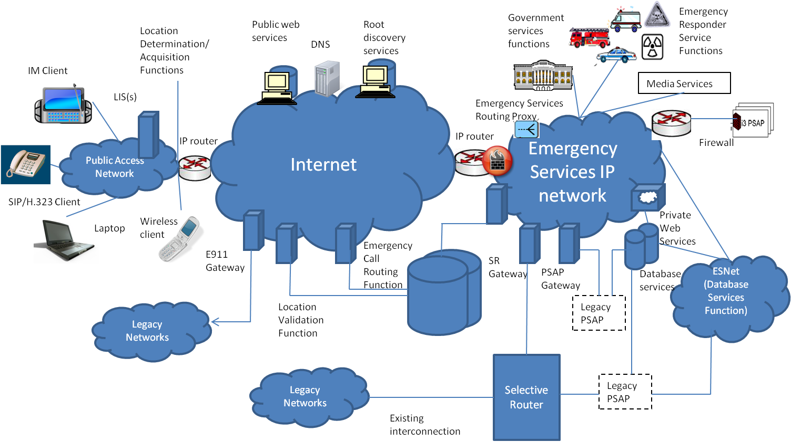
Figure 2. NENA i3 functional architecture for emergency services [1]
 | OST Recommendation on IEC | NENA i3 Technical Requirements Document | Notes
Public Access Network | - Location Determination/Acquisition Function (IP)  - LIS Server  - SIP/H.323 client, Laptop  - IP enabled sensor and monitoring devices  - Wireless Client (IP) | - Location Determination/Acquisition Function (IP)  - LIS Server  - SIP/H.323 client, IM client, Laptop  - Wireless Client (IP) | Proposed support for IP enabled sensor and monitoring devices in the OST recommendation.
IECRS IP Access Network | - Telecom Subscriber Data  - RTO, CCTNS and other public web services  - Gateway  - Location Validation  - Emergency Call Routing Function | - Public Web Services  - Root Discovery Service  - DNS, E 911 Gateway  - Location Validation  - Emergency Call Routing Function | Support to interconnect existing subscriber data, RTO and Police records in the OST recommendation
Emergency Service IP Network | - Emergency Services Routing Proxy  - Government Services Functions (Broadcasts, Notifications, MHA)  - Emergency Responder Service Functions  - Media Services (Conference, Logging, Recording, Backup etc)  - PSAP Gateway (Primary Command Center, Secondary Command Center, Regional PSAPs via MPLS)  - Legacy Network Gateway (LNG)  - Legacy PSAP Network Gateway (LPG)  - Security Certificate Server  - Private Web Services  - Emergency Call Routing Function | - Emergency Services Routing Proxy  - Government Services Function  - Emergency Responder Service Functions  - Media Services  - SR Gateway  - PSAP Gateway  - Private Web Services  - Emergency Call Routing Function | MPLS gateways to multiple PSAPs, security Certificate server in the OST recommendation within the ESI Net
Support for Legacy Networks | - PSTN and non-IP wireless phones  - MSC Switch for Wireless  - Central Office Switch for PSTN | - Legacy networks  - Selective Router | Support for MSC upgrades to support wireless circuit switched networks (GSM/CDMA)
PSAP | - GHR-IECS Primary Command Center  - GHR-IECS Secondary Command Center  - IECS Regional PSAPs, Legacy PSAP (EMRI 108) | - Legacy PSAP  - i3 PSAP | Support to interconnect hierarchical PSAPs and legacy PSAPs run by EMRI 108 service
Databases | - Location Validation/ Routing Databases  - 911 Database services  - ESNet Database service Function | - Location Validation/ Routing Databases  - IECS Database services  - ESNet Databse service Function
Table 1: Comparison of the OST proposed reference architecture for IECS with the i3 reference architecture from NENA

Since the functional architecture of the proposed IECRS system is based on the NENA i3 architecture for NG 911 services, in this section the NENA i3 architecture [70] is described in detail.

The i3 solution (Figure 2) encompasses the definition of:
- The architecture of the emergency calling system;
- External interfaces between PSAPs and public/private networks delivering 9-1-1 calls to the ESInet;
- External interfaces to systems and databases not in the PSAP that supply data and assistance in processing a call;
- External interfaces to systems that handle a call past the point where a call taker has exclusive control over it, such as the handoff to the Computer Aided Dispatch system;
- External interfaces to upper level management systems, such as disaster management systems, as well as peer PSAPs;
- Functions such as location-based routing, data creation and maintenance.

The scope of i3 architecture includes call routing and location validation functions which are used by the origination network. Origination networks can be built using a generic SIP architecture, or IMS-based SIP architecture. In the subsection 2.1.1, brief description of each of the functional elements depicted in Figure 2 of the NENA i3 architecture and terminology used in this context is provided.

Description of Functional Elements

- IP client – This term is used to refer to the IP endpoint communications equipment or application that is used to originate a voice or text request for emergency services (e.g., by calling 9-1-1). The term IP device or IP endpoint may also be used.

- Routing Proxy – A term used in SIP to describe a SIP server that receives SIP requests and forwards them on behalf of the requestor. A routing proxy determines that next hop for a SIP message and forwards the message.

- User Agent (UA) – Terminology used in the context of SIP to identify the IP device. In SIP, a UA is a network element that is capable of generating SIP requests (e.g., INVITE) and is capable of generating responses for received requests.

- Legacy PSAP – This term is used to PSAPs that are not capable of communicating with VoIP protocols or of supporting the i3-based interfaces specified as part of the i3 Solution.

- PSTN Gateway – This term is used to refer to a signaling and media interconnection point between callers in the PSTN and the i3 architecture, so that i3 PSAPs are able to receive emergency calls from the PSTN and are able to communicate with legacy PSAPs (that are not equipped with a Legacy PSAP Gateway).

- Time Division Multiplexing (TDM) Gateway – This term is used to refer to the signaling and media interconnection/interworking point between the conventional Selective Router and i3 PSAPs.

- Domain Name Server (DNS) –The DNS is used to resolve Domain Names. The input to a DNS is a domain name (e.g., gisfi.org); the response is the IP address of the domain. The DNS allows people to use easy to remember text-based addresses and the DNS translates those names into routable IP addresses.

- Web Services – Web Services identifies an industry standard protocol for exchanges of information. In the i3 architecture, this term is being used to refer public and private data services to which i3 PSAPs may desire to have access.

- Location Determination Functions – Location determination includes the functions to accurately and automatically (without input from the user) determine the position estimate of the IP endpoint device and associate that location information uniquely with that device.

- Location Acquisition Functions: Location acquisition refers to the functions necessary to make that location information available to the device on request, or in the case of devices that are not location-aware, to make that location information available to a Proxy acting on behalf of that device so that the location information can be used for emergency calling.

- Location Information Server (LIS) – The LIS stores the relationship between a unique identifier for a physical endpoint termination and a location, described as either geo-coordinates or a civic address). The administrator/owner of the LIS is responsible for creating and maintaining this relationship, and for ensuring that civic location data is pre-validated by a Validation Function. The LIS may be used during location determination and acquisition. The LIS may also support assignment of a location query key to a particular IP device, and download of this key to the IP device to support subsequent queries for the location from other elements in the IP domain.

- Validation Function (VF) – The VF is used to validate civic location objects against the next generation of the Master Street Address Guide (MSAG). Pre-validation of the civic location information ensures that the calls can be routed to the appropriate PSAP and that emergency services can be dispatched to the correct location.

- Emergency Call Routing Function (ECRF) – The ECRF receives location information (either civic address or geo-coordinates) as input and uses this information to provide a Uniform Resource Identifier (URI) that can be used to route an emergency call toward the appropriate PSAP for the caller’s location. Depending on the identity and credentials of the entity requesting the routing information, the response may identify the PSAP, or an Emergency Services Routing Proxy that acts on behalf of the PSAP to provide final routing to the PSAP itself. The same database that is used to route a call to the correct PSAP may also be used to subsequently route the call to the correct responder, e.g., to support selective transfer capabilities.

- Root Discovery Function – The i3 databases are distributed. The Root Discovery Function is used by entities to discover the appropriate Location Validation Function or Emergency Call Routing Function for a given location.

- Emergency Services Routing Proxy (ESRP) – This ESRP is a routing proxy that may act on behalf of a group of PSAPs, to provide final routing to the PSAP, based on the caller’s location.

- Emergency Services IP Network – This term is used to refer to a private IP network or IP Virtual Private Network (VPN) that is used for communications between PSAPs and among other entities that support or are supported by PSAPs in providing emergency call handling and response.

- Public Safety Answering Point (PSAP) – The i3 PSAP is a PSAP that is capable of receiving IP-based signaling for delivery of emergency calls and for originating calls. The internal functions are not being specified in the i3 requirements, but the i3 PSAP is expected to be able to use SIP signaling for calls and IP-based data protocols for exchange of other information.

- Legacy PSAP Gateway – This term is used to refer to the protocol and media interworking functions necessary to allow a Legacy PSAP to interface with i3 PSAPs and other entities on the Emergency Services IP network.

- Responder Services Functions – This term is used to refer to the agencies that provide emergency response in conforming i3 implementations, e.g., Police, Fire, Emergency Medical Service, Poison Control, HazMat (hazardous materials response teams), Coast Guard, etc.

- Database/Media Service Functions – This term is used to refer to the Databases and Database Access Services that provide information requested by PSAPs and other entities on the Emergency Services IP network in support of emergency services handling. Media Service functions might include such things as conference bridge resources, or logging recording services.

- Government Services Functions – This term is used to refer to government services that might be involved in emergency call handling or escalation. Examples might include: escalation of emergency incidents that require coordination among multiple government agencies, beyond PSAPs; broadcasts; notification services; Homeland Security.

- An Emergency Services IP Network (ESInet) is a unique instance of a communications network dedicated for public safety use. An ESInet delivers emergency requests and corresponding data to emergency services providers and facilitates communication between emergency service providers and other supporting entities. An ESInet is typically deployed to support a set of PSAPs and other public safety agencies on a geographic basis. A given PSAP, or other appropriate entity, may connect to one or more ESInets. ESInets may be interconnected to facilitate emergency event handling and other related interactions.

- Back to Back User Agent (B2BUA) – This is a logical entity that receives a request and processes it as a user agent server (UAS). In order to determine how the request should be answered, it acts as a user agent client (UAC) and generates requests. Unlike a proxy server it maintains dialog state and must participate in all requests sent on the dialogs it established.

- Border Control Function (BCF) – The BCF provides a secure entry into the ESInet for emergency calls presented to the network. The BCF incorporates firewall, admission control, and may include anchoring of session and media as well as other security mechanisms to prevent deliberate or malicious attacks on PSAPs or other entities connected to the ESInet.

- Policy-based Routing Function (PRF) – This functional element applies techniques to determine alternate routing addresses based on policy information associated with the destination PSAP. The PRF uses its state knowledge, such as PSAP registration state or time of day and the policy for a PSAP to make a route determination. The PRF resides in the terminating ESInet.

- Originating ESInet – The originating ESInet is the first emergency services network in the call flow. Originating networks (those initiating 9-1-1 calls) deliver their emergency calls to this network. An originating ESInet will make routing decisions and forward the emergency call to another ESInet for routing to the PSAP.

- Intermediate ESInet – The intermediate ESInet is a network that may exist between the originating and terminating ESInets. An Intermediate ESInet receives a call from an originating ESInet (or another intermediate ESInet) and forwards the call to another intermediate ESInet or the terminating ESInet.

- Terminating ESInet – A terminating ESInet does the final routing to the PSAP. If there is only one ESInet in the call flow then the terminating ESInet has the role of originating ESInet as well.

2.1.1.1 Terminology used in the context of NG 911

Agency: An organization that is a client of a database or service.

Agent: A person employed by or contracted by an agency.

Call: A single communication to a PSAP that results in a defined action by a call taker. A call does not have to be a literal phone call. It could be an Instant Message, a SMS text message, an Automatic Crash Alert, etc. The life cycle of a call includes: call origination, call abandonment or completion, call duration, call clearing, and post-call processing of indefinite duration.

Incident: A defined public safety event that incurs a response within the domain of a PSAP. Examples include a traffic accident (including subsequent secondary crashes), a hazardous material spill, etc. Multiple Calls may be associated with an Incident. An Incident may include other Incidents in a hierarchical fashion. The life cycle of an Incident includes: Incident declaration, Incident processing, Incident clearing and post-incident processing of indefinite duration.

Call Identifier: An identifier assigned by the first element in the first ESInet which handles a call. The form of a Call Identifier is a Globally Unique Identifier (GUID). Call Identifiers are globally unique.

Incident Identifier: An identifier assigned by the first PSAP which declares an incident. The form of an Incident Identifier is a URI GUID. Incident Identifiers are globally unique.

Call Architecture
A Location Acquisition Function is used in the access network to obtain the location of a caller, which is retrieved on demand from a LIS. Locations in civic address form are validated prior to being stored in the LIS by the Location Validation Function. A 9-1-1 call includes location information with the call. A carrier, enterprise or other call presenter uses the location (included with the call) with the ECRF to determine a URI to route to. Calls are presented by the origination network to the ESInet, possibly through a BCF, either directly to a PSAP or to an ESRP.

Within the ESInet, the ESRP, if used, will (logically) use the same ECRF to further onward route the call. If the ESInet is hierarchical in nature, an ESRP instance may be used at each level of the hierarchy. The call would then traverse multiple ESRPs from the access network to the PSAP. The final proxy is a PSAP proxy, which forwards the call to one of its User Agents. The PSAP may use ECRF to determine the proper responders.

Relationship of NENA i3 to IETF Standards
The NENA i3 system boundary is at the ESInet. Callers will be presented to this network by carriers, enterprises or other entities following many of the Internet Engineering Task Force (IETF) protocol standards. The overall description of the IETF approach to emergency calls is detailed in Framework for Emergency Calling in Internet Multimedia [4]. The specific recommendations for telephones and proxy servers (carrier softswitches) are detailed in Best Current Practice for Communications Services in support of Emergency Calling [59].

The IETF standards based solution delivers location information to the endpoint (the “phone”) or have available a reference to the location. The endpoint is, directly or indirectly, a subscriber to the access infrastructure provider (AIP) and it is, directly or indirectly, a subscriber to the communication service provider (CSP). The AIP tells the endpoint where it is, the endpoint tells the CSP where it is. The CSP can then route the call based on the location. The subsection 2.1.4 outlines the applicable IETF standards for transfer of location information and its usage thereafter by the i3 network architecture.

Location Information
NENA Technical Requirements Document for Location Information to Support IP-Based Emergency Services [62] outlines NENA’s generic technical requirements that should be accounted for by standard bodies involved in IP Location. Also, NENA Recommended Method(s) for Location Determination to Support IP-Based Emergency Services - Technical Information Document [63] specifically addresses the residential broadband access network topologies in relation to IP Location.

IETF standards define the following mechanisms:
- Representation of Location-by-Value;
- Representation of Location-by-Reference;
- Acquisition of Location Information by the endpoint from a Server (this is called a “Location Configuration Protocol” (LCP);
- Communication of Location Information to downstream elements;
- Exchange of Location-by-Reference with Location-by-Value by a LIS.

The i3 location architecture is based on the following IETF standards:
- Geopriv requirements [5]
- A Presence-based GEOPRIV Location Object Format [6], with an update to the document [64]
- Dynamic Host Configuration Protocol Option for Coordinate-based Location Configuration Information [7]
- Dynamic Host Configuration Protocol (DHCPv4 and DHCPv6) Option for Civic Addresses Configuration Information [8] and an update [65]
- HTTP Enabled Location Delivery (HELD) [9]
- Session Initiation Protocol Location Conveyance [10]

2.1.4.1 Location-by-Value (LbyV)

Location-by-Value is defined as location information readily consumable by the recipient of the location without transformation. It is formatted in a Presence Information Data Format Location Object (PIDF-LO) document as per RFC-4119 and following the recommendations of the PIDF-LO profile Internet draft [64]. The location can be expressed in a civic form as per the Revised Civic LO Internet Draft [65] or in a geodetic form as per RFC4119 as modified by [64].

2.1.4.2 Location-by-Reference (LbyR)

Location-by-Reference is defined as a URI that, when de-referenced in the correct manner by an authenticated and authorized entity, will yield the location value of the endpoint. The construction of the user part of the Location-by-Reference URI should follow strict privacy and confidentiality rules so the identity and/or the location of the target cannot be derived from the identifier by an unauthorized party. The IETF Internet Draft describing LbyR requirements [66] provides guidance as to how to construct a valid location URI for Location-by-Reference.

A successful de-reference of the identifier will result in providing a Location-by-Value to the requester. De-reference mechanisms are currently being defined within the IETF, one using SIP [31] and one using HELD [67].

The i3 call signaling architecture is based on the following IETF standards, a summary of which can be found in [11]:
- SIP: Session Initiation Protocol [12]
- RTP: A Transport Protocol for Real-Time Applications [13]
- SDP: Session Description Protocol [14]
- SIP: Locating SIP Servers [15]
- An Offer/Answer Model with the Session Description Protocol (SDP) [16]
- SIP-Specific Event Notification [17]
- The Session Initiation Protocol UPDATE Method [18]
- A Privacy Mechanism for the Session Initiation Protocol (SIP) [19]
- Private Extensions to the Session Initiation Protocol (SIP) for Asserted Identity within Trusted Networks [20]
- Session Initiation Protocol Extension for Instant Messaging [21]
- The Reason Header Field for the Session Initiation Protocol (SIP) [22]
- The Session Initiation Protocol (SIP) Refer Method [23]
- Grouping of Media Lines in the Session Description Protocol (SDP) (RFC3388) [24]
- An Extension to the Session Initiation Protocol (SIP) for Symmetric Response Routing [25]
- Real Time Control Protocol (RTCP) attribute in Session Description Protocol (SDP) [26]
- Control of Service Context using SIP Request-URI [27]
- Connected Identity in the Session Initiation Protocol (SIP) [28]
- Indicating User Agent Capabilities in the Session Initiation Protocol (SIP) [29]
- Caller Preferences for the Session Initiation Protocol (SIP) [30]
- Early Media and Ringing Tone Generation in the Session Initiation Protocol (SIP), G. Camarillo, H. Schulzrinne, Internet Engineering Task Force [31]
- A Watcher Information Event Template-Package for the Session Initiation Protocol (SIP) [32]
- The Session Initiation Protocol (SIP) "Replaces" Header [32]
- The Session Initiation Protocol (SIP) Referred-By Mechanism [33]
- The SIP Referred-By Mechanism [34]
- Best Current Practices for Third Party Call Control in the Session Initiation Protocol [35]
- Using E.164 numbers with the Session Initiation Protocol (SIP) [36]
- Early Media and Ringing Tone Generation in the Session Initiation Protocol (SIP) [37]
- Presence Information Data Format (PIDF) [38]
- Session Timers in the Session Initiation Protocol (SIP) [39]
- Internet Media Type message/sipfrag [40]
- The Session Initiation Protocol (SIP) "Join" Header [41]
- Transcoding Services Invocation in the Session Initiation Protocol (SIP) Using Third Party Call Control (3pcc) [42]
- Basic Network Media Services with SIP [43]
- An Extension to the Session Initiation Protocol (SIP) for Request History Information (RFC4244) [44]
- Actions Addressing Identified Issues with the Session Initiation Protocol's (SIP) Non-INVITE Transaction ( [44]
- Actions Addressing Identified Issues with the Session Initiation Protocol's (SIP) Non-INVITE Transaction [45]
- Extending the Session Initiation Protocol (SIP) Reason Header for Preemption Events [46]
- Communications Resource Priority for the Session Initiation Protocol (SIP) ( [47]
- Suppression of Session Initiation Protocol (SIP) REFER Method Implicit Subscription [48]
- Conveying Feature Tags with the Session Initiation Protocol (SIP) REFER Method [49]
- Addressing an Amplification Vulnerability in Session Initiation Protocol (SIP) Forking Proxies [50]
- Session Initiation Protocol Call Control - Conferencing for User Agents [51]
- Obtaining and Using Globally Routable User Agent (UA) URIs (GRUU) in the Session Initiation Protocol (SIP) [53]
- Managing Client Initiated Connections in the Session Initiation Protocol (SIP) [54]
- SDP: Session Description Protocol [55]
- Session Initiation Protocol Package for Voice Quality Reporting Event [56]
- Interactive Connectivity Establishment (ICE): A Methodology for Network Address Translator (NAT) Traversal for Offer/Answer Protocols [57]
- A Uniform Resource Name (URN) for Services [58]

Routing of IP-based Emergency Calls in a generic IETF SIP originating network
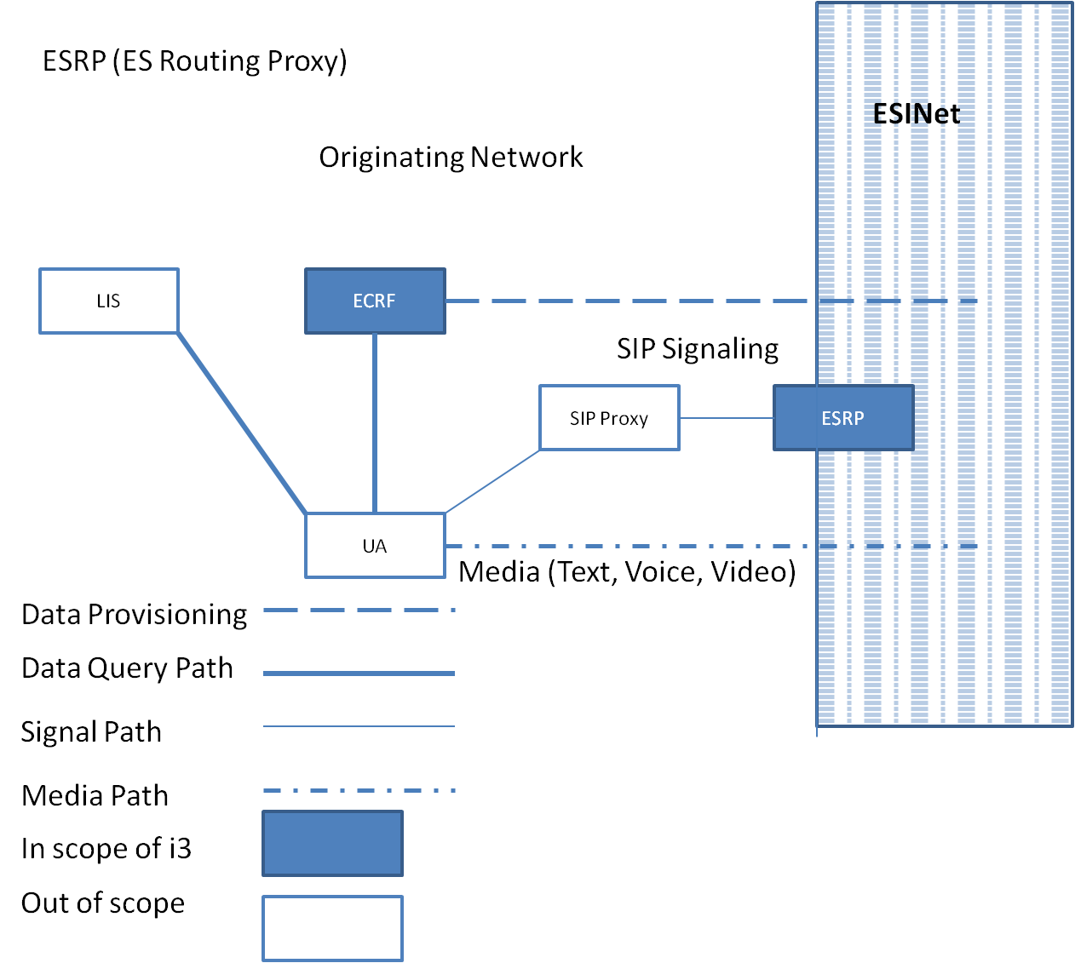
Figure 3. Generic SIP Edge-based Call Routing Architecture – Origination Network Example

Emergency Context Resolution with Internet Technologies – ECRIT defines a database query (“mapping”) where location information and a Service URN is sent in the query and a URL of where to deliver the call is returned. In i3, this is called an Emergency Call Routing Function (ECRF). The call would then be routed using normal SIP (or other protocols supported) to the indicated destination. The protocol defined by the IETF that provides the mapping is called Location to Service Translation (LoST) [61].
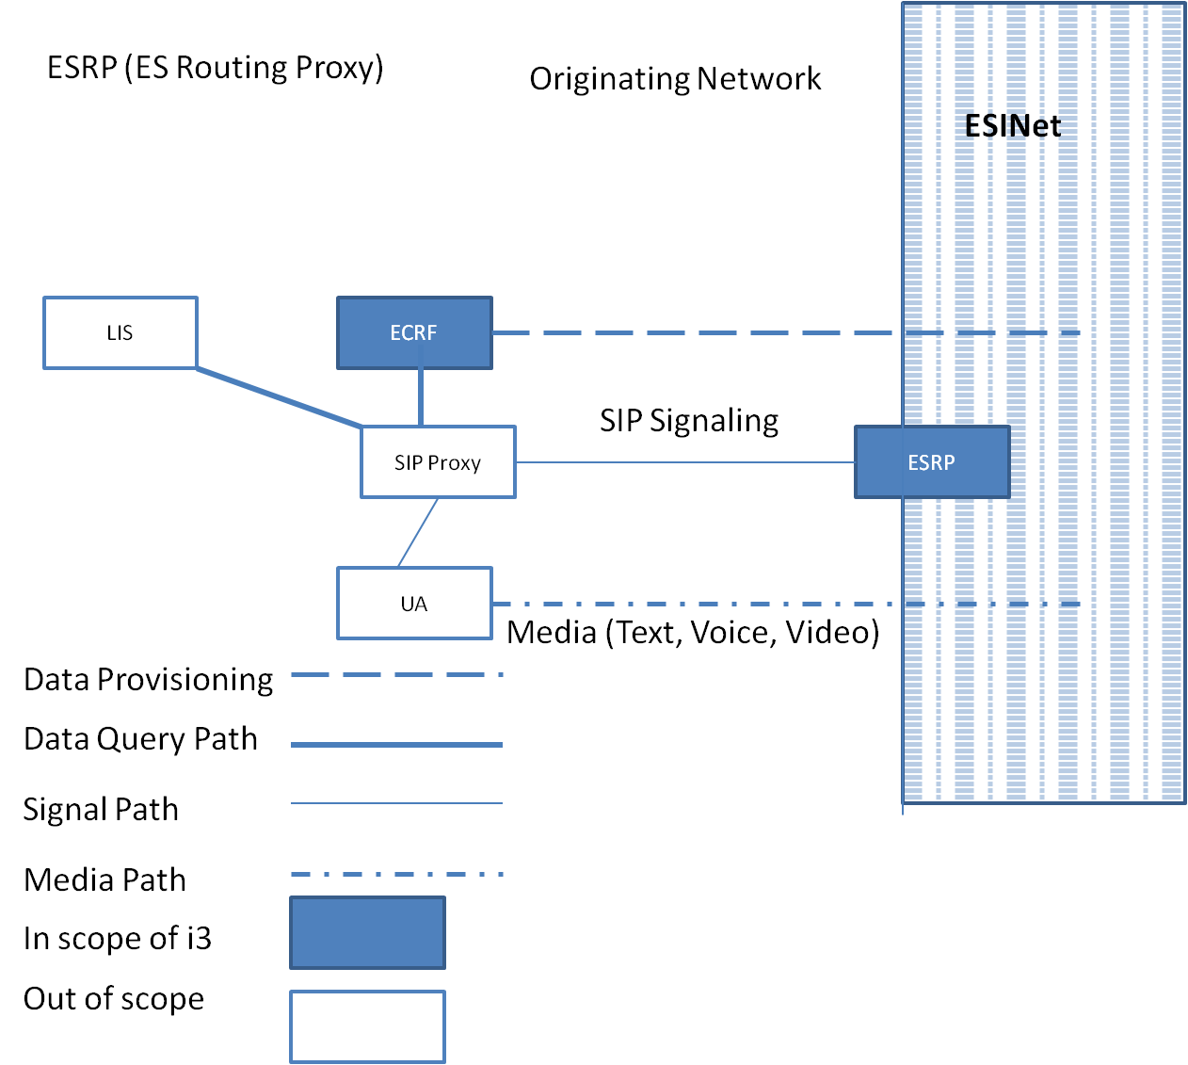
Figure 4. Generic SIP Proxy based call routing architecture – Originating Network Example

Calls will be routed to an ESRP due to the route taken as a result of ECRF mapping. This element, which might be operated on behalf of, for example, a state agency, would take all calls for that state, and make another routing decision to send them to the appropriate PSAP. The reason for deploying an ESRP is to position robust firewalls and other protective devices (such as the BCF), with large amounts of IP bandwidth between the sources of calls and the PSAP. This provides an outer defensive perimeter for malicious calls or Denial of Service attacks against the PSAP. i3 envisions that the same ECRF, using LoST as the interface protocol will be able to be queried by the ESRP to determine how to onward route to the PSAP.

Similarly, the ECRF mechanism may be used by the PSAP to determine how to route a call to the correct responder. The ECRF will allow civic and geo boundaries for PSAPs (and ESRPs) as well as any number of responders to be stored. This allows any PSAP to route a call to any responder based on the location of the caller. This mechanism directly encodes service boundaries.

Generic SIP as an Emergency Services IP Network
The ESRP is a normal SIP proxy server with additional functionality. The ECRF and LVF use the LoST protocol. The call taker in a PSAP has a UA that terminates calls (User Agent Server according to RFC3261).

2.1.6.1 Simple ESInet
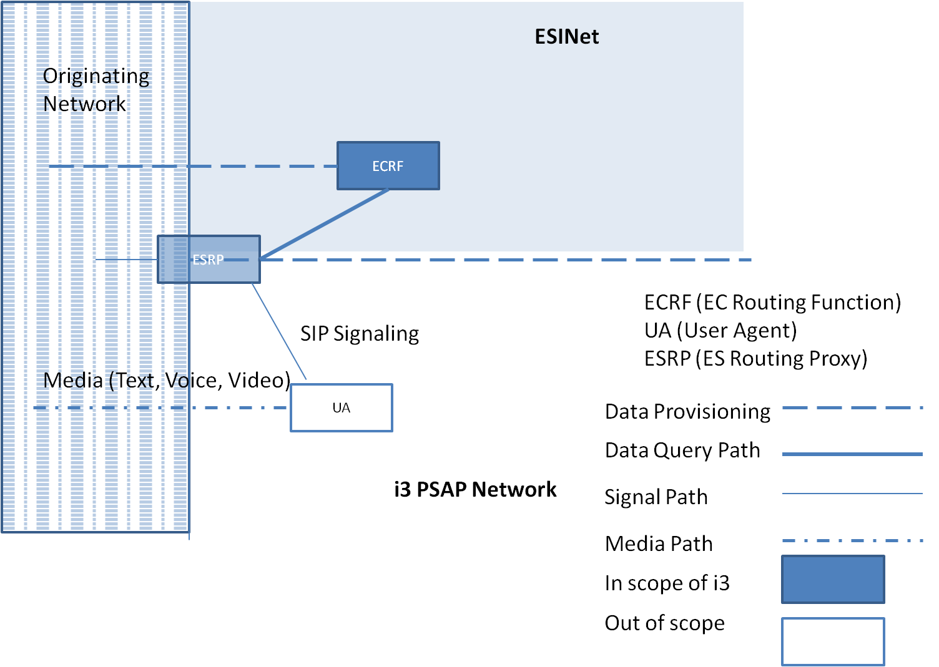
Figure 5. Generic SIP ESINet Architecture – Single ESRP Example shown

In this simple architecture (Figure. 5), a single ESRP and ECRF component are involved to process the call to the appropriate User Agent. The call may go through a series of transactions between the ESRP, ECRF and UA in order to reach the final destination UA within the ESInet.

2.1.6.2 Multiple ESRPs in ESInet Architecture

Typically, the PSAP would have an ESRP of its own at the entrance to its Local Area Network (LAN). The ESRP at the ESInet edge would route to the PSAP ESRP which would route to the call taker (Figure. 6). The ESRP at the edge of the ESInet might be operated at the state level. In some areas, the local operator of the ESInet may be at a county or region level, and it may choose to run an ESRP. The state ESRP routes to the county/regional intermediate ESRP, which routes to the PSAP ESRP. Each of the ESRPs has access to the ECRF, and has a PRF that together guide the selection of the next hop. In this case, each ESRP will invoke the ECRF for determining the next hop until it resolves to the destination UA.
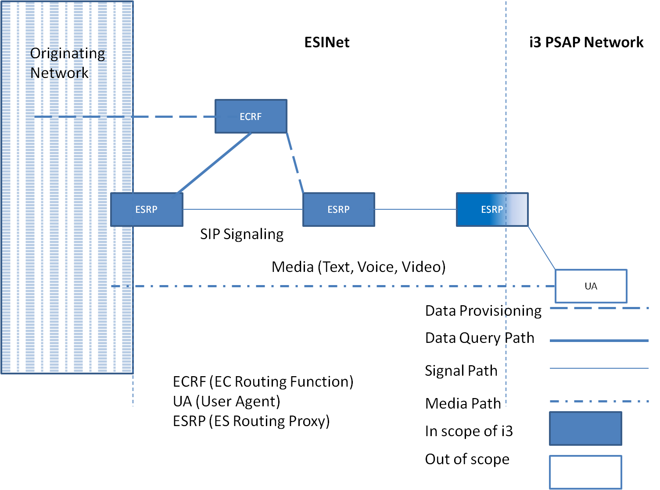
Figure 6. Generic SIP ESINet Architecture-Multiple ESRPs example

2.1.6.3 Internal ESRP functions
A representative view of general functions that an ESRP must include is shown in the following Figure 7.
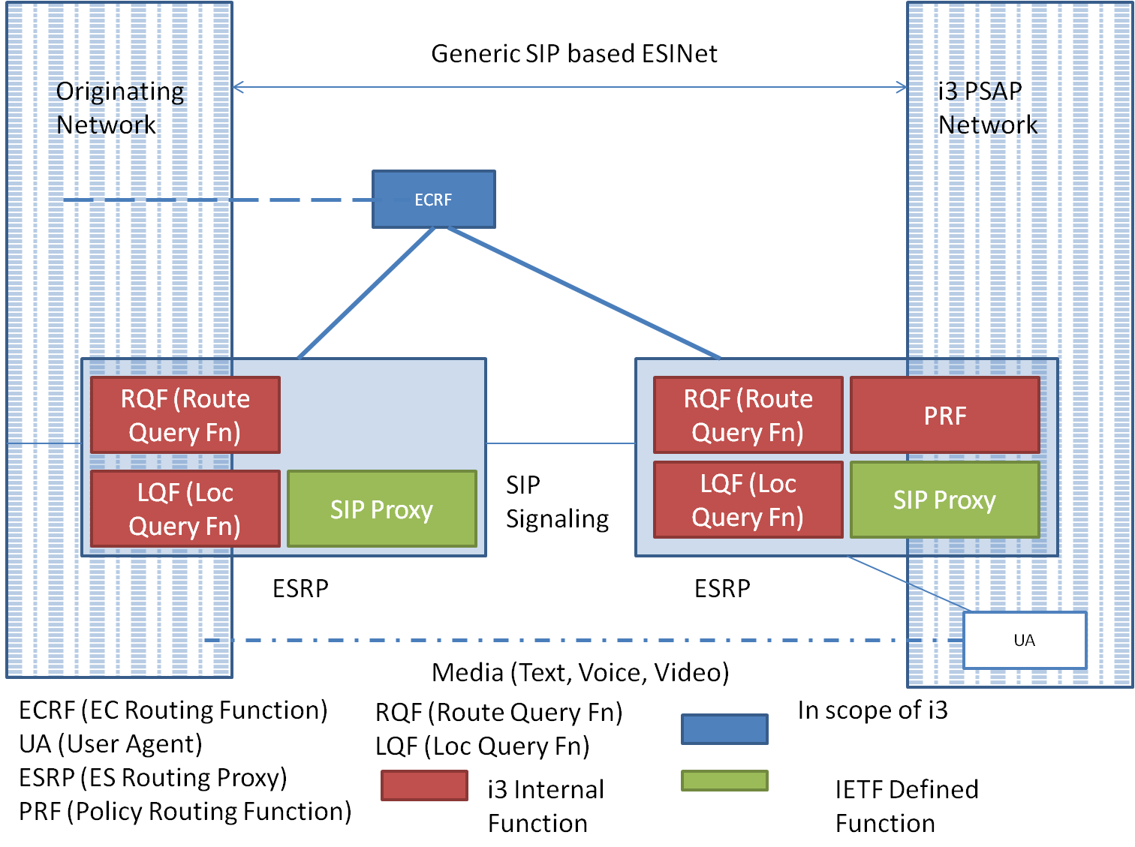
Figure 7. Generic SIP ESInet architecute- Detailed ESRP Functional View

Emergency Service Routing Proxy – By definition, an ESRP is fundamentally a SIP Proxy, but with some added features required for the receipt, querying, and egress handling of an emergency call. The SIP Proxy part of the ESRP function is expected to behave as per RFC 3261 [12].

Location Query Function (LQF) – Uses a dereferencing protocol (SIP or HTTP) to exchange a location reference (LbyR) for location information (LbyV).

Routing Query Function (RQF) – Uses the LoST protocol to find a tentative list of next hops given the location information.

Policy Routing Function (PRF) – Uses the policy of the destination PSAP, PSAP state, congestion state, time of day, etc to determine choose one of the next hops that will receive the call.

End to End generic SIP emergency call architecture
The following Figure 8 shows an end-to-end functional architecture based on a generic SIP solution.
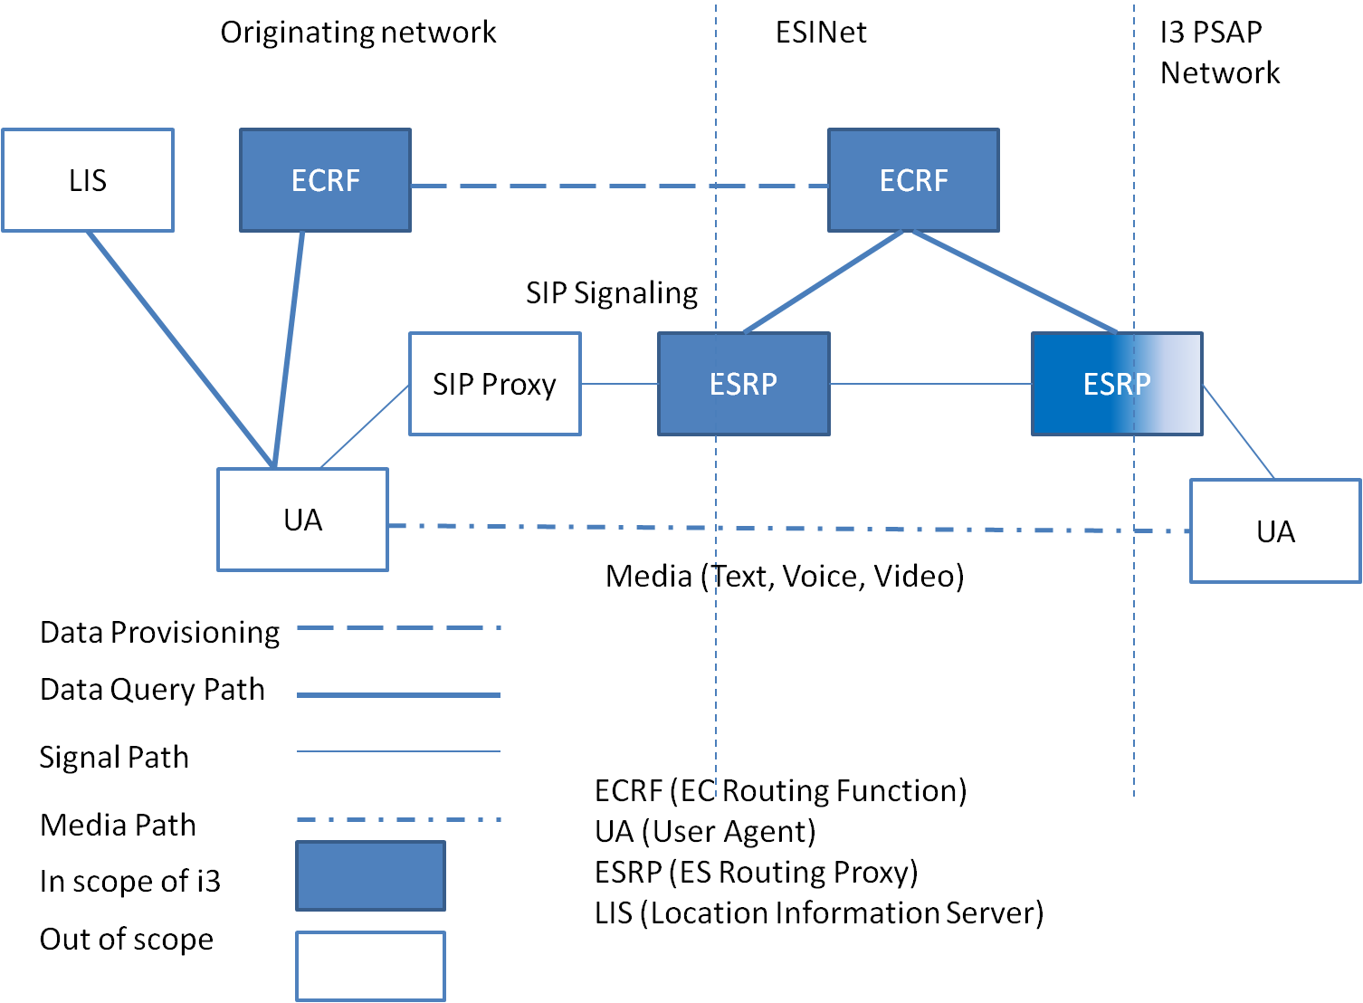
Figure 8. Generic SIP ESInet Architecture- End to End Example

A user agent will use a Location Acquisition Protocol to access a LIS for location information. The user agent queries the ECRF using LoST to obtain a PSAP/ESRP URI, the local dial string for that location (e.g. 9-1-1) and a confirmation that the location provided by the LIS is valid.

A high level call flow within this functional architecture is as follows:
1. The calling UA requests its location information from the LIS;
2. The calling UA requests routing and dial string/service URNs information based on the provided location from the designated ECRF within the Origination Network;
3. The calling UA recognizes the dial string in the dialed digits as an emergency call;
4. The calling UA requests current location from the LIS, and re-queries the ECRF using the updated location to get new routing information.
5. The calling UA attaches location and service URN to the signaling message and forwards the call to the designated SIP Proxy;
6. The Origination Network SIP Proxy forwards the call to the designated ESRP;
7. The near-end ESRP uses the provided location and service URN to request further refined routing and services information within the ESInet through the ESInet’s ECRF ;
8. The near-end ESRP forwards the call to the far-end ESRP as per ECRF directives;
9. Far-end ESRP requests final routing and services information from the ECRF and forwards the call to the terminating UA (an i3 PSAP, Responder, Government or any other supported service);
10. Media is established between originating and terminating UAs. The call is processed.

Legacy Gateway Architectures -- Examples in i3
Though i3 is commonly defined as IP end-to-end, it is understood that there will continue to be a percentage of wireline and wireless (circuit switched) originating networks deployed after emergency service networks and PSAPs have evolved to support the i3 Solution. Since any i3 PSAP will need to be able to receive emergency calls which originate on these legacy networks, there is an acknowledgement that gateways will be required.

2.1.8.1 Legacy Wireline Origination Network
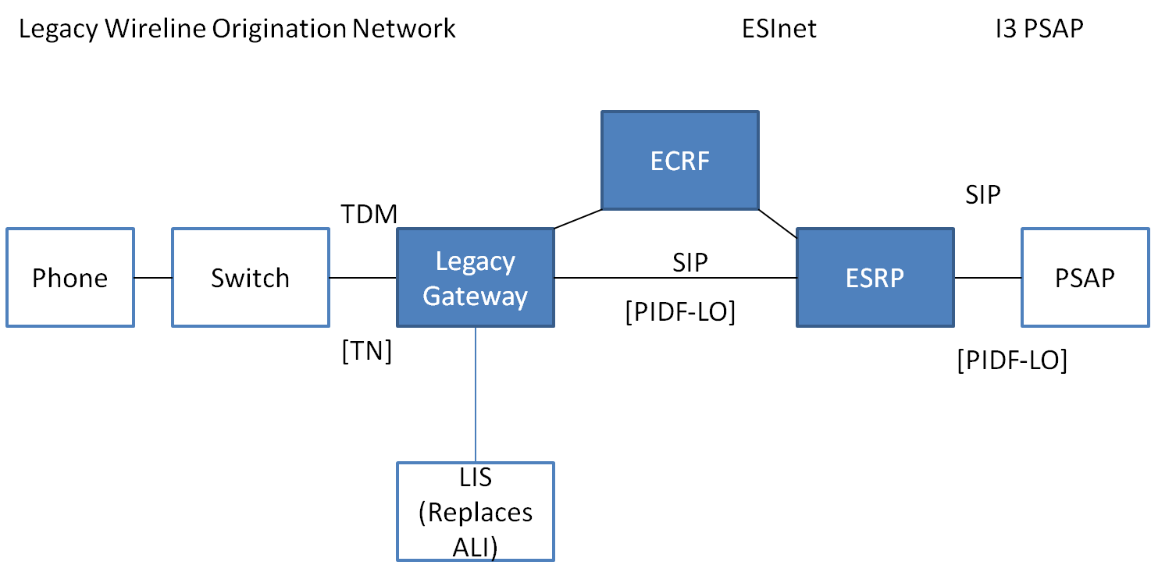
Figure 9. Example legacy wireless origination network to ESInet (LbyV)

In this case, all calls (including legacy wireline originated calls) are routed (using the LoST mechanism), and arrive as IP with location and caller information (e.g., callback number) in the signaling (Figure. 9). This means there is a legacy gateway with a PSTN interface towards the origination network, and an IP interface towards the ESInet. Logically, the legacy gateway resides between the origination network and the ESInet. The PSTN side has trunk interfaces equivalent to a selective router, commonly SS7, but allowing Centralized Automatic Message Accounting (CAMA)/ Integrated Services Digital Network (ISDN). Unlike an IP origination, the legacy wireline signaling will not have location information attached in PIDF-LO form. The legacy gateway must obtain the location information based on the calling number/ANI it receives with the call. To support legacy wireline origination, a LIS will logically replace the ALI database. The LIS will store location information keyed by TN and provide a PIDF-LO to the gateway. The relationship between the gateway and LIS is static and provisioning will be used to introduce the LIS to the gateway.

The legacy gateway takes the location it obtains from the LIS, submits it to the ECRF via LoST and obtains an ESRP URI to route the call onward. Again, the relationship between the legacy gateway and the ECRF is provisioned. The legacy gateway inserts the PIDF-LO into the SIP signaling, along with the ESRP URI and routes the call as it would for any IP origination. The signaling will also include caller information in the From: and/or P-Asserted-Identity headers. While location by value is preferred, the LIS may return a location reference, which would be used in an analogous way as a location reference would be used in IP origination networks. The gateway would dereference to obtain a location value, use that value to query the ECRF, and pass the reference in the SIP signaling towards the ESRP.
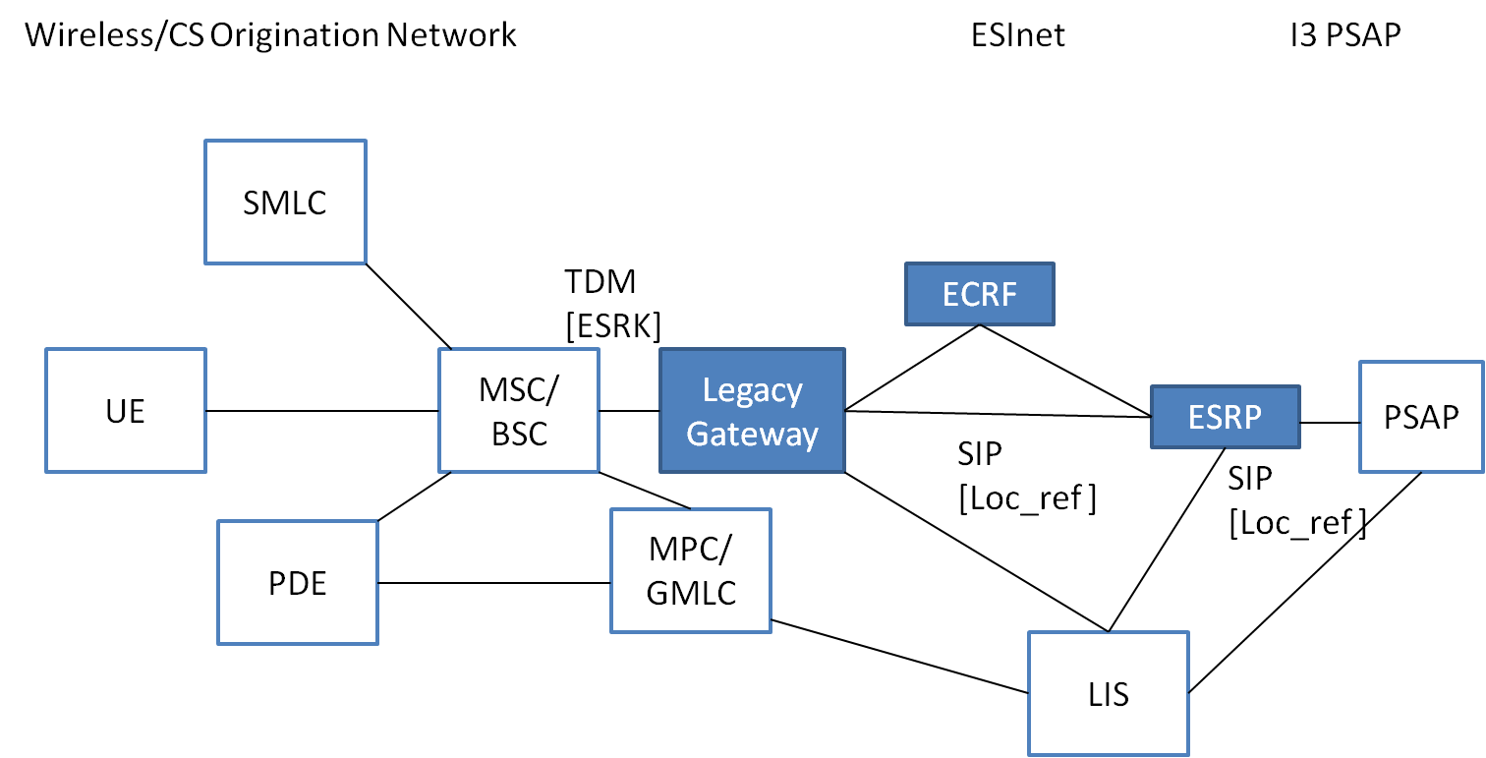
Figure 10. Example Wireless/CS Origination Network to ESINet (LbyR)

In case of legacy wireless/CS call origination, the legacy gateway takes the location it obtains from the LIS, submits it to the ECRF via LoST and obtains an ESRP URI to route the call onward (Figure. 10). Again, the relationship between the legacy gateway and the ECRF is provisioned. The LIS is responsible for determining if the wireless/CS network is Phase II capable. If it is, the location returned by the LIS may be just a reference, which the gateway must dereference to obtain a value it can use to query the ECRF; it may include the value as well as the reference. The dereferencing function is expected to involve interaction with elements in the legacy wireless network (e.g., MPC/GMLC) where Phase II location information is maintained. The reference will be added to the SIP signaling. The gateway routes the call as it would with any IP origination. The signaling would include callback number in the From: and/or P-Asserted-Identity headers. ESRPs that are traversed by the call must repeat the dereferencing process, using the resulting location value to query the ECRF. They will then route the call forward. The PSAP must also perform dereferencing and final routing, potentially involving an interaction with the ECRF. If the LIS determines that the origination network is Phase I capable only, then it will return a location value, which will be used to query the ECRF and placed in the SIP signaling. This location value (formatted as civic location information in a PIDF-LO) will be included in outgoing SIP signaling, and will be used by ESRPs in the call path to interact with the ECRF to determine subsequent routing for the call. The location value will also be delivered to the PSAP with the call, along with callback number.

Description of Call Flow
2.1.9.1 Basic 9-1-1 call
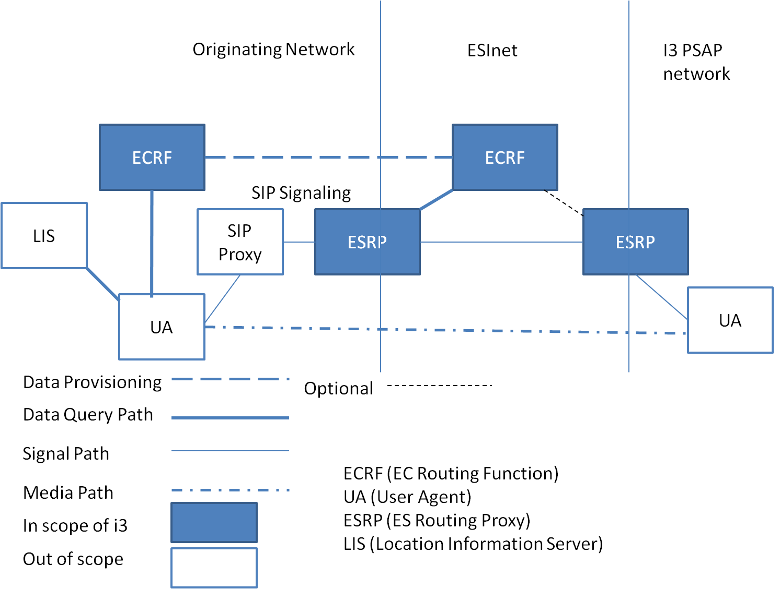
Figure 11. Generic SIP call architecture
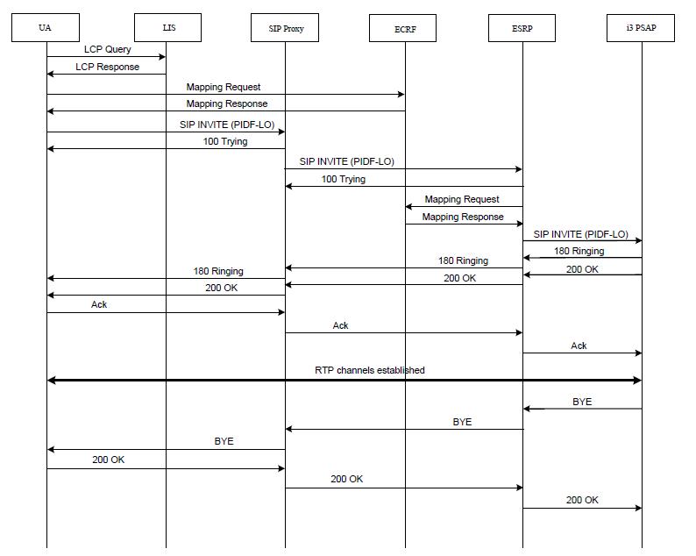
Figure 12. Generic SIP emergency call flow between UA and PSAP

The procedures for initiating a 9-1-1 call at a user agent and processing the call at the carrier, enterprise or other entity is defined in [59]. Following these procedures will result in an ECRF authoritative for the location of the caller providing a URI which ultimately routes to the proper PSAP. The i3 solution provides for one or more intermediary proxies (ESRPs) between the call origination emergency call routing element and the final ESRP. These proxies use the location of the caller, and (logically) the same ECRF to further route the call. This is accomplished by provisioning the ECRF to provide routing information to requestors based on the identity used for authentication of the requestor to the ECRF. A carrier, enterprise or unknown query for most services would receive a URI which routes to the (top level or entry) ESRP corresponding to the location presented. The ESRP, which would make the SAME query (same location, same service) would receive a more precise route, which may be repeated if there is more than one level of ESRP and the final ESRP would receive the URI of the PSAP. In this manner, the ECRF returns different results for the same query depending on the identity of the element making the request. Calls are presented to the first ESRP through a Border Control Function (BCF). The BCF provides front-line defense against deliberate attack on the Emergency Services IP Network. The PSAP would have a BCF between it and the ESInet; although the network is managed, it should not be assumed secure.
The PSAP receives the call, with the location information attached, from an ESRP. The PSAP proxy server may route the call to an available call taker. It may be necessary for the PSAP to transfer the call to a secondary PSAP (or PSAPs) for dispatch of responders based on the location of the caller. The PSAP may use (logically) the same ECRF, but possibly a different service request, and, because it is authenticated to the ECRF as a PSAP, it will receive the URI of the secondary PSAP appropriate for the service requested. In this context “service” is the service request in the LoST protocol. The ECRF provides routing from the carrier to the ESRP, from one level of ESRP to another, from the lowest level ESRP to the PSAP and from the PSAP to the dispatcher(s). The LoST protocol uses location + service as input, and provides URI(s) output, and the i3 architecture makes use of this function for all routing.

Gap analysis based on survey of the NENA standards
The current reference architecture (Fig. 1) is based on NENA i3 architecture (Fig. 2). It is found that this architecture may not be suitable for adaptation to Indian network conditions in the present form. Some of the reasons are as follows:
a. IECRS IP access network architecture needs to be defined. Since there is no currently deployed emergency / disaster relief and recovery network in India, the architecture and performance features of this national backbone network needs to be defined.
b. Location Information Server (LIS) – The LIS stores the relationship between a unique identifier for a physical endpoint termination and a location, described as either geo-coordinates or a civic address. The NENA standards recommend IETF protocols to query this element to obtain location details, which is assumed to be obtained from the applicable access network. The challenge in India is that most of the deployed cellular networks are based on circuit switched technologies like GSM and CDMA. In such networks, the Gateway Mobile Location Center (GMLC) would be the node that can obtain location information of any UE. Therefore, for the current reference architecture to be adapted, either an appropriate protocol to map the requested information between IETF and cellular network positioning protocol would be necessary. Otherwise the location determining function within the emergency network needs to be redesigned. Secondly support for self positioning technologies on the user equipment such as GPS is not mandatory in India currently and hence the UE will not be in a position to communicate its location along with the emergency request call.
c. An ESInet delivers emergency requests and corresponding data to emergency services providers and facilitates communication between emergency service providers and other supporting entities. An ESInet is typically deployed to support a set of PSAPs and other public safety agencies on a geographic basis. A given PSAP, or other appropriate entity, may connect to one or more ESInets. Since emergency responders are a state subject in India, every state might need a different ESInet. A hierarchical ESInet architecture may be needed to support all the requirements of stakeholders.

Proposal
We propose the GISFI members, to discuss and approve this input document for inclusion in the TR on Emergency Telecommunication Services.

References:
[URLs last accessed on 1 March 2013]

[1] i3 Technical Requirements Document, National Emergency Number Association, NENA 08-751
[2] NENA Master Glossary of 9-1-1 Terminology, National Emergency Number Association, NENA 00-001
[3] Interim VoIP Architecture for Enhanced 9-1-1 Services (i2), National Emergency Number Association, NENA 08-001
[4] Framework for Emergency Calling in Internet Multimedia, B. Rosen, J. Polk, H. Schulzrinne, A. Newton, Internet Engineering Task Force, draft-ietf-ecrit-framework
[5] Geopriv Requirements, J.Cueller et. Al, Internet Engineering Task Force, RFC 3693
[6] A Presence-based GEOPRIV Location Object Format, J. Peterson, Internet Engineering Task Force, RFC 4119
[7] Dynamic Host Configuration Protocol Option for Coordinate-based Location Configuration Information, J. Polk, J. Schnizlein, M. Linsner, Internet Engineering Task Force, RFC 3825
[8] Dynamic Host Configuration Protocol (DHCPv4 and DHCPv6) Option for Civic Addresses Configuration Information, H. Schulzrinne, Internet Engineering Task Force, RFC 4776
[9] HTTP Enabled Location Delivery (HELD) M. Barnes, ed., Internet Engineering Task Force, draft-ietf-geopriv-http-location-delivery
[10] Session Initiation Protocol Location Conveyance, J. Polk, B. Rosen, Internet Engineering Task Force, draft-ietf-sip-location-conveyance
[11] A Hitchhikers Guide to the Session Initiation Protocol (SIP), J. Rosenberg, Internet Engineering Task Force, draft-ietf-sip-hitchhikers-guide
[12] Session Initiation Protocol, J, Rosenberg et. al., Internet Engineering Task Force, RFC 3261
[13] RTP: A Transport Protocol for Real-Time Applications, H. Schulzrinne et. al., Internet Engineering Task Force, RFC 3550
[14] SDP: Session Description Protocol, J. Handley, V. Jacobson, Internet Engineering Task Force, RFC 4566
[15] Session Initiation Protocol (SIP): Locating SIP Servers, J. Rosenberg, H. Schulzrinne, Internet Engineering Task Force, RFC 3263
[16] An Offer/Answer Model with the Session Description Protocol (SDP), J. Rosenberg, H. Schulzrinne, Internet Engineering Task Force, RFC 3264
[17] Session Initiation Protocol (SIP)-Specific Event Notification, A. Roach, Internet Engineering Task Force, RFC 3265
[18] The Session Initiation Protocol UPDATE Method, J. Rosenberg, Internet Engineering Task Force, RFC 3311
[19] A Privacy Mechanism for the Session Initiation Protocol (SIP), J. Peterson, RFC 3323
[20] Private Extensions to the Session Initiation Protocol (SIP) for Asserted Identity within Trusted Networks, C. Jennings, J. Peterson, M. Watson, Internet Engineering Task Force, RFC 3325
[21] Session Initiation Protocol (SIP) Extension for Instant Messaging, B. Campbell et. al., Internet Engineering Task Force, RFC 3428
[22] The Reason Header Field for the Session Initiation Protocol (SIP), H. Schulzrinne, D. Oran, G. Camarillo, Internet Engineering Task Force, RFC 3326
[23] The Session Initiation Protocol (SIP) Refer Method, R. Sparks, Internet Engineering Task Force, RFC 3515
[24] Grouping of Media Lines in the Session Description Protocol (SDP), G. Camarillo et. al., Internet Engineering Task Force, RFC 3388
[25] An Extension to the Session Initiation Protocol (SIP) for Symmetric Response Routing, J. Rosenberg, H. Schulzrinne, Internet Engineering Task Force, RFC 3581
[26] Real Time Control Protocol (RTCP) attribute in Session Description Protocol (SDP), C. Huitema, Internet Engineering Task Force, RFC 3605
[27] Control of Service Context using SIP Request-URI, B. Campbell, R. Sparks, Internet Engineering Task Force, RFC 3087
[28] Connected Identity in the Session Initiation Protocol (SIP), J. Elwell, Internet Engineering Task Force, RFC 4916
[29] Indicating User Agent Capabilities in the Session Initiation Protocol (SIP), J. Rosenberg, H. Schulzrinne, P. Kyzivat, Internet Engineering Task Force, RFC 3840
[30] Caller Preferences for the Session Initiation Protocol (SIP), J. Rosenberg, H. Schulzrinne, P. Kyzivat, Internet Engineering Task Force, RFC 3841
[31] A Presence Event Package for the Session Initiation Protocol (SIP), J. Rosenberg, Internet Engineering Task Force, RFC 3856
[32] A Watcher Information Event Template-Package for the Session Initiation Protocol (SIP), J. Rosenberg, Internet Engineering Task Force, RFC 3857
[33] The Session Initiation Protocol (SIP) "Replaces" Header, R. Mahy, B. Biggs, R. Dean, Internet Engineering Task Force, RFC 3891
[34] The Session Initiation Protocol (SIP) Referred-By Mechanism, R. Sparks, Internet Engineering Task Force, RFC 3892
[35] Best Current Practices for Third Party Call Control (3pcc) in the Session Initiation Protocol (SIP), J. Rosenberg et. al., Internet Engineering Task Force, RFC 3725
[36] Using E.164 numbers with the Session Initiation Protocol (SIP), J. Peterson et. al., Internet Engineering Task Force, RFC 3824
[37] Early Media and Ringing Tone Generation in the Session Initiation Protocol (SIP), G. Camarillo, H. Schulzrinne, Internet Engineering Task Force, RFC 3960
[38] Presence Information Data Format (PIDF), H. Sugano, Internet Engineering Task Force, RFC 3863
[39] Session Timers in the Session Initiation Protocol (SIP), S. Donovan, J. Rosenberg, Internet Engineering Task Force, RFC 4028
[40] Internet Media Type message/sipfrag, R. Sparks, Internet Engineering Task Force, RFC 3420
[41] The Session Initiation Protocol (SIP) "Join" Header, R. Mahy, D. Petrie, Internet Engineering Task Force, RFC 3911
[42] Transcoding Services Invocation in the Session Initiation Protocol (SIP) Using Third Party Call Control (3pcc), G. Camarillo et. al., Internet Engineering Task Force, RFC 4117
[43] Basic Network Media Services with SIP, J. Berger et. al., Internet Engineering Task Force, RFC 4240
[44] An Extension to the Session Initiation Protocol (SIP) for Request History Information, M. Barnes et. al., Internet Engineering Task Force, RFC 4244
[45] Actions Addressing Identified Issues with the Session Initiation Protocol's (SIP) Non-INVITE Transaction, R. Sparks, Internet Engineering Task Force, RFC 4320
[46] Extending the Session Initiation Protocol (SIP) Reason Header for Preemption Events, J. Polk, Internet Engineering Task Force, RFC 4411
[47] Communications Resource Priority for the Session Initiation Protocol (SIP), H. Schulzrinne, J. Polk, Internet Engineering Task Force, RFC 4412
[48] Suppression of Session Initiation Protocol (SIP) REFER Method Implicit Subscription, O. Levin, Internet Engineering Task Force, RFC 4488
[49] Conveying Feature Tags with the Session Initiation Protocol (SIP) REFER Method, O. Levin, A. Johnston, Internet Engineering Task Force, RFC 4508
[50] Addressing an Amplification Vulnerability in Session Initiation Protocol (SIP) Forking Proxies, R. Sparks et. al., draft-ietf-sip-fork-loop-fix
[51] Session Initiation Protocol Call Control - Conferencing for User Agents, A. Johnston, O. Levin, Internet Engineering Task Force, RFC4579
[52] A Session Initiation Protocol (SIP) Event Package for Conference State, R. Rosenberg, H. Schulzrinne, O. Levin, Internet Engineering Task Force, RFC 4579
[53] Obtaining and Using Globally Routable User Agent (UA) URIs (GRUU) in the Session Initiation Protocol (SIP), J. Rosenberg, Internet Engineering Task Force, draft-ietf-sip-gruu
[54] Managing Client Initiated Connections in the Session Initiation Protocol (SIP), C. Jennings et. al., Internet Engineering Task Force, draft-ietf-sip-outbound
[55] SDP: Session Description Protocol, M. Handley et. al, Internet Engineering Task Force, RFC 4566
[56] Session Initiation Protocol Package for Voice Quality Reporting Event, A. Pendleton et. al., Internet Engineering Task Force, draft-ietf-sipping-rtcp-summary
[57] Interactive Connectivity Establishment (ICE): A Methodology for Network Address Translator (NAT) Traversal for Offer/Answer Protocols, J. Rosenberg, Internet Engineering Task Force, draft-ietf-mmusic-ice
[58] A Uniform Resource Name (URN) for Services, H. Schulzrinne, Internet Engineering Task Force, draft-ietf-ecrit-service-urn
[59] Best Current Practice for Communications Services in support of Emergency Calling, B. Rosen, J. Polk, Internet Engineering Task Force, draft-ietf-ecrit-phonebcp
[60] Location-to-URL Mapping Architecture and Framework, H. Schulzrinne, Internet Engineering Task Force, draft-ietf-ecrit-mapping-arch
[61] LoST: A Location-to-Service Translation Protocol, T. Hardie et. al., Internet Engineering Task Force, draft-ietf-ecrit-lost
[62] NENA Technical Requirements Document for Location Information to Support IP-Based Emergency Services, NENA 08-752, Issue 1
[63] NENA Recommended Method(s) for Location Determination to Support IP-Based Emergency Services - Technical Information Document, NENA 08-505, Issue 1
[64] GEOPRIV PIDF-LO Usage Clarification, Considerations and Recommendations, J. Winterbotton, M. Thomson, H. Tschofenig, Internet Engineering Task Force, draft-ietf-geopriv-pdif-lo-profile
[65] Revised Civic Location Format for PIDF-LO, M. Thomson, J. Winterbottom, Internet Engineering Task Force, draft-ietf-geopriv-revised-civic-lo
[66] Requirements for a Location-by-Reference Mechanism used in Location Configuration and Conveyance, R. Marshall, Internet Engineering Task Force, draft-marshall-geopriv-lbyr-requirements
[67] Using HELD as a Location URI Dereference Protocol, J. Winterbottom, M. Thomson, M. Dawson, Internet Engineering Task Force, draft-winterbottom-geopriv-held-deref-bcp
[68] http://www.ustda.gov/program/regions/southasia/
[69] http://trai.gov.in/Content/Event_Sessions.aspx?EVENT_ID=116&EventType=1&qid=0
[70] NENA Functional and Interface Standards for Next Generation 9-1-1 Version 1.0 (i3) NENA 08-002 Version 1.0, December 18, 2007

Abbreviation
AIP Access Infrastructure Provider
B2BUA Back to Back User Agent
BCF Border Control Function
BPR&D Bureau of Police Research & Development
CAMA Centralized Automatic Message Accounting
CCTNS Crime and Criminal Tracking Network & Systems
CSP Communication Service Provider
DHCP Dynamic Host Configuration Protocol
DNS Domain Name Service
DoS Denial of Service
ECRF Emergency Call Routing Function
ECRIT Emergency Context Resolution with Internet Technologies
EMRI Emergency Management and Research Institute
ESInet Emergency Services IP Network
ESRP Emergency Services Routing Proxy
GMLC Gateway Mobile Location Centre
GUID Globally Unique ID
HELD HTTP Enabled Location Delivery
HTTP Hyper Text Transfer Protocol
IECRS Integrated Emergency Communication and Response System
IECS Integrated Emergency Communication System
IETF Internet Engineering Task Force
IM Instant Message
IMS IP Multimedia Subsystem
IP Internet Protocol
ISDN Integrated Services Digital Network
LAF Location Acquisition functions
LAN Local Area Network
LbyR Location-by-Reference
LbyV Location-by-Value
LCP Location Configuration Protocol
LDF Location Determination Functions
LIS Location Information Server
LoST Location to Service Translation
LQF Location Query Function
LVF Location Validation Function
MHA Ministry of Home Affairs
MPC Mobile Positioning Center
MPLS Multi Protocol Label Switching
MSAG Master Street Address Guide
MSC Main Switching Centre
NAT Network Address Translation
NENA National Emergency Number Authority
OST Optimal Solutions and Technologies
PIDF-LO Presence Information Data Format Location Object
PRF Policy-based Routing Function
PSAP Public Service Answering Points
PSTN Public Switched Telephone Network
RDF Root Discovery Function
RQF Route Query Function
RTO Road Transport Organization
RTP Real Time Protocol
RTSP Real Time Control Protocol
SDP Session description Protocol
SIP Session Initial Protocol
SMS Short Message Service
SR Selective Router
TDM Time Division Multiplexing
TN Telephone Number
UA User Agent
UAC User Agent Client
UAS User Agent Server
URI Uniform Resource Identifier
URN Uniform Resource Name
USTDA U.S. Trade and Development Agency
VF Validation Function
VoIP Voice over Internet Protocol
VPN Virtual Private Network

